PHENIKAA UNIVERSITY
SCHOOL OF COMPUTING PHENIKAA
*****


DETAILED SOFTWARE ARCHITECTURE REPORT
HANOI BOOKING HOTEL RESERVATION APPLICATION
Project Supervisor: MSc. Vu Quang Dung
Class: Kiến trúc phần mềm 1-3-25(N01)
Project Team: Group 15

Full Name | Student ID | Primary Responsibility | Contribution rate
Nguyen Ngoc Khanh | 23010255 | Architecture coordination, backend, and integration  Presentation architecture and usability  Data, booking, and payment architecture  AI architecture, verification, and documentation | 100%

Hanoi - 2026

ACKNOWLEDGEMENTS
The project team sincerely thanks the lecturer and supervisor for guidance in requirements analysis, C4 modeling, architectural decision-making, API design, and software verification. Their feedback helped the team move beyond a feature-oriented description and examine how architectural boundaries affect security, transaction integrity, maintainability, and operational readiness.
The team also acknowledges the value of the actual Hanoi Booking source code and executed test evidence. The current implementation reveals practical trade-offs that cannot be understood from idealized diagrams alone. This report therefore distinguishes implemented mechanisms from proposed improvements and presents a migration path that is realistic for a small academic development team.

ABSTRACT
Hanoi Booking is a Flask-based hotel reservation and management application that combines hotel discovery, room booking, VNPay sandbox payment, account management, owner and administrator dashboards, notifications, reviews, and an AI booking assistant. This report provides a detailed architectural analysis of the implemented system and a proposed modular-monolith target architecture.
The analysis applies functional and non-functional requirements, use-case modeling, C4 views, architecture decision records, source-code decomposition, API specifications, data architecture, security controls, quality-attribute scenarios, testing evidence, deployment environments, and a phased migration roadmap. The implemented architecture is evaluated honestly: current route-centric and ORM-heavy responsibilities are not presented as completed service or repository layers.
Actual verification evidence is integrated into the architecture assessment. The core test suite executed fifteen tests, with nine passing and six failing, and measured 82.1 percent targeted coverage for selected core modules. The verified failures directly inform the proposed transaction, payment-adapter, authorization, and security-control decisions.

EXECUTIVE SUMMARY
The current Hanoi Booking architecture is operationally simple and appropriate for an academic team: one Flask application renders pages, exposes JSON endpoints, accesses relational data through SQLAlchemy, and invokes VNPay, SMTP, Gemini, and ChromaDB. The same simplicity, however, concentrates routing, validation, authorization, transaction control, persistence queries, and provider integration in a small number of modules, especially app.py.
The recommended near-term target is not microservices. It is a modular monolith organized around explicit application services, domain policies, repositories for consistency-sensitive data, and external-service adapters. This target preserves a single deployment and straightforward relational transactions while improving testability, security review, and change isolation.
- Keep a modular monolith until independent deployment or scaling needs are demonstrated.
- Create explicit transaction boundaries for booking, cancellation, and payment finalization.
- Treat VNPay callbacks as untrusted input and verify signature, amount, reference, and idempotency before mutation.
- Centralize authorization, validation, error handling, and external-service policies.
- Use actual automated tests and traceability as architecture fitness evidence.

TABLE OF CONTENTS
ACKNOWLEDGEMENTS 2
ABSTRACT 3
EXECUTIVE SUMMARY 4
TABLE OF CONTENTS 5
LIST OF FIGURES 9
LIST OF TABLES 10
GLOSSARY AND ABBREVIATIONS 12
1. Introduction 13
1.1 Project Overview 13
1.2 Objectives 13
1.3 Scope and Boundaries 13
1.4 Stakeholders 13
2. Requirements Analysis 14
2.1 Functional Requirements 14
2.2 Non-Functional Requirements 14
2.3 Use Case Analysis 14
2.4 Architecturally Significant Requirements 24
2.5 Requirement Prioritization 25
2.6 Requirement-to-Module Mapping 25
2.7 Requirement-to-API Mapping 25
2.8 Requirement-to-Test Mapping 25
3. Source Code Structure and Target Mapping 27
3.1 Current Source Tree 27
3.2 Folder Responsibilities 28
3.3 Current Folder to Target Folder Mapping 28
3.4 File-Level Improvement Priorities 28
4. C4 Model 29
4.1 C4 Model Purpose and Scope 29
4.2 Current Context View 30
4.3 Target Context View 31
4.4 Current Container View 32
4.5 Target Container View 33
4.6 Current Component View 35
4.7 Target Component View 36
4.8 Current Code View 37
4.9 Target Authentication Code View 38
4.10 Target Booking Code View 39
4.11 Target Payment Code View 41
4.12 Target AI Code View 42
4.13 Diagram Summary Table 43
4.14 C4 Level Comparison: Current vs Target 43
4.15 C4 Model Limitations 43
5. Architecture Decisions 44
5.1 ADR-01: Keep a Modular Monolith 44
5.2 ADR-02: Introduce an Application Service Layer 45
5.3 ADR-03: Use Repositories Selectively 46
5.4 ADR-04: Centralize Authorization 47
5.5 ADR-05: Add a Payment Adapter 48
5.6 ADR-06: Add a Booking Transaction Boundary 49
5.7 ADR-07: Add an AI Safety Layer 50
5.8 ADR Traceability and Interaction Analysis 52
5.9 Decision Interaction and Sequencing 52
6. System Architecture 53
6.1 Architectural Overview 53
6.2 Layer Responsibilities 53
6.3 Authentication Module 53
6.4 Hotel and Room Module 56
6.5 Booking Module 59
6.6 Payment Module 61
6.7 User Portal Module 64
6.8 Owner and Admin Module 67
6.9 Review Module 69
6.10 Notification Module 72
6.11 AI Assistant Module 75
6.12 Data Architecture 78
6.13 Cross-Module Interaction Analysis 82
7. API Design 83
7.1 API Design Objectives 83
7.2 Design Principles 83
7.3 Consolidated API Endpoint List 83
7.4 Detailed API Specification 86
7.5 API Request and Response Examples 110
7.6 API Error Response Standard 110
7.7 API Security Rules 110
8. Security and Quality Attributes 111
8.1 Threat Model Summary 111
8.2 Security Control Matrix 111
8.3 Quality Attribute Scenario Table 111
8.4 Risk Register 111
8.5 Trust Boundary Analysis 111
8.6 Authentication and Authorization Matrix 112
8.7 Security Control Design Details 112
8.8 Quality Attribute Trade-off Analysis 112
8.9 Residual Risk and Ownership 113
8.10 Security Incident Response Expectations 113
8.11 Quality Attribute Measurement Plan 113
9. Testing and Verification 115
9.1 Test Strategy 115
9.2 Test Environment 115
9.3 Test Case Summary 115
9.4 Executed Test Results 116
9.5 Blocked and Not Executed Tests 116
9.6 Defect Summary 116
9.7 Architecture Impact of Test Results 117
9.8 Regression Test Plan 117
9.9 Executed Evidence Ledger 117
9.10 Defect-to-Architecture Mapping 118
9.11 Coverage Gap Analysis 118
9.12 Proposed Verification Catalogue 118
9.13 Test Gates for Architecture Migration 119
10. Deployment Architecture 120
10.1 Development Deployment 120
10.2 Test Deployment 120
10.3 Production Target Deployment 120
10.4 Environment Variables 120
10.5 Backup and Recovery 121
10.6 Observability: Logs, Metrics, and Audit Trail 121
11. Migration Roadmap 122
11.1 Migration Principles 122
11.2 Migration Backlog 122
11.3 Migration Risk Register 122
11.4 Migration Success Metrics 122
11.5 Refactoring Order 123
11.6 Phase Objectives and Dependencies 123
11.7 Detailed Migration Backlog 123
11.8 Entry, Exit, and Rollback Criteria 123
11.9 Migration Traceability Matrix 124
11.10 Delivery Governance and Metrics 124
12. Conclusion 125
Appendix A. Source File Inventory 126
Appendix B. Complete Route Inventory 128
Appendix C. Technology and Tool Environment 130
Appendix D. References 131

LIST OF FIGURES
Figure 1. Customer Booking Use Case Diagram 15
Figure 2. Owner and Admin Management Use Case Diagram 15
Figure 3. Search Hotel Interaction and Responsibility Flow 17
Figure 4. Create Booking Interaction and Responsibility Flow 19
Figure 5. VNPay Payment Interaction and Responsibility Flow 21
Figure 6. Owner Manage Rooms Interaction and Responsibility Flow 22
Figure 7. AI Booking Assistant Interaction and Responsibility Flow 24
Figure 8. C4 Model Reading Guide 29
Figure 9. Current Context View 30
Figure 10. Target Context View 31
Figure 11. Current Container View 32
Figure 12. Target Container View 34
Figure 13. Current Component View 35
Figure 14. Target Component View 36
Figure 15. Current Code View 37
Figure 16. Target Authentication Code View 38
Figure 17. Target Booking Code View 40
Figure 18. Target Payment Code View 41
Figure 19. Target AI Code View 42
Figure 20. Architecture Decision Implementation Roadmap 52
Figure 21. Target Modular Layered Architecture 53
Figure 22. Current Relational Entity Relationship View 78
Figure 23. Booking State Model 79
Figure 24. Payment State Model 79
Figure 25. Actual Automated Test Result Summary 115
Figure 26. Actual Pytest Execution Evidence 116
Figure 27. Verified Defects by Severity 117
Figure 28. Target Production Deployment Architecture 120
Figure 29. Current-to-Target Architecture Migration Roadmap 122

LIST OF TABLES
Table 1. Project team 1
Table 2. Glossary and abbreviations 12
Table 3. Stakeholder goals and architectural concerns 13
Table 4. Functional requirements 14
Table 5. Non-functional requirements 14
Table 6. Use-case actors 14
Table 7. Architecturally significant requirements 24
Table 8. Requirement-to-module mapping 25
Table 9. Requirement-to-API mapping 25
Table 10. Requirement-to-test mapping 25
Table 11. Current folder and file responsibilities 28
Table 12. Current-to-target folder mapping 28
Table 13. C4 current-versus-target comparison 43
Table 14. ADR-to-risk, evidence, and migration traceability 52
Table 15. Architecture decision interaction and sequencing 52
Table 16. Target layer responsibilities 53
Table 17. Entity responsibilities and risks 78
Table 18. Transaction boundary analysis 79
Table 19. Entity ownership and cardinality analysis 80
Table 20. Data isolation and concurrency strategy 81
Table 21. Data quality and validation matrix 81
Table 22. Complete Flask endpoint inventory 83
Table 23. Representative API request and response examples 110
Table 24. API error response standard 110
Table 25. Threat model summary 111
Table 26. Security control matrix 111
Table 27. Quality attribute scenarios 111
Table 28. Architecture risk register 111
Table 29. Hanoi Booking trust boundary analysis 111
Table 30. Authentication and authorization matrix 112
Table 31. Security control implementation and verification 112
Table 32. Quality attribute trade-offs 112
Table 33. Residual risk ownership and monitoring 113
Table 34. Quality attribute measurement plan 113
Table 35. Actual test environment 115
Table 36. Actual executed test summary 115
Table 37. Blocked and not executed tests 116
Table 38. Verified defect summary 116
Table 39. Executed test evidence ledger 117
Table 40. Defect-to-architecture traceability 118
Table 41. Testing coverage gap analysis 118
Table 42. Proposed and blocked verification catalogue 118
Table 43. Environment deployment comparison 120
Table 44. Environment variable policy 120
Table 45. Observability requirements 121
Table 46. Migration backlog 122
Table 47. Migration risk register 122
Table 48. Migration success metrics 122
Table 49. Migration phase objectives and dependencies 123
Table 50. Detailed migration backlog 123
Table 51. Migration entry, exit, and rollback criteria 123
Table 52. Migration traceability matrix 124
Table 53. Source and configuration file inventory 126
Table 54. Complete route inventory 128
Table 55. Tools and implementation environment 130

GLOSSARY AND ABBREVIATIONS
Table 2. Glossary and abbreviations
Term | Definition
ADR | Architecture Decision Record
ASR | Architecturally Significant Requirement
C4 | Context, Container, Component, and Code architecture views
DTO | Data Transfer Object
RAG | Retrieval-Augmented Generation
RBAC | Role-Based Access Control
Idempotency | Repeated processing has the same effect as one processing

1. Introduction

1.1 Project Overview
Hanoi Booking supports the complete customer journey from hotel discovery to room reservation and payment, while also providing operational dashboards and an AI-assisted consultation channel. The system is browser-based and uses a relational database as the source of truth for transactional records.

1.2 Objectives
- Provide reliable hotel discovery and booking.
- Preserve room, booking, and payment consistency.
- Protect customer and owner data through role and ownership controls.
- Support gradual evolution without unnecessary distributed-system complexity.

1.3 Scope and Boundaries
The system owns users, hotel profiles, rooms, bookings, payments, reviews, notifications, and hotel locations. VNPay owns payment processing; SMTP owns message delivery; Gemini owns language generation; ChromaDB stores derived retrieval data rather than authoritative business records.

1.4 Stakeholders
Table 3. Stakeholder goals and architectural concerns
Stakeholder | Primary Goal | Architecture Concern
Customer | Discover and book rooms safely | Correctness, usability, payment integrity
Hotel Owner | Manage owned hotels and revenue | Tenant isolation, dashboard accuracy
Administrator | Control system-wide data | Authorization and auditability
Maintainer | Change and diagnose the system | Modularity, testability, observability
External Providers | Receive valid integration requests | Contract correctness and resilience

2. Requirements Analysis

2.1 Functional Requirements
Table 4. Functional requirements
ID | Area | Requirement
FR01 | Authentication | Register, authenticate, verify, reset credentials, and log out users.
FR02 | Hotel Search | Search hotels by destination and name.
FR03 | Room Details | Display room, service, image, price, and availability information.
FR04 | Booking | Create, inspect, and cancel room bookings.
FR05 | Payment | Initiate VNPay payment and process callbacks.
FR06 | Reviews | Submit and display hotel reviews.
FR07 | Notifications | Provide booking and account notifications.
FR08 | Owner Operations | Show owned-hotel bookings, rooms, payments, and statistics.
FR09 | Administration | Manage hotels, users, and system statistics.
FR10 | AI Assistant | Answer FAQ, recommend hotels, find nearby hotels, and assist booking.

2.2 Non-Functional Requirements
Table 5. Non-functional requirements
ID | Quality Attribute | Requirement
NFR01 | Performance | Common requests should remain interactive under normal load.
NFR02 | Security | Protect sessions, credentials, authorization, and payment integrity.
NFR03 | Availability | Core booking remains usable when optional services fail.
NFR04 | Data Integrity | Booking, room inventory, and payment state remain consistent.
NFR05 | Maintainability | Responsibilities remain understandable and independently testable.
NFR06 | AI Safety | AI minimizes sensitive data and cannot book without confirmation.

2.3 Use Case Analysis

2.3.1 Actor Identification
Table 6. Use-case actors
Actor | Responsibilities
Customer | Search, book, pay, review, and manage profile
Owner | Monitor owned hotels, rooms, bookings, and revenue
Administrator | Manage system-wide resources
VNPay | Process payment and return transaction result
Gemini | Generate AI-assisted responses

2.3.2 Use Case Diagrams
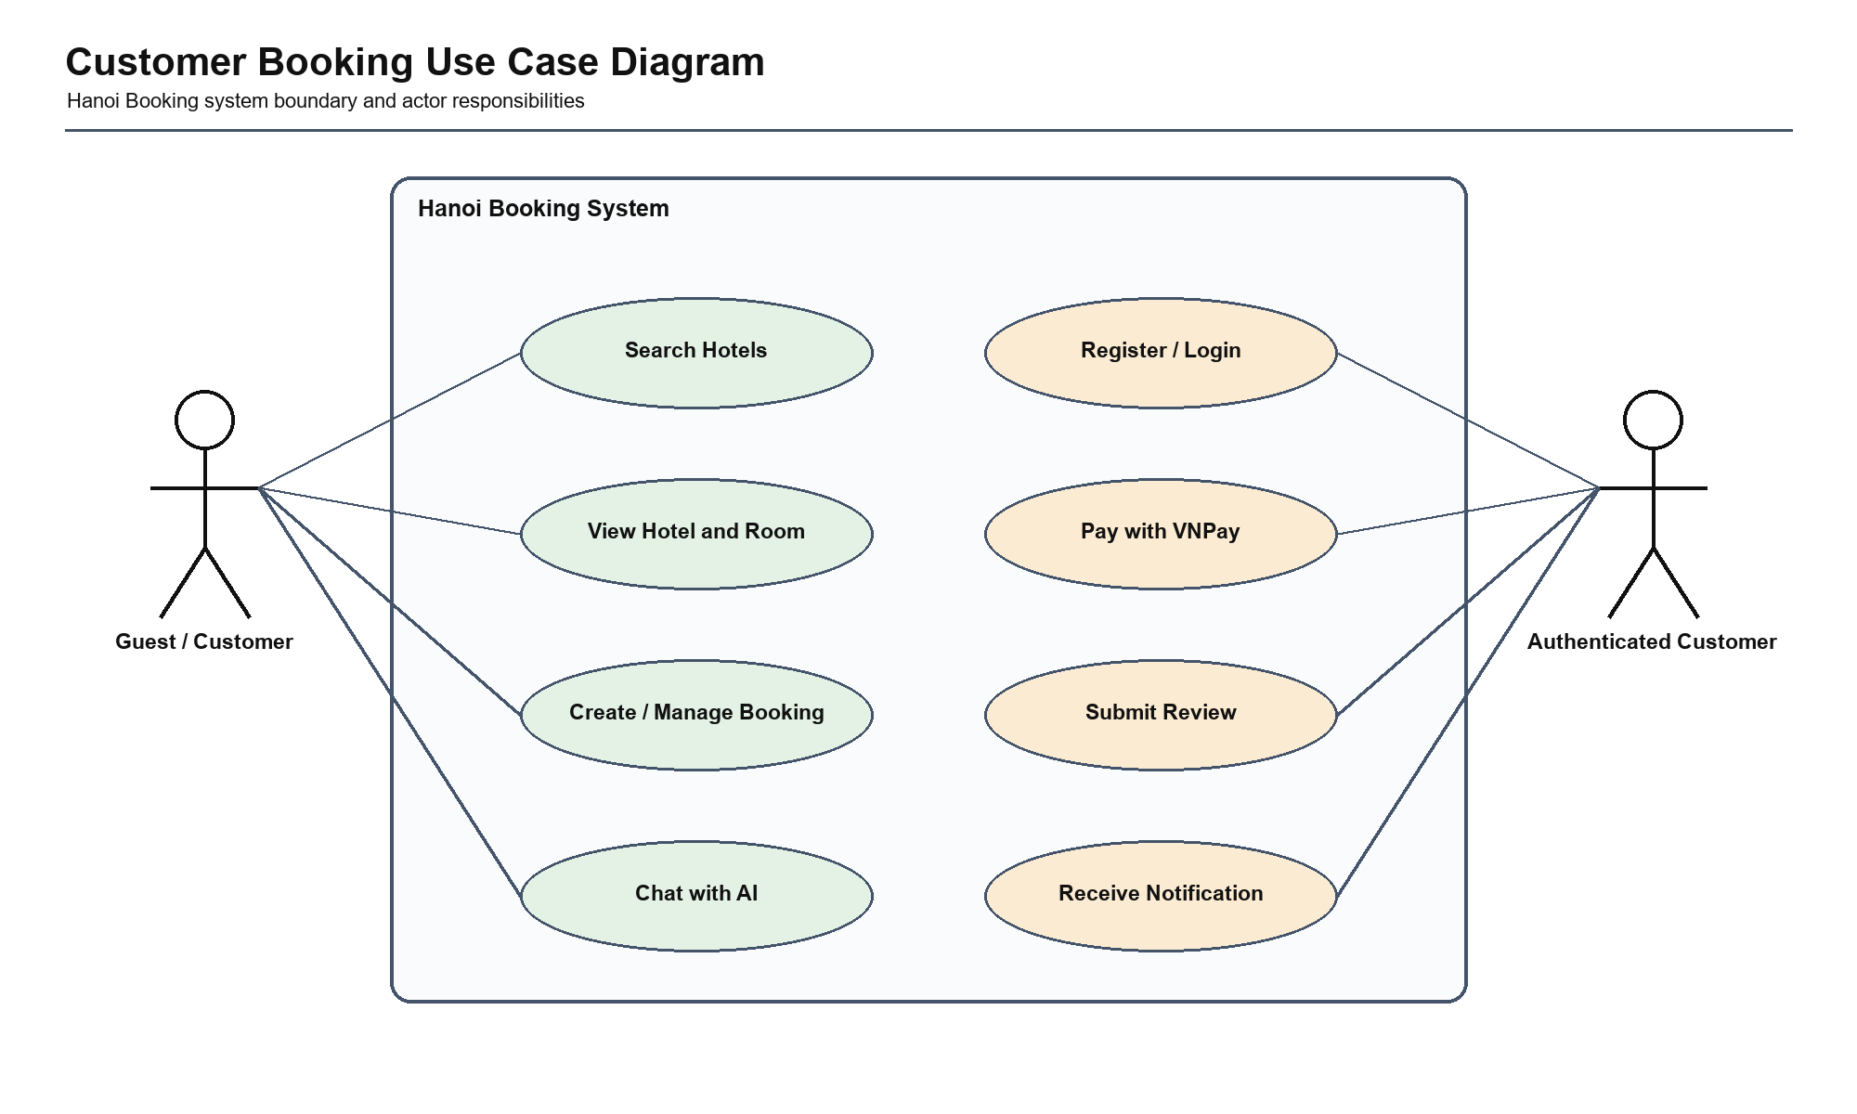
Figure 1. Customer Booking Use Case Diagram
The customer view separates public discovery from authenticated booking, payment, review, notification, and AI-assisted behavior. The system boundary makes Hanoi Booking responsible for enforcing identity, reservation, and payment rules before external services participate.
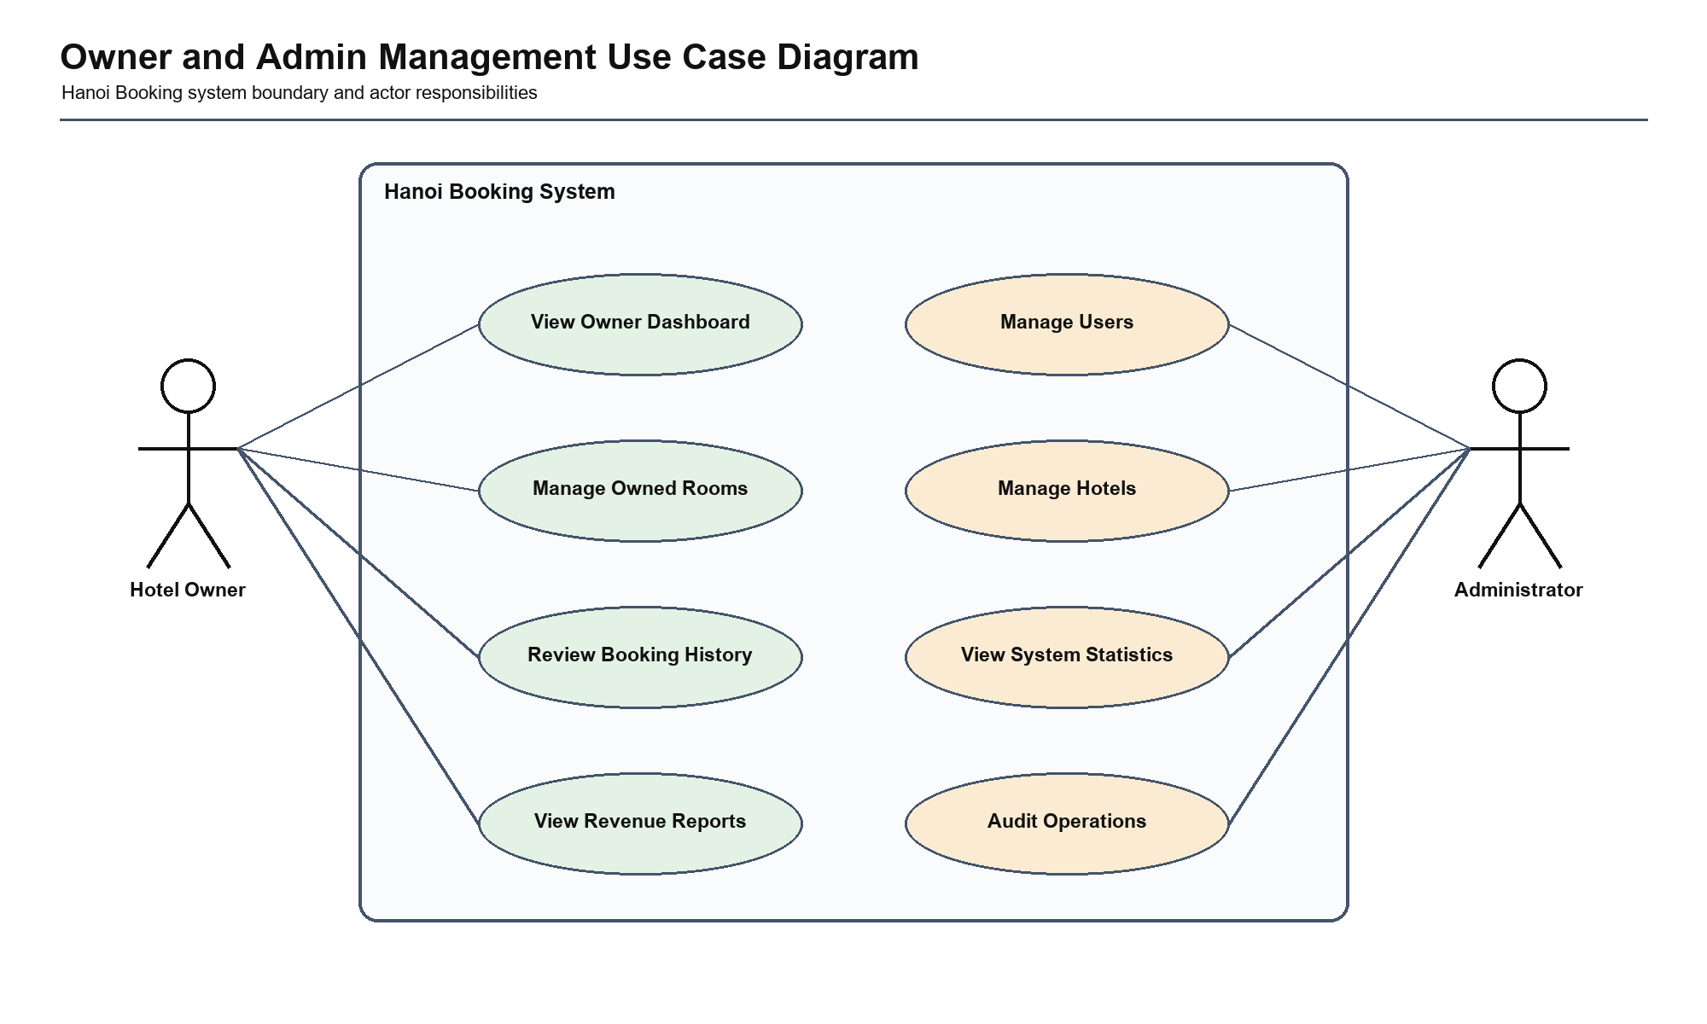
Figure 2. Owner and Admin Management Use Case Diagram
The management view separates hotel-owner responsibilities from system-wide administrator capabilities. This boundary highlights tenant isolation: owners operate only on assigned hotels, while administrator actions require an explicit privileged role and audit trail.

2.3.3 Use Case: Search Hotel
Use case specification: Search Hotel
Field: Actor Description: Customer / Guest
Field: Precondition Description: The application is available.
Field: Main Flow Description: Enter destination or hotel name; submit search; system queries matching hotels and available rooms; results are displayed.
Field: Alternative Flow Description: Unknown destination returns an empty-result message.
Field: Postcondition Description: Matching hotels or a controlled empty result is displayed.
Field: Related API/Route Description: /search, /search-by-name
Field: Data Entities Description: Hotel, Room, HotelLocation
2.3.3.1 Business Rules
Search terms are normalized before querying; unavailable rooms must not be advertised as bookable; location search is read-only; empty results are valid outcomes rather than system errors.
2.3.3.2 Exception Cases and Recovery
Invalid or unknown destinations return a controlled empty result. Database timeout, malformed coordinates, and expensive unbounded queries must be handled without exposing internal SQL or provider details.
2.3.3.3 Architecture Impact
A HotelQueryService should own search composition and return stable read models. This keeps presentation formatting out of SQLAlchemy queries and permits indexing, caching, pagination, and query profiling without changing browser routes.
2.3.3.4 Security Concern
Search is public, but input length, wildcard use, coordinate range, result size, and error output require validation. Public search must not expose owner-only operational or customer booking data.
2.3.3.5 Test Coverage
TC-UI-01 provides executed HTTP/render evidence and TC-ROOM-01 verifies available-room filtering. Proposed tests cover empty results, invalid coordinates, pagination, SQL injection resistance, and query latency.
Search Hotel detailed responsibility flow
Step: 1 Action: Receive destination/name/coordinate criteria Architecture Control: Validate length, format, and coordinate range Output: Validated search criteria
Step: 2 Action: Resolve location or search mode Architecture Control: Do not treat an unknown location as a system failure Output: Query strategy
Step: 3 Action: Query hotels and room availability Architecture Control: Apply bounded filters, pagination, and read-only access Output: Candidate read models
Step: 4 Action: Transform results for presentation Architecture Control: Do not expose owner/customer operational data Output: Public result DTOs
Step: 5 Action: Render results or controlled empty state Architecture Control: Keep internal query/provider errors private Output: HTML/JSON response
Search Hotel exception decision matrix
Exception Category: Validation Example: Missing, malformed, or out-of-range input Required Decision: Reject before service mutation State Guarantee: Persistent state unchanged
Exception Category: Authorization Example: Guest, wrong role, or wrong resource owner Required Decision: Deny without protected-data disclosure State Guarantee: Protected data and state unchanged
Exception Category: Conflict Example: Unavailable inventory, invalid transition, or repeated action Required Decision: Return controlled conflict/idempotent result State Guarantee: No duplicate or inconsistent mutation
Exception Category: Infrastructure/provider Example: Database error, timeout, or unavailable external service Required Decision: Rollback or apply explicit fallback policy State Guarantee: Transaction consistency preserved
Search Hotel architecture and verification mapping
Concern: Input and identity Current Boundary: /search, /search-by-name Target Owner: Search Hotel application service Verification: Validation and authorization tests
Concern: Business consistency Current Boundary: Hotel, Room, HotelLocation Target Owner: Domain policy and transaction boundary Verification: State, rollback, and concurrency tests
Concern: Failure handling Current Boundary: Route/provider/database exceptions Target Owner: Controlled result and audit policy Verification: Negative-path and recovery tests
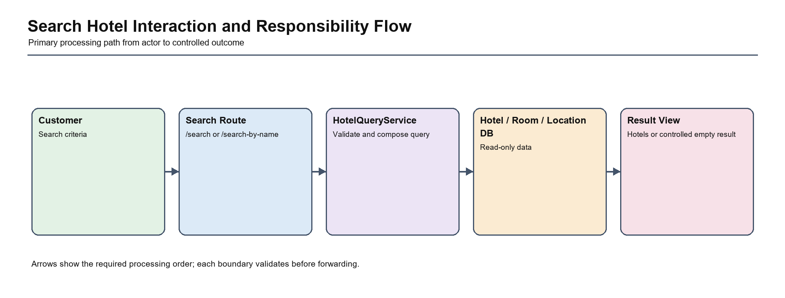
Figure 3. Search Hotel Interaction and Responsibility Flow
The flow assigns the Search Hotel use case to one clear application boundary and shows the ordered path from actor input to a controlled result. It prevents routes, providers, AI tools, or database access from becoming alternative owners of the business decision.

2.3.4 Use Case: Create Booking
Use case specification: Create Booking
Field: Actor Description: Authenticated Customer
Field: Precondition Description: The selected room exists and dates are valid.
Field: Main Flow Description: Select dates and quantity; validate availability; calculate price; create pending booking; reserve inventory.
Field: Alternative Flow Description: Invalid date or insufficient inventory rejects the operation.
Field: Postcondition Description: A pending booking is created or the request is rejected without mutation.
Field: Related API/Route Description: /book/<room_id>, /book_and_pay/<room_id>
Field: Data Entities Description: Booking, Room, User
2.3.4.1 Business Rules
The customer must be authenticated; start date must precede end date; requested quantity must be positive; room inventory cannot become negative; total price is calculated by trusted server logic; a booking transition must be valid for its current state.
2.3.4.2 Exception Cases and Recovery
Reject past dates, invalid ranges, missing rooms, insufficient stock, repeated submission, unauthorized ownership, database conflict, and concurrent final-room requests. Rejection must leave both Booking and Room unchanged.
2.3.4.3 Architecture Impact
BookingService must own validation, inventory reservation, booking creation, and commit/rollback as one transaction. Route functions and AI tools may request the use case but cannot reproduce or bypass its rules.
2.3.4.4 Security Concern
The server must derive user identity from the authenticated session and must not trust submitted price, status, or owner identifiers. Cancellation and detail access require resource ownership checks.
2.3.4.5 Test Coverage
TC-BOOK-01 passed for the valid path. TC-BOOK-02 failed for insufficient stock and TC-RELIABILITY-01 failed for concurrency control; both failures directly justify ADR-06. Proposed MySQL integration tests exercise row locking, duplicate submission, rollback, and cancellation.
Create Booking detailed responsibility flow
Step: 1 Action: Load authenticated customer and selected room Architecture Control: Verify identity and resource existence Output: Authorized request context
Step: 2 Action: Validate dates, quantity, state, and trusted price inputs Architecture Control: Reject before mutation Output: Validated booking command
Step: 3 Action: Reserve inventory atomically Architecture Control: Conditional update or row lock prevents overbooking Output: Reserved inventory
Step: 4 Action: Create pending booking in the same transaction Architecture Control: Server calculates total and initial state Output: Pending Booking record
Step: 5 Action: Commit once and return result Architecture Control: Rollback inventory and booking on failure Output: Booking confirmation or controlled rejection
Create Booking exception decision matrix
Exception Category: Validation Example: Missing, malformed, or out-of-range input Required Decision: Reject before service mutation State Guarantee: Persistent state unchanged
Exception Category: Authorization Example: Guest, wrong role, or wrong resource owner Required Decision: Deny without protected-data disclosure State Guarantee: Protected data and state unchanged
Exception Category: Conflict Example: Unavailable inventory, invalid transition, or repeated action Required Decision: Return controlled conflict/idempotent result State Guarantee: No duplicate or inconsistent mutation
Exception Category: Infrastructure/provider Example: Database error, timeout, or unavailable external service Required Decision: Rollback or apply explicit fallback policy State Guarantee: Transaction consistency preserved
Create Booking architecture and verification mapping
Concern: Input and identity Current Boundary: /book/<room_id>, /book_and_pay/<room_id> Target Owner: Create Booking application service Verification: Validation and authorization tests
Concern: Business consistency Current Boundary: Booking, Room, User Target Owner: Domain policy and transaction boundary Verification: State, rollback, and concurrency tests
Concern: Failure handling Current Boundary: Route/provider/database exceptions Target Owner: Controlled result and audit policy Verification: Negative-path and recovery tests
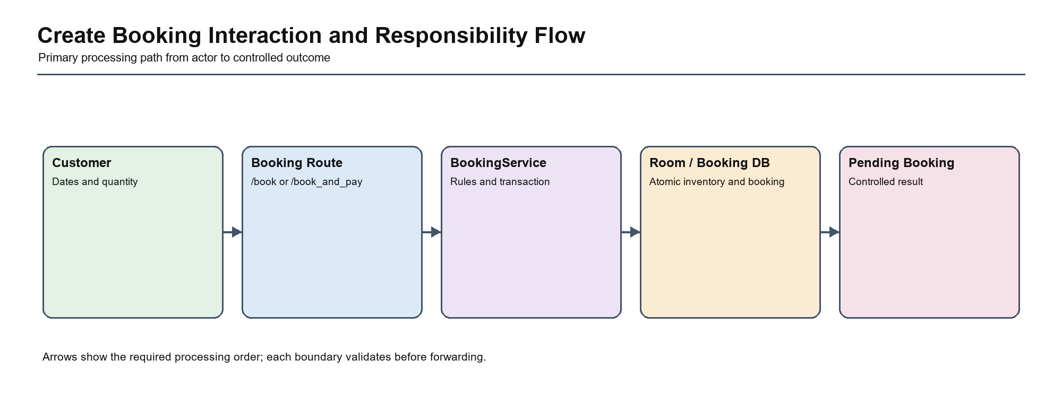
Figure 4. Create Booking Interaction and Responsibility Flow
The flow assigns the Create Booking use case to one clear application boundary and shows the ordered path from actor input to a controlled result. It prevents routes, providers, AI tools, or database access from becoming alternative owners of the business decision.

2.3.5 Use Case: VNPay Payment
Use case specification: VNPay Payment
Field: Actor Description: Customer and VNPay
Field: Precondition Description: An owned pending booking exists.
Field: Main Flow Description: Validate booking; create signed payment URL; redirect to VNPay; receive callback; verify provider data; finalize booking/payment.
Field: Alternative Flow Description: Invalid signature, amount, reference, or failed payment is rejected or marked failed.
Field: Postcondition Description: Payment and booking states are synchronized.
Field: Related API/Route Description: /vnpay_pay, /vnpay_return
Field: Data Entities Description: Payment, Booking
2.3.5.1 Business Rules
Only an owned payable booking can initiate payment; amount and transaction reference originate from trusted records; callback signature, amount, reference, and terminal state must be verified; repeated callbacks are idempotent.
2.3.5.2 Exception Cases and Recovery
Reject forged signature, mismatched amount, unknown reference, expired session, provider failure, repeated callback, and callback after cancellation. A failed verification cannot mutate Payment or Booking.
2.3.5.3 Architecture Impact
PaymentService coordinates the use case while VNPayAdapter owns signing and verification. Provider query parameters remain outside domain logic, and final state changes occur in a single transaction.
2.3.5.4 Security Concern
The callback is an internet-facing trust boundary. It must use constant-time signature comparison, strict allow-listed parameters, replay protection, secure secrets, audit logs, and generic user-facing errors.
2.3.5.5 Test Coverage
TC-PAY-01 passed for deterministic outbound hashing. TC-PAY-02 failed because incoming callback verification was not identified. Proposed tests cover tampered signature, amount mismatch, replay, unknown reference, provider failure, and idempotent finalization.
VNPay Payment detailed responsibility flow
Step: 1 Action: Load owned payable booking Architecture Control: Verify customer, amount, and eligible state Output: Trusted payment command
Step: 2 Action: Create unique reference and signed URL Architecture Control: VNPayAdapter owns provider parameters and secret use Output: Redirect URL
Step: 3 Action: Receive untrusted provider callback Architecture Control: Do not mutate before verification Output: Callback verification input
Step: 4 Action: Verify signature, amount, reference, state, and replay Architecture Control: Reject any mismatch Output: Verified provider result
Step: 5 Action: Finalize Payment and Booking atomically Architecture Control: Idempotent terminal-state transition Output: Synchronized financial and booking state
VNPay Payment exception decision matrix
Exception Category: Validation Example: Missing, malformed, or out-of-range input Required Decision: Reject before service mutation State Guarantee: Persistent state unchanged
Exception Category: Authorization Example: Guest, wrong role, or wrong resource owner Required Decision: Deny without protected-data disclosure State Guarantee: Protected data and state unchanged
Exception Category: Conflict Example: Unavailable inventory, invalid transition, or repeated action Required Decision: Return controlled conflict/idempotent result State Guarantee: No duplicate or inconsistent mutation
Exception Category: Infrastructure/provider Example: Database error, timeout, or unavailable external service Required Decision: Rollback or apply explicit fallback policy State Guarantee: Transaction consistency preserved
VNPay Payment architecture and verification mapping
Concern: Input and identity Current Boundary: /vnpay_pay, /vnpay_return Target Owner: VNPay Payment application service Verification: Validation and authorization tests
Concern: Business consistency Current Boundary: Payment, Booking Target Owner: Domain policy and transaction boundary Verification: State, rollback, and concurrency tests
Concern: Failure handling Current Boundary: Route/provider/database exceptions Target Owner: Controlled result and audit policy Verification: Negative-path and recovery tests
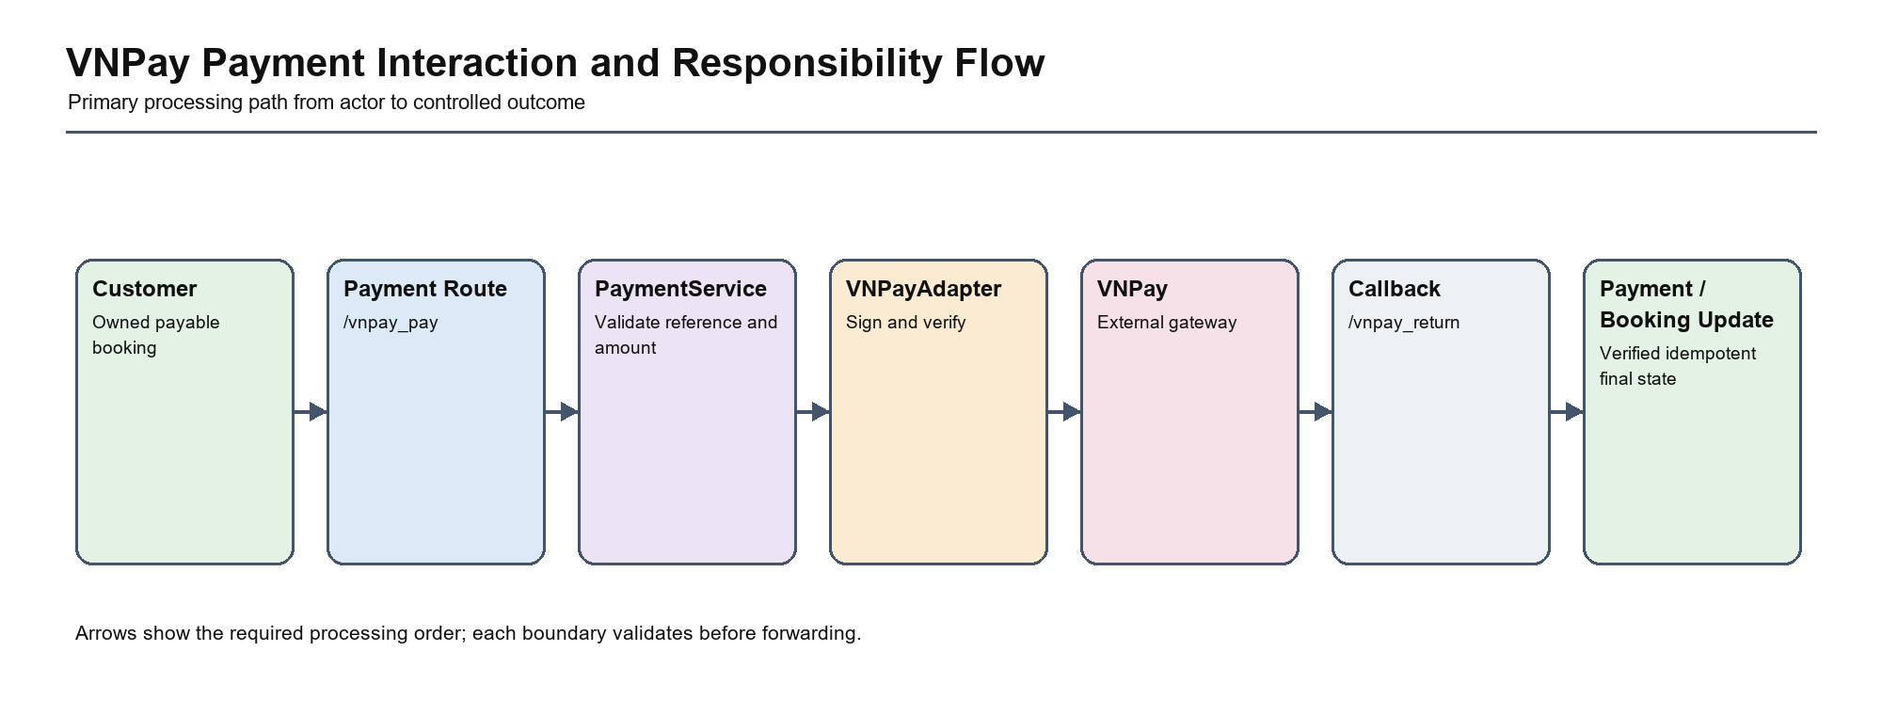
Figure 5. VNPay Payment Interaction and Responsibility Flow
The flow assigns the VNPay Payment use case to one clear application boundary and shows the ordered path from actor input to a controlled result. It prevents routes, providers, AI tools, or database access from becoming alternative owners of the business decision.

2.3.6 Use Case: Owner Manage Rooms
Use case specification: Owner Manage Rooms
Field: Actor Description: Hotel Owner
Field: Precondition Description: Owner is authenticated and owns the hotel.
Field: Main Flow Description: Open dashboard; retrieve owned room and booking data; review availability and revenue.
Field: Alternative Flow Description: Cross-owner request is forbidden.
Field: Postcondition Description: Only owned-hotel operational data is displayed.
Field: Related API/Route Description: /api/owner/dashboard, /api/owner/room-types
Field: Data Entities Description: Hotel, Room, Booking, Payment
2.3.6.1 Business Rules
An owner can view and manage only hotels assigned to that owner. Dashboard totals must be derived from the same tenant scope, and administrative privileges must be explicit rather than inferred from URL access.
2.3.6.2 Exception Cases and Recovery
Reject unauthenticated requests, customer-role requests, cross-owner hotel identifiers, deleted resources, inconsistent reporting filters, and malformed date ranges without disclosing protected tenant data.
2.3.6.3 Architecture Impact
ManagementService and OwnershipPolicy should centralize tenant scope before repositories execute dashboard and reporting queries. This prevents every owner endpoint from implementing a slightly different ownership filter.
2.3.6.4 Security Concern
Cross-tenant disclosure is the dominant risk. Deny-by-default policy, server-side owner identity, audit events, pagination, and response DTOs are required for every owner/admin endpoint.
2.3.6.5 Test Coverage
Owner/admin end-to-end tests are currently Not Executed because a seeded role environment is unavailable. Proposed coverage includes an endpoint-role matrix, cross-owner denial, aggregate isolation, pagination, and audit verification.
Owner Manage Rooms detailed responsibility flow
Step: 1 Action: Authenticate owner/admin actor Architecture Control: Reject guest/customer role Output: Authorized management identity
Step: 2 Action: Resolve requested hotel scope Architecture Control: Apply ownership policy before query Output: Tenant-scoped context
Step: 3 Action: Query room, booking, payment, and reporting data Architecture Control: Every aggregate retains tenant filter Output: Operational read models
Step: 4 Action: Apply pagination and presentation transformation Architecture Control: Avoid unbounded query and protected-data leakage Output: Dashboard DTOs
Step: 5 Action: Return dashboard or controlled denial Architecture Control: Audit cross-tenant and administrative access Output: Management response and audit event
Owner Manage Rooms exception decision matrix
Exception Category: Validation Example: Missing, malformed, or out-of-range input Required Decision: Reject before service mutation State Guarantee: Persistent state unchanged
Exception Category: Authorization Example: Guest, wrong role, or wrong resource owner Required Decision: Deny without protected-data disclosure State Guarantee: Protected data and state unchanged
Exception Category: Conflict Example: Unavailable inventory, invalid transition, or repeated action Required Decision: Return controlled conflict/idempotent result State Guarantee: No duplicate or inconsistent mutation
Exception Category: Infrastructure/provider Example: Database error, timeout, or unavailable external service Required Decision: Rollback or apply explicit fallback policy State Guarantee: Transaction consistency preserved
Owner Manage Rooms architecture and verification mapping
Concern: Input and identity Current Boundary: /api/owner/dashboard, /api/owner/room-types Target Owner: Owner Manage Rooms application service Verification: Validation and authorization tests
Concern: Business consistency Current Boundary: Hotel, Room, Booking, Payment Target Owner: Domain policy and transaction boundary Verification: State, rollback, and concurrency tests
Concern: Failure handling Current Boundary: Route/provider/database exceptions Target Owner: Controlled result and audit policy Verification: Negative-path and recovery tests
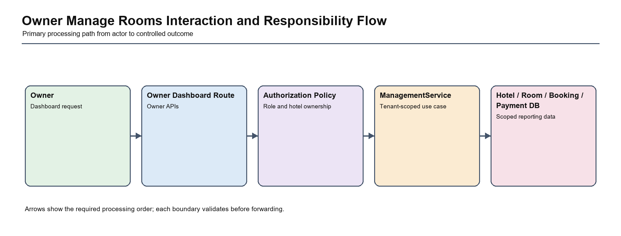
Figure 6. Owner Manage Rooms Interaction and Responsibility Flow
The flow assigns the Owner Manage Rooms use case to one clear application boundary and shows the ordered path from actor input to a controlled result. It prevents routes, providers, AI tools, or database access from becoming alternative owners of the business decision.

2.3.7 Use Case: AI Booking Assistant
Use case specification: AI Booking Assistant
Field: Actor Description: User / Customer
Field: Precondition Description: Chat API is available; booking actions require authentication.
Field: Main Flow Description: Send message; classify intent; retrieve context or rooms; generate response; require confirmation before booking.
Field: Alternative Flow Description: Provider failure returns deterministic fallback; unsafe or incomplete request does not mutate data.
Field: Postcondition Description: A safe response or confirmed action is returned.
Field: Related API/Route Description: /api/chat
Field: Data Entities Description: BookingState, Hotel, Room, Booking
2.3.7.1 Business Rules
AI output is advisory until deterministic tools confirm domain facts; mutation requires explicit user confirmation and authentication; generated text cannot set price, inventory, role, or payment state; sensitive data sent to providers is minimized.
2.3.7.2 Exception Cases and Recovery
Provider timeout, malformed model output, unsupported intent, missing coordinates, hallucinated hotel, unsafe prompt, and interrupted confirmation return deterministic fallback without mutation.
2.3.7.3 Architecture Impact
AIChatService and constrained SafeDomainTools isolate probabilistic reasoning from transaction services. All booking or payment actions reuse BookingService and PaymentService rather than duplicating logic in LangGraph nodes.
2.3.7.4 Security Concern
Prompt injection, data leakage, excessive provider data, and unsafe tool invocation require allow-listed tools, explicit confirmation, output validation, rate limits, timeouts, and audit records.
2.3.7.5 Test Coverage
Executed location-helper tests passed and provide evidence for deterministic distance logic. Proposed tests cover provider outage, prompt injection, privacy minimization, tool authorization, confirmation requirements, and safe fallback.
AI Booking Assistant detailed responsibility flow
Step: 1 Action: Receive chat message and optional location context Architecture Control: Validate size, authentication context, and privacy Output: Safe conversational input
Step: 2 Action: Classify intent and select allow-listed tool Architecture Control: Generated output cannot directly mutate data Output: Constrained tool request
Step: 3 Action: Retrieve deterministic domain facts Architecture Control: Use service/query boundaries and minimize provider data Output: Grounded context
Step: 4 Action: Generate response or request explicit confirmation Architecture Control: Validate output and preserve deterministic fallback Output: Safe response/confirmation
Step: 5 Action: Execute confirmed action through business service Architecture Control: Reuse BookingService/PaymentService policies Output: Controlled domain result
AI Booking Assistant exception decision matrix
Exception Category: Validation Example: Missing, malformed, or out-of-range input Required Decision: Reject before service mutation State Guarantee: Persistent state unchanged
Exception Category: Authorization Example: Guest, wrong role, or wrong resource owner Required Decision: Deny without protected-data disclosure State Guarantee: Protected data and state unchanged
Exception Category: Conflict Example: Unavailable inventory, invalid transition, or repeated action Required Decision: Return controlled conflict/idempotent result State Guarantee: No duplicate or inconsistent mutation
Exception Category: Infrastructure/provider Example: Database error, timeout, or unavailable external service Required Decision: Rollback or apply explicit fallback policy State Guarantee: Transaction consistency preserved
AI Booking Assistant architecture and verification mapping
Concern: Input and identity Current Boundary: /api/chat Target Owner: AI Booking Assistant application service Verification: Validation and authorization tests
Concern: Business consistency Current Boundary: BookingState, Hotel, Room, Booking Target Owner: Domain policy and transaction boundary Verification: State, rollback, and concurrency tests
Concern: Failure handling Current Boundary: Route/provider/database exceptions Target Owner: Controlled result and audit policy Verification: Negative-path and recovery tests
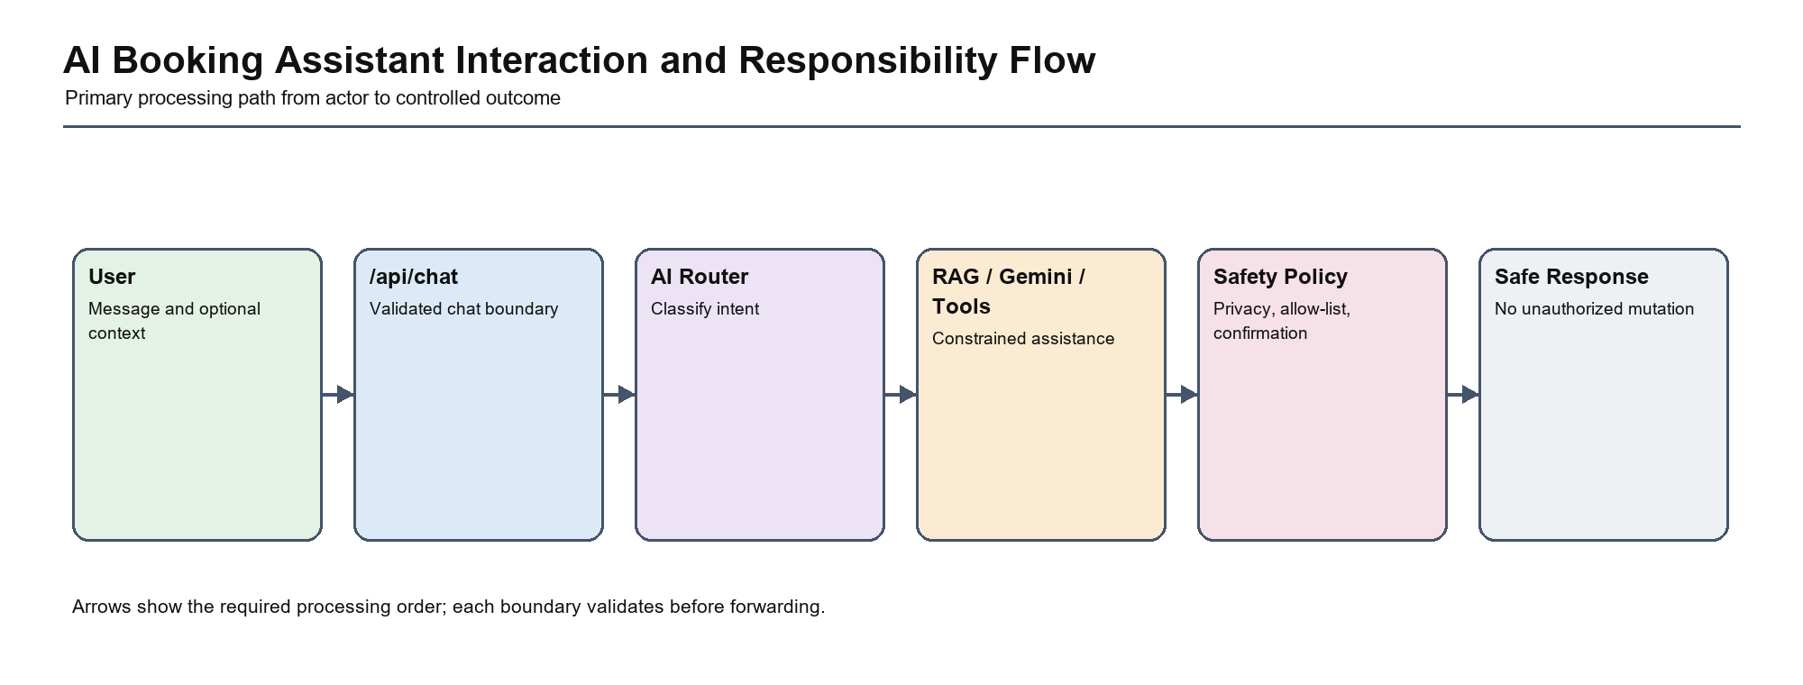
Figure 7. AI Booking Assistant Interaction and Responsibility Flow
The flow assigns the AI Booking Assistant use case to one clear application boundary and shows the ordered path from actor input to a controlled result. It prevents routes, providers, AI tools, or database access from becoming alternative owners of the business decision.

2.4 Architecturally Significant Requirements
Table 7. Architecturally significant requirements
ASR | Stimulus | Expected Response | Architecture Strategy
ASR-01 Security | Unauthorized or forged request | Reject before protected data or state is exposed | Central policy, CSRF, rate limiting, verified callback
ASR-02 Integrity | Concurrent final-room booking | At most one reservation succeeds | Atomic conditional update or row lock
ASR-03 Availability | Gemini or SMTP unavailable | Core booking remains usable | Timeouts and deterministic fallback
ASR-04 Maintainability | Add or modify a business feature | Change is localized and regression-tested | Modular monolith and services

2.5 Requirement Prioritization
Payment integrity, room inventory, authentication, and authorization are P0 concerns because failures can produce financial loss or unauthorized access. Search usability, presentation refinements, and optional AI improvements follow after transactional and security controls.

2.6 Requirement-to-Module Mapping
Table 8. Requirement-to-module mapping
Requirement | Module | Primary Routes | Data Entity | Test Case
FR01 | Authentication | /login, /register, password routes | User, UserSecurity | TC-AUTH-01, TC-AUTH-02
FR02 | Hotel/Room | /search, /search-by-name | Hotel, Room, HotelLocation | TC-UI-01
FR03 | Hotel/Room | /hotel/<id>, room APIs | Room, Service, RoomImage | TC-ROOM-01
FR04 | Booking | booking and delete routes | Booking, Room, User | TC-BOOK-01, TC-BOOK-02
FR05 | Payment | /vnpay_pay, /vnpay_return | Payment, Booking | TC-PAY-01, TC-PAY-02
FR06 | Review | /hotel/<id>/review | Review, User, Hotel | TC-REV-01
FR07 | Notification | /api/user/notifications | Notification, User | TC-NOTIFY-01
FR08 | Owner/Admin | owner and hotel dashboard APIs | Hotel, Room, Booking, Payment | TC-OWNER-01
FR09 | Owner/Admin | manage users/hotels, statistics | User, Hotel | TC-ADMIN-01
FR10 | AI Assistant | /api/chat | BookingState and domain tools | TC-AI-01, TC-AI-02

2.7 Requirement-to-API Mapping

Table 9. Requirement-to-API mapping
Requirement | API/Route | Actor
FR01 | /login, /register, password routes | Customer / Owner / Admin as applicable
FR02 | /search, /search-by-name | Customer / Owner / Admin as applicable
FR03 | /hotel/<id>, room APIs | Customer / Owner / Admin as applicable
FR04 | booking and delete routes | Customer / Owner / Admin as applicable
FR05 | /vnpay_pay, /vnpay_return | Customer / Owner / Admin as applicable
FR06 | /hotel/<id>/review | Customer / Owner / Admin as applicable
FR07 | /api/user/notifications | Customer / Owner / Admin as applicable
FR08 | owner and hotel dashboard APIs | Customer / Owner / Admin as applicable
FR09 | manage users/hotels, statistics | Customer / Owner / Admin as applicable
FR10 | /api/chat | Customer / Owner / Admin as applicable

2.8 Requirement-to-Test Mapping

Table 10. Requirement-to-test mapping
Requirement | Test Case | Evidence Status
FR01 | TC-AUTH-01, TC-AUTH-02 | Passed
FR02 | TC-UI-01 | Passed
FR03 | TC-ROOM-01 | Passed
FR04 | TC-BOOK-01, TC-BOOK-02 | Partially Verified
FR05 | TC-PAY-01, TC-PAY-02 | Partially Verified
FR06 | TC-REV-01 | Not Executed
FR07 | TC-NOTIFY-01 | Not Executed
FR08 | TC-OWNER-01 | Not Executed
FR09 | TC-ADMIN-01 | Not Executed
FR10 | TC-AI-01, TC-AI-02 | Passed
NFR01 Availability | External-service resilience tests | Blocked
NFR02 Security | Security control tests | Failed
NFR03 Performance | Load and response-time tests | Not Executed
NFR04 Reliability | Concurrency and consistency tests | Failed
NFR05 Maintainability | Automated regression suite | Passed
NFR06 Observability | Log, metric, and audit verification | Not Executed

3. Source Code Structure and Target Mapping

3.1 Current Source Tree
pt_tke_pm/
|-- app.py
|-- config.py
|-- models.py
|-- utils.py
|-- setup_database.sql
|-- requirements.txt
|-- ai_agent/
| |-- __init__.py
| |-- graph.py
| |-- nodes/__init__.py
| |-- nodes/booking.py
| |-- nodes/management.py
| |-- nodes/nearby.py
| |-- nodes/rag_faq.py
| |-- nodes/router.py
| |-- prompts.py
| |-- state.py
| |-- test_agent.py
| |-- tools/__init__.py
| |-- tools/db_tools.py
| |-- tools/location_tools.py
| |-- tools/payment_tools.py
|-- chatbot_system/
| |-- build_vector_db.py
| |-- chatbot.py
| |-- docs/codebase_data.txt
| |-- extract_project_data.py
| |-- requirements.txt
| |-- test_chatbot.py
|-- hotelsmanagementweb/
| |-- css/base.css
| |-- css/booking.css
| |-- css/detailroom.css
| |-- css/home.css
| |-- css/register.css
| |-- css/test.css
| |-- css/user.css
| |-- database/btl_csdl_bookings.sql
| |-- database/btl_csdl_hotel_images.sql
| |-- database/btl_csdl_hotels.sql
| |-- database/btl_csdl_notifications.sql
| |-- database/btl_csdl_payment.sql
| |-- database/btl_csdl_room_images.sql
| |-- database/btl_csdl_rooms.sql
| |-- database/btl_csdl_services.sql
| |-- database/btl_csdl_users.sql
| |-- database/db.sql
| |-- database/hotel.sql
| |-- database/image.sql
| |-- database/room.sql
| |-- database/services.sql
| |-- database/update_hotels.sql
| |-- database/users.sql
| |-- js/main.js
| |-- js/user.js
| |-- pages/ai_chat_widget.html
| |-- pages/booking.html
| |-- pages/detailroom.html
| |-- pages/header.html
| |-- pages/home.html
| |-- pages/register.html
| |-- pages/user.html
|-- migrations/
| |-- alembic.ini
| |-- env.py
| |-- script.py.mako
| |-- versions/b0ffc569636c_initial_migration.py
|-- tests/
| |-- test_quality_core.py
|-- hotelsmanagementweb/assets/ (grouped static hotel and UI images)
|-- report_diagrams/ and detailed_architecture_diagrams/ (generated documentation assets)
|-- test_evidence/ (JUnit, coverage, screenshots, and result charts)

3.2 Folder Responsibilities
Table 11. Current folder and file responsibilities
Path | Current Responsibility | Architecture Observation
app.py | Flask configuration, routes, authorization, queries, integrations, and orchestration | Largest concentration of responsibilities
models.py | SQLAlchemy entities and relationships | Transactional data model
utils.py | Shared CRUD, booking, payment, review, and email helpers | Mixes use-case and infrastructure concerns
ai_agent/ | LangGraph state, nodes, and tools | Explicit AI orchestration boundary
chatbot_system/ | RAG extraction, vector build, and chatbot | Derived knowledge subsystem
hotelsmanagementweb/pages/ | Server-rendered HTML views | Presentation layer
hotelsmanagementweb/css/ and js/ | Browser styling and interaction | Static presentation assets
migrations/ and SQL files | Schema creation and evolution | Data infrastructure
tests/ and test_evidence/ | Automated checks and evidence | Architecture verification assets

3.3 Current Folder to Target Folder Mapping
Table 12. Current-to-target folder mapping
Current Location | Target Location | Migration Purpose
app.py route groups | app/blueprints/<domain>/routes.py | Separate presentation boundaries
app.py orchestration and utils.py | app/services/<domain>_service.py | Own complete use cases and transactions
distributed validation | app/dto/ and app/validation/ | Standardize input and output contracts
distributed ORM queries | app/repositories/ | Isolate consistency-sensitive persistence
VNPay/SMTP/Gemini calls | app/integrations/ | Create provider adapters and failure policies
role/owner checks | app/policies/authorization.py | Centralize deny-by-default access control
before-request cleanup | app/jobs/ | Move scheduled work out of request path

3.4 File-Level Improvement Priorities
The first extraction target is not every file. The highest-value boundaries are booking transactions, payment verification, authorization policy, and external-service adapters. These areas have verified defects or high security impact. Read-only hotel queries and presentation helpers can be migrated after the consistency-sensitive workflows are stable.

4. C4 Model

4.1 C4 Model Purpose and Scope
The C4 model provides a progressive explanation from external actors to code-level responsibilities. Hanoi Booking requires both current and target views because the proposed service/repository structure is not fully implemented.
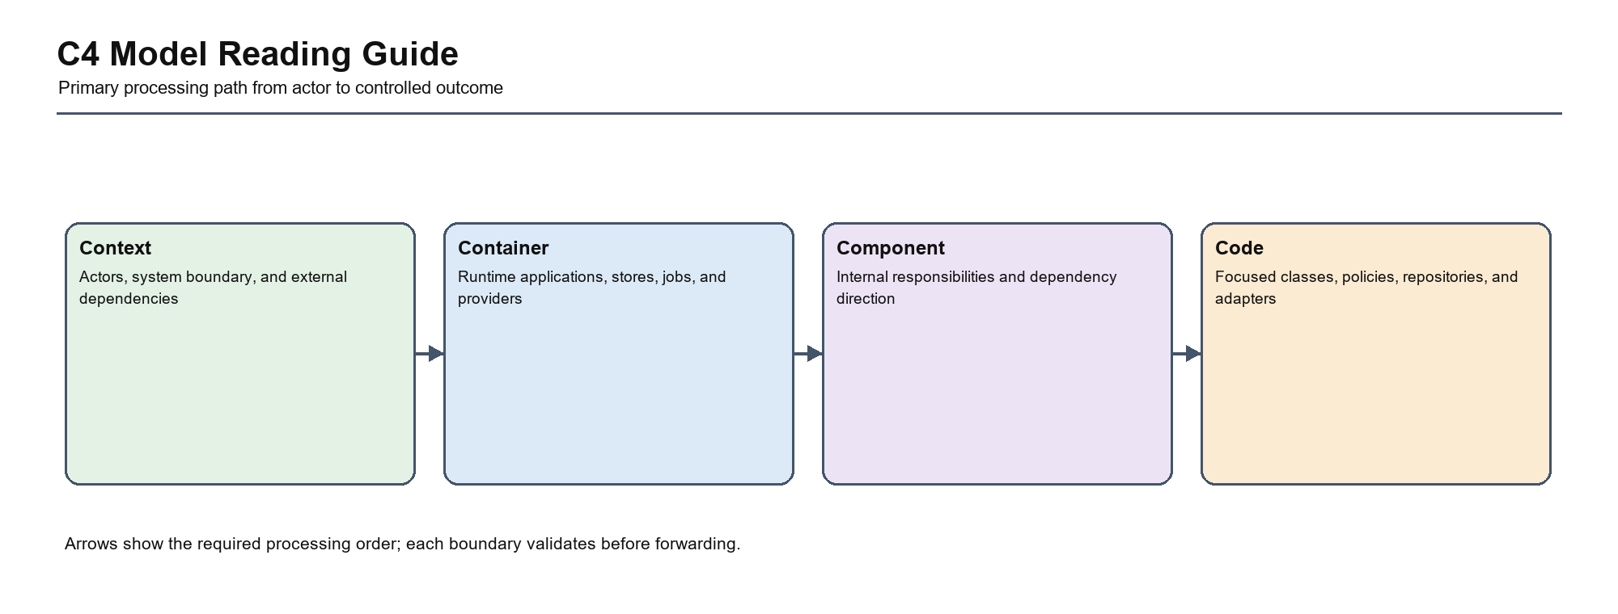
Figure 8. C4 Model Reading Guide
4.1.1 Main Responsibility
Define the system boundary, human actors, external providers, and the trust changes that occur when data leaves Hanoi Booking.
4.1.2 Key Components
Customer, owner, administrator, Hanoi Booking, VNPay, SMTP, Gemini, and the derived ChromaDB knowledge capability.
4.1.3 Dependency Direction
Human actors initiate requests toward Hanoi Booking. The system invokes external providers; providers never receive authority to bypass Hanoi Booking validation or directly change relational records.
4.1.4 Current Risk
The implemented view concentrates orchestration in app.py and allows route, ORM, provider, and presentation concerns to change together. This makes ownership, transaction scope, failure behavior, and security review difficult to verify.
4.1.5 Target Improvement
Introduce the target boundary incrementally around verified risks: booking inventory, payment callback verification, authorization, secure configuration, and optional-service fallback.
Detailed analysis of C4 Model Purpose and Scope
Analysis Area: Responsibility Hanoi Booking Interpretation: Define the system boundary, human actors, external providers, and the trust changes that occur when data leaves Hanoi Booking. Evidence or Control: Diagram boundary and source structure
Analysis Area: Dependencies Hanoi Booking Interpretation: Human actors initiate requests toward Hanoi Booking. The system invokes external providers; providers never receive authority to bypass Hanoi Booking validation or directly change relational records. Evidence or Control: Module dependency rules and adapter contracts
Analysis Area: Risk Hanoi Booking Interpretation: The implemented view concentrates orchestration in app.py and allows route, ORM, provider, and presentation concerns to change together. This makes ownership, transaction scope, failure behavior, and security review difficult to verify. Evidence or Control: Verified defects, route concentration, and review
Analysis Area: Improvement Hanoi Booking Interpretation: Introduce the target boundary incrementally around verified risks: booking inventory, payment callback verification, authorization, secure configuration, and optional-service fallback. Evidence or Control: ADR, migration task, and regression evidence

4.2 Current Context View
The current context positions the Flask application as the central business and integration boundary. VNPay is financially critical, while SMTP and Gemini should remain optional dependencies.
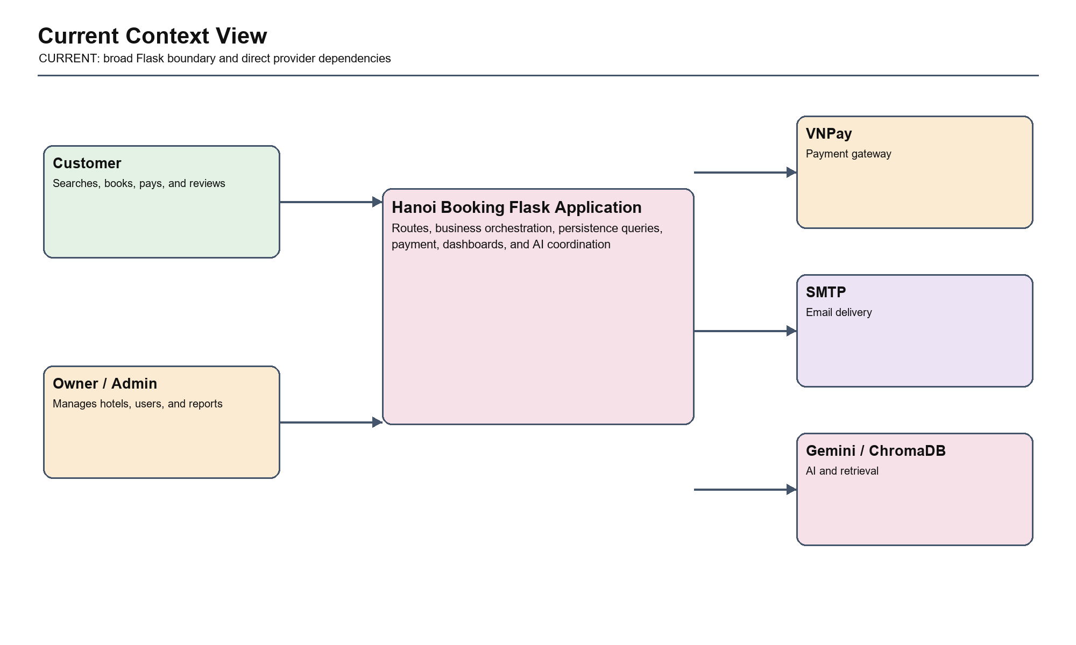
Figure 9. Current Context View
4.2.1 Main Responsibility
Define the system boundary, human actors, external providers, and the trust changes that occur when data leaves Hanoi Booking.
4.2.2 Key Components
Customer, owner, administrator, Hanoi Booking, VNPay, SMTP, Gemini, and the derived ChromaDB knowledge capability.
4.2.3 Dependency Direction
Human actors initiate requests toward Hanoi Booking. The system invokes external providers; providers never receive authority to bypass Hanoi Booking validation or directly change relational records.
4.2.4 Current Risk
The implemented view concentrates orchestration in app.py and allows route, ORM, provider, and presentation concerns to change together. This makes ownership, transaction scope, failure behavior, and security review difficult to verify.
4.2.5 Target Improvement
Introduce the target boundary incrementally around verified risks: booking inventory, payment callback verification, authorization, secure configuration, and optional-service fallback.
Detailed analysis of Current Context View
Analysis Area: Responsibility Hanoi Booking Interpretation: Define the system boundary, human actors, external providers, and the trust changes that occur when data leaves Hanoi Booking. Evidence or Control: Diagram boundary and source structure
Analysis Area: Dependencies Hanoi Booking Interpretation: Human actors initiate requests toward Hanoi Booking. The system invokes external providers; providers never receive authority to bypass Hanoi Booking validation or directly change relational records. Evidence or Control: Module dependency rules and adapter contracts
Analysis Area: Risk Hanoi Booking Interpretation: The implemented view concentrates orchestration in app.py and allows route, ORM, provider, and presentation concerns to change together. This makes ownership, transaction scope, failure behavior, and security review difficult to verify. Evidence or Control: Verified defects, route concentration, and review
Analysis Area: Improvement Hanoi Booking Interpretation: Introduce the target boundary incrementally around verified risks: booking inventory, payment callback verification, authorization, secure configuration, and optional-service fallback. Evidence or Control: ADR, migration task, and regression evidence

4.3 Target Context View
The target context strengthens trust boundaries through verified callbacks, privacy controls, secure configuration, and explicit degraded behavior.
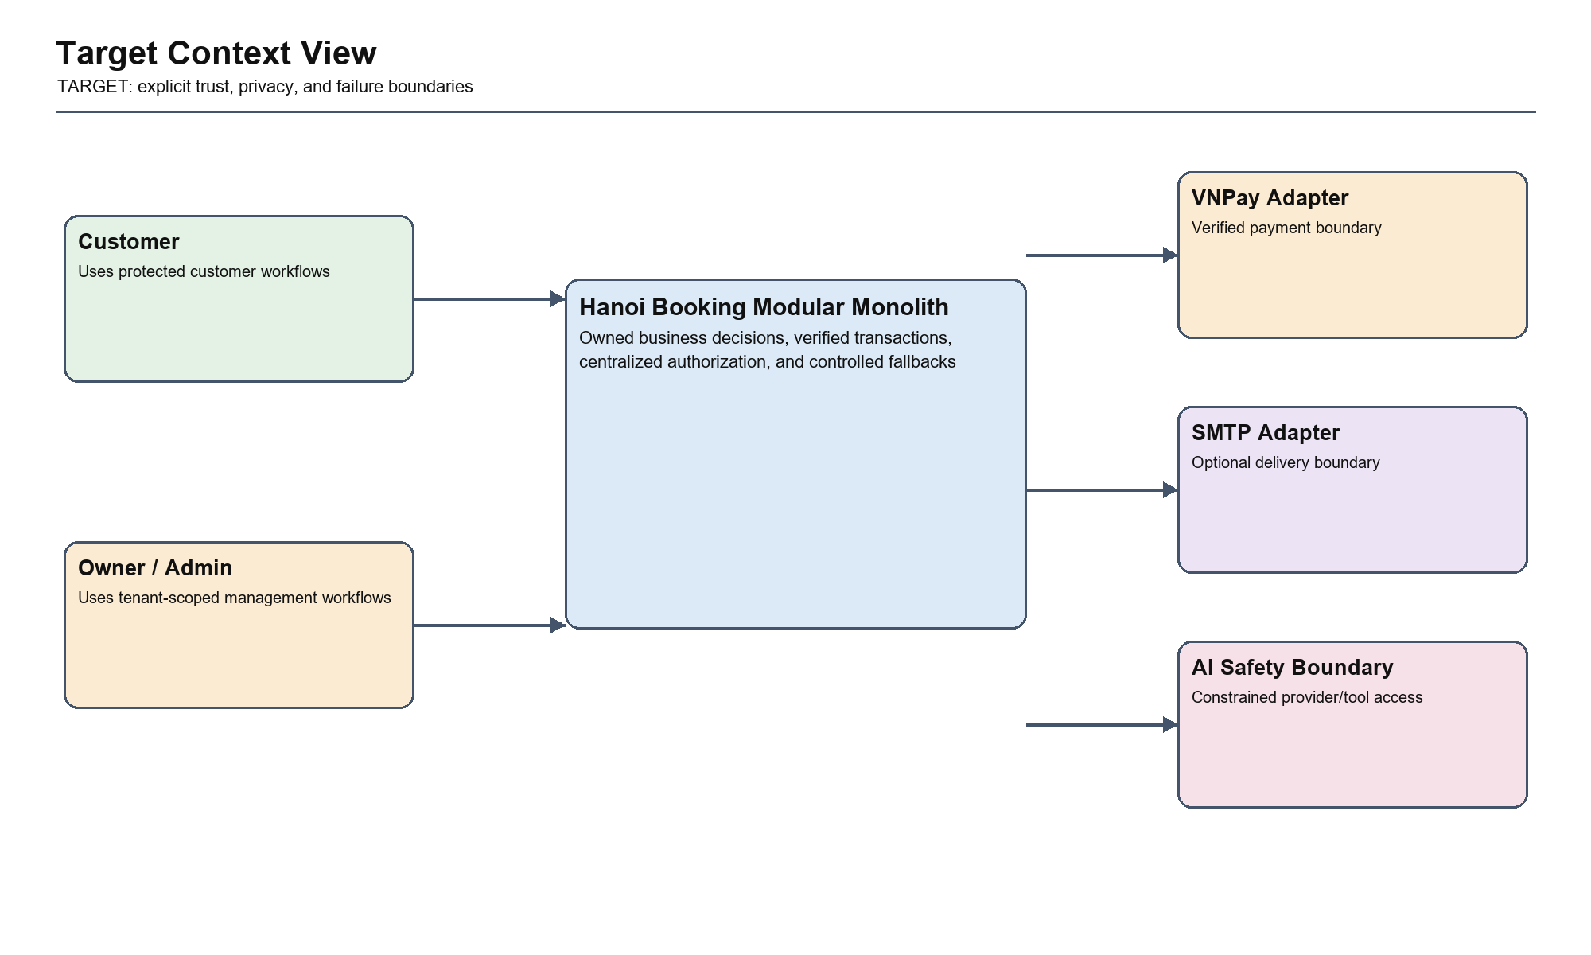
Figure 10. Target Context View
4.3.1 Main Responsibility
Define the system boundary, human actors, external providers, and the trust changes that occur when data leaves Hanoi Booking.
4.3.2 Key Components
Customer, owner, administrator, Hanoi Booking, VNPay, SMTP, Gemini, and the derived ChromaDB knowledge capability.
4.3.3 Dependency Direction
Human actors initiate requests toward Hanoi Booking. The system invokes external providers; providers never receive authority to bypass Hanoi Booking validation or directly change relational records.
4.3.4 Current Risk
The target view can become documentation-only if dependency rules are not enforced by module structure, tests, code review, and migration ownership.
4.3.5 Target Improvement
Validate the target with architecture fitness tests, service-level regression tests, dependency review, and traceability from ADRs to implementation tasks.
Detailed analysis of Target Context View
Analysis Area: Responsibility Hanoi Booking Interpretation: Define the system boundary, human actors, external providers, and the trust changes that occur when data leaves Hanoi Booking. Evidence or Control: Diagram boundary and source structure
Analysis Area: Dependencies Hanoi Booking Interpretation: Human actors initiate requests toward Hanoi Booking. The system invokes external providers; providers never receive authority to bypass Hanoi Booking validation or directly change relational records. Evidence or Control: Module dependency rules and adapter contracts
Analysis Area: Risk Hanoi Booking Interpretation: The target view can become documentation-only if dependency rules are not enforced by module structure, tests, code review, and migration ownership. Evidence or Control: Verified defects, route concentration, and review
Analysis Area: Improvement Hanoi Booking Interpretation: Validate the target with architecture fitness tests, service-level regression tests, dependency review, and traceability from ADRs to implementation tasks. Evidence or Control: ADR, migration task, and regression evidence

4.4 Current Container View
The current runtime contains a browser, one Flask application, MySQL, ChromaDB, and external providers.
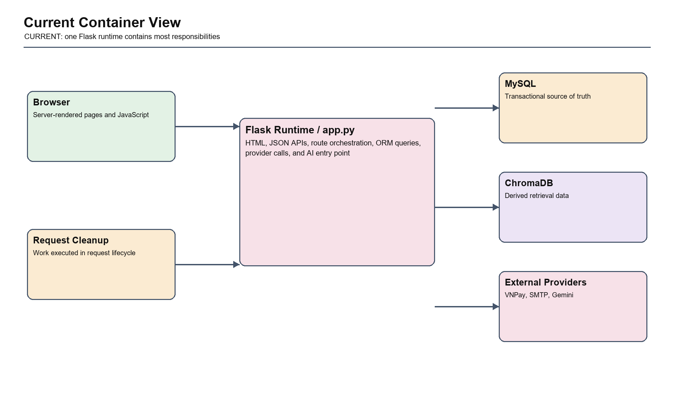
Figure 11. Current Container View
4.4.1 Main Responsibility
Explain the independently running stores, browser, Flask runtime, jobs, and provider connections that participate in production behavior.
4.4.2 Key Components
Browser presentation, Flask application, relational database, vector store, scheduled jobs, reverse proxy, and external provider endpoints.
4.4.3 Dependency Direction
Browser and jobs call the Flask boundary; Flask owns relational transactions and calls adapters; ChromaDB supplies derived context but does not become the source of truth.
4.4.4 Current Risk
The implemented view concentrates orchestration in app.py and allows route, ORM, provider, and presentation concerns to change together. This makes ownership, transaction scope, failure behavior, and security review difficult to verify.
4.4.5 Target Improvement
Introduce the target boundary incrementally around verified risks: booking inventory, payment callback verification, authorization, secure configuration, and optional-service fallback.
Detailed analysis of Current Container View
Analysis Area: Responsibility Hanoi Booking Interpretation: Explain the independently running stores, browser, Flask runtime, jobs, and provider connections that participate in production behavior. Evidence or Control: Diagram boundary and source structure
Analysis Area: Dependencies Hanoi Booking Interpretation: Browser and jobs call the Flask boundary; Flask owns relational transactions and calls adapters; ChromaDB supplies derived context but does not become the source of truth. Evidence or Control: Module dependency rules and adapter contracts
Analysis Area: Risk Hanoi Booking Interpretation: The implemented view concentrates orchestration in app.py and allows route, ORM, provider, and presentation concerns to change together. This makes ownership, transaction scope, failure behavior, and security review difficult to verify. Evidence or Control: Verified defects, route concentration, and review
Analysis Area: Improvement Hanoi Booking Interpretation: Introduce the target boundary incrementally around verified risks: booking inventory, payment callback verification, authorization, secure configuration, and optional-service fallback. Evidence or Control: ADR, migration task, and regression evidence

4.5 Target Container View

The target retains one main application deployment while adding production hosting controls and a separate scheduled-job responsibility.
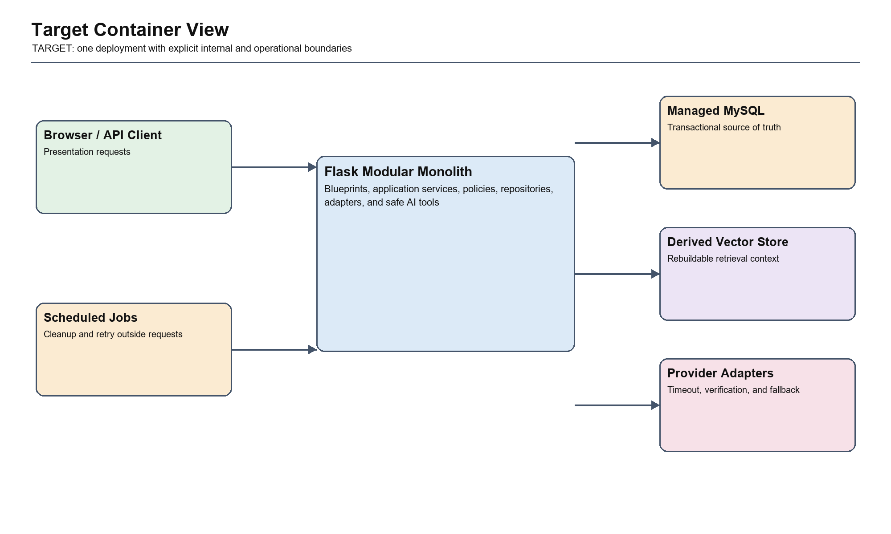
Figure 12. Target Container View
4.5.1 Main Responsibility
Explain the independently running stores, browser, Flask runtime, jobs, and provider connections that participate in production behavior.
4.5.2 Key Components
Browser presentation, Flask application, relational database, vector store, scheduled jobs, reverse proxy, and external provider endpoints.
4.5.3 Dependency Direction
Browser and jobs call the Flask boundary; Flask owns relational transactions and calls adapters; ChromaDB supplies derived context but does not become the source of truth.
4.5.4 Current Risk
The target view can become documentation-only if dependency rules are not enforced by module structure, tests, code review, and migration ownership.
4.5.5 Target Improvement
Validate the target with architecture fitness tests, service-level regression tests, dependency review, and traceability from ADRs to implementation tasks.
Detailed analysis of Target Container View
Analysis Area: Responsibility Hanoi Booking Interpretation: Explain the independently running stores, browser, Flask runtime, jobs, and provider connections that participate in production behavior. Evidence or Control: Diagram boundary and source structure
Analysis Area: Dependencies Hanoi Booking Interpretation: Browser and jobs call the Flask boundary; Flask owns relational transactions and calls adapters; ChromaDB supplies derived context but does not become the source of truth. Evidence or Control: Module dependency rules and adapter contracts
Analysis Area: Risk Hanoi Booking Interpretation: The target view can become documentation-only if dependency rules are not enforced by module structure, tests, code review, and migration ownership. Evidence or Control: Verified defects, route concentration, and review
Analysis Area: Improvement Hanoi Booking Interpretation: Validate the target with architecture fitness tests, service-level regression tests, dependency review, and traceability from ADRs to implementation tasks. Evidence or Control: ADR, migration task, and regression evidence

4.6 Current Component View
The implemented component structure centers on app.py, models, utilities, AI modules, and direct integrations.
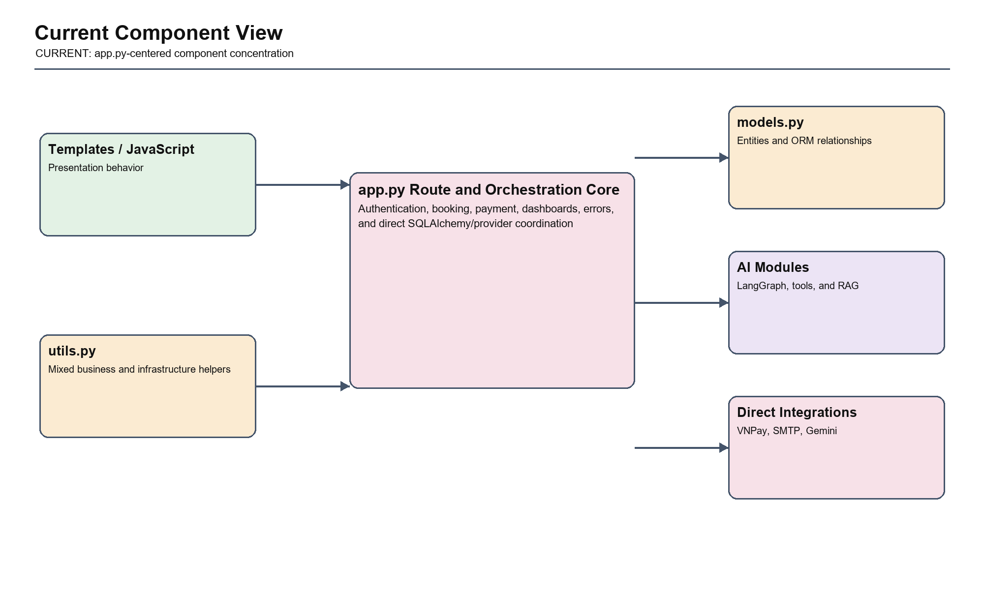
Figure 13. Current Component View
4.6.1 Main Responsibility
Show how route handling, application orchestration, policies, persistence, integrations, and AI responsibilities are grouped inside the Flask deployment.
4.6.2 Key Components
Blueprints/routes, application services or current route orchestration, domain policies, SQLAlchemy models/repositories, integration adapters, and AI tools.
4.6.3 Dependency Direction
Presentation depends on application interfaces; application services depend on domain rules and abstractions; repositories and adapters implement outward-facing abstractions.
4.6.4 Current Risk
The implemented view concentrates orchestration in app.py and allows route, ORM, provider, and presentation concerns to change together. This makes ownership, transaction scope, failure behavior, and security review difficult to verify.
4.6.5 Target Improvement
Introduce the target boundary incrementally around verified risks: booking inventory, payment callback verification, authorization, secure configuration, and optional-service fallback.
Detailed analysis of Current Component View
Analysis Area: Responsibility Hanoi Booking Interpretation: Show how route handling, application orchestration, policies, persistence, integrations, and AI responsibilities are grouped inside the Flask deployment. Evidence or Control: Diagram boundary and source structure
Analysis Area: Dependencies Hanoi Booking Interpretation: Presentation depends on application interfaces; application services depend on domain rules and abstractions; repositories and adapters implement outward-facing abstractions. Evidence or Control: Module dependency rules and adapter contracts
Analysis Area: Risk Hanoi Booking Interpretation: The implemented view concentrates orchestration in app.py and allows route, ORM, provider, and presentation concerns to change together. This makes ownership, transaction scope, failure behavior, and security review difficult to verify. Evidence or Control: Verified defects, route concentration, and review
Analysis Area: Improvement Hanoi Booking Interpretation: Introduce the target boundary incrementally around verified risks: booking inventory, payment callback verification, authorization, secure configuration, and optional-service fallback. Evidence or Control: ADR, migration task, and regression evidence

4.7 Target Component View
The proposed component structure introduces Blueprints, application services, domain policies, repositories, and integration adapters.
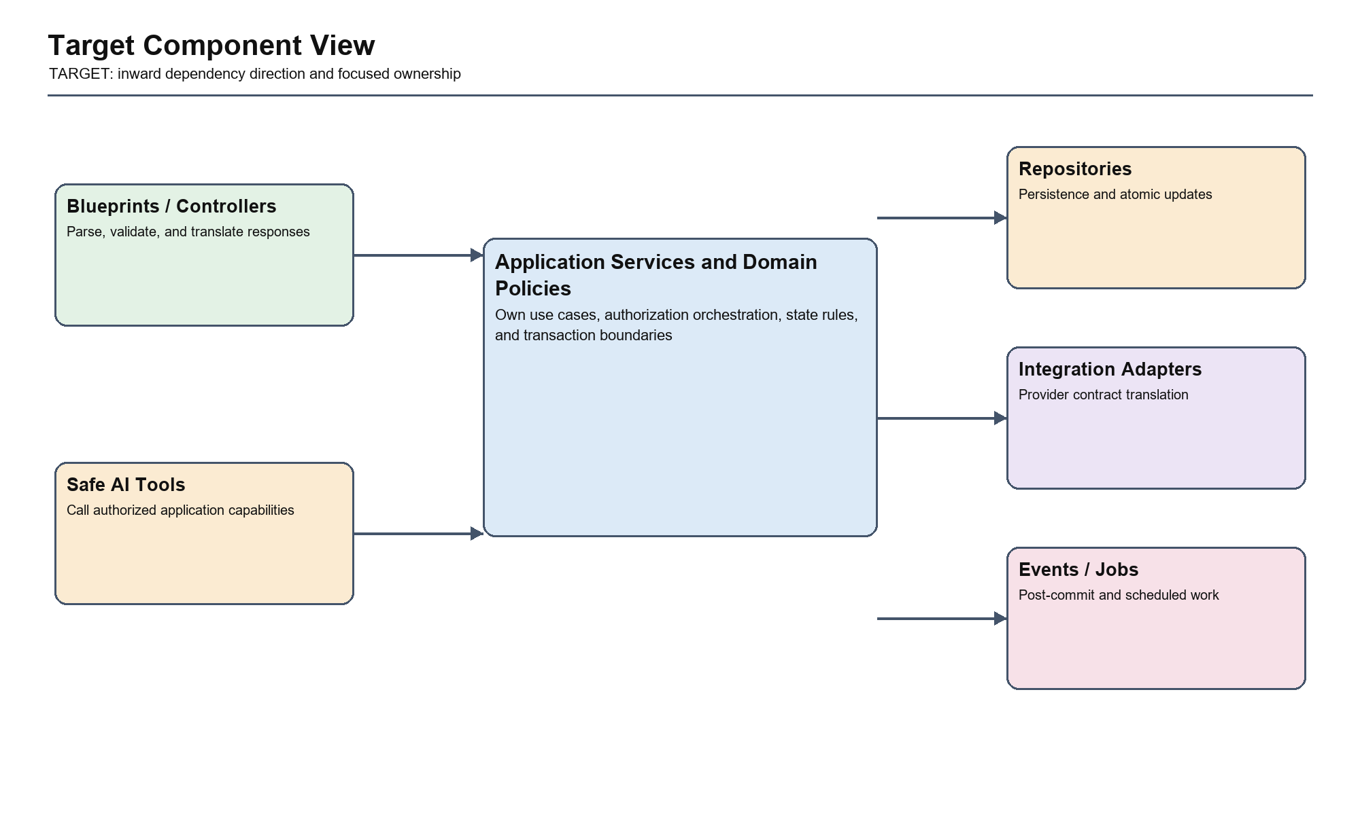
Figure 14. Target Component View
4.7.1 Main Responsibility
Show how route handling, application orchestration, policies, persistence, integrations, and AI responsibilities are grouped inside the Flask deployment.
4.7.2 Key Components
Blueprints/routes, application services or current route orchestration, domain policies, SQLAlchemy models/repositories, integration adapters, and AI tools.
4.7.3 Dependency Direction
Presentation depends on application interfaces; application services depend on domain rules and abstractions; repositories and adapters implement outward-facing abstractions.
4.7.4 Current Risk
The target view can become documentation-only if dependency rules are not enforced by module structure, tests, code review, and migration ownership.
4.7.5 Target Improvement
Validate the target with architecture fitness tests, service-level regression tests, dependency review, and traceability from ADRs to implementation tasks.
Detailed analysis of Target Component View
Analysis Area: Responsibility Hanoi Booking Interpretation: Show how route handling, application orchestration, policies, persistence, integrations, and AI responsibilities are grouped inside the Flask deployment. Evidence or Control: Diagram boundary and source structure
Analysis Area: Dependencies Hanoi Booking Interpretation: Presentation depends on application interfaces; application services depend on domain rules and abstractions; repositories and adapters implement outward-facing abstractions. Evidence or Control: Module dependency rules and adapter contracts
Analysis Area: Risk Hanoi Booking Interpretation: The target view can become documentation-only if dependency rules are not enforced by module structure, tests, code review, and migration ownership. Evidence or Control: Verified defects, route concentration, and review
Analysis Area: Improvement Hanoi Booking Interpretation: Validate the target with architecture fitness tests, service-level regression tests, dependency review, and traceability from ADRs to implementation tasks. Evidence or Control: ADR, migration task, and regression evidence

4.8 Current Code View
The current code view is dominated by relational entities and route/helper functions rather than explicit domain services.
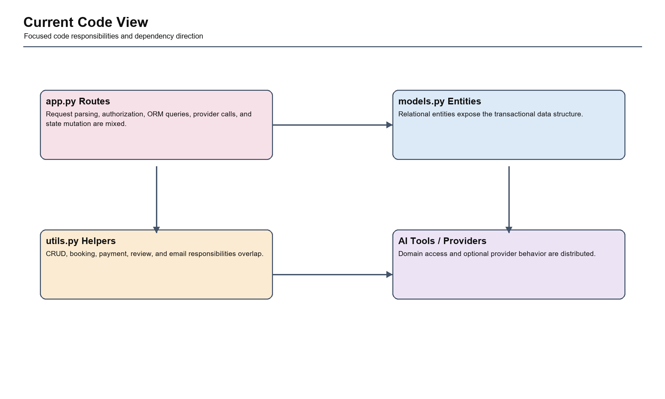
Figure 15. Current Code View
4.8.1 Main Responsibility
Make the classes and data structures that own business rules, transactions, and provider translation explicit enough to guide implementation and testing.
4.8.2 Key Components
Focused service, repository, policy, adapter, entity, and state classes associated with the selected authentication, booking, payment, or AI capability.
4.8.3 Dependency Direction
Services coordinate policies and repositories. Provider-specific classes remain at the edge, while domain rules remain independent of Flask, SQLAlchemy request context, and provider query formats.
4.8.4 Current Risk
The implemented view concentrates orchestration in app.py and allows route, ORM, provider, and presentation concerns to change together. This makes ownership, transaction scope, failure behavior, and security review difficult to verify.
4.8.5 Target Improvement
Introduce the target boundary incrementally around verified risks: booking inventory, payment callback verification, authorization, secure configuration, and optional-service fallback.
Detailed analysis of Current Code View
Analysis Area: Responsibility Hanoi Booking Interpretation: Make the classes and data structures that own business rules, transactions, and provider translation explicit enough to guide implementation and testing. Evidence or Control: Diagram boundary and source structure
Analysis Area: Dependencies Hanoi Booking Interpretation: Services coordinate policies and repositories. Provider-specific classes remain at the edge, while domain rules remain independent of Flask, SQLAlchemy request context, and provider query formats. Evidence or Control: Module dependency rules and adapter contracts
Analysis Area: Risk Hanoi Booking Interpretation: The implemented view concentrates orchestration in app.py and allows route, ORM, provider, and presentation concerns to change together. This makes ownership, transaction scope, failure behavior, and security review difficult to verify. Evidence or Control: Verified defects, route concentration, and review
Analysis Area: Improvement Hanoi Booking Interpretation: Introduce the target boundary incrementally around verified risks: booking inventory, payment callback verification, authorization, secure configuration, and optional-service fallback. Evidence or Control: ADR, migration task, and regression evidence

4.9 Target Authentication Code View
Authentication workflows move behind AuthService, AuthRepository, and explicit security policies.
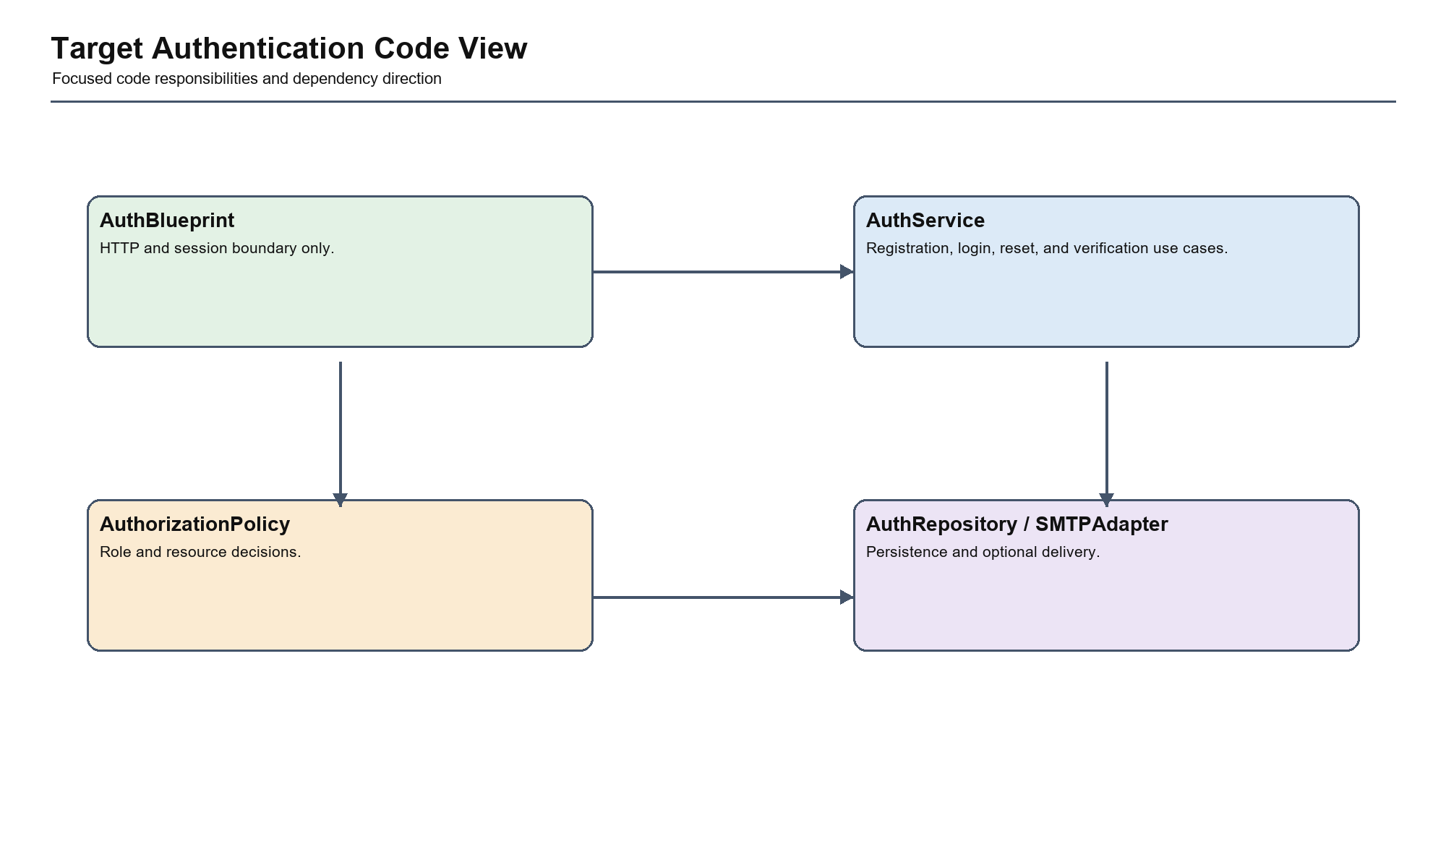
Figure 16. Target Authentication Code View
4.9.1 Main Responsibility
Make the classes and data structures that own business rules, transactions, and provider translation explicit enough to guide implementation and testing.
4.9.2 Key Components
Focused service, repository, policy, adapter, entity, and state classes associated with the selected authentication, booking, payment, or AI capability.
4.9.3 Dependency Direction
Services coordinate policies and repositories. Provider-specific classes remain at the edge, while domain rules remain independent of Flask, SQLAlchemy request context, and provider query formats.
4.9.4 Current Risk
The target view can become documentation-only if dependency rules are not enforced by module structure, tests, code review, and migration ownership.
4.9.5 Target Improvement
Validate the target with architecture fitness tests, service-level regression tests, dependency review, and traceability from ADRs to implementation tasks.
Detailed analysis of Target Authentication Code View
Analysis Area: Responsibility Hanoi Booking Interpretation: Make the classes and data structures that own business rules, transactions, and provider translation explicit enough to guide implementation and testing. Evidence or Control: Diagram boundary and source structure
Analysis Area: Dependencies Hanoi Booking Interpretation: Services coordinate policies and repositories. Provider-specific classes remain at the edge, while domain rules remain independent of Flask, SQLAlchemy request context, and provider query formats. Evidence or Control: Module dependency rules and adapter contracts
Analysis Area: Risk Hanoi Booking Interpretation: The target view can become documentation-only if dependency rules are not enforced by module structure, tests, code review, and migration ownership. Evidence or Control: Verified defects, route concentration, and review
Analysis Area: Improvement Hanoi Booking Interpretation: Validate the target with architecture fitness tests, service-level regression tests, dependency review, and traceability from ADRs to implementation tasks. Evidence or Control: ADR, migration task, and regression evidence

4.10 Target Booking Code View

BookingService owns validation, atomic inventory reservation, cancellation, and state transitions.
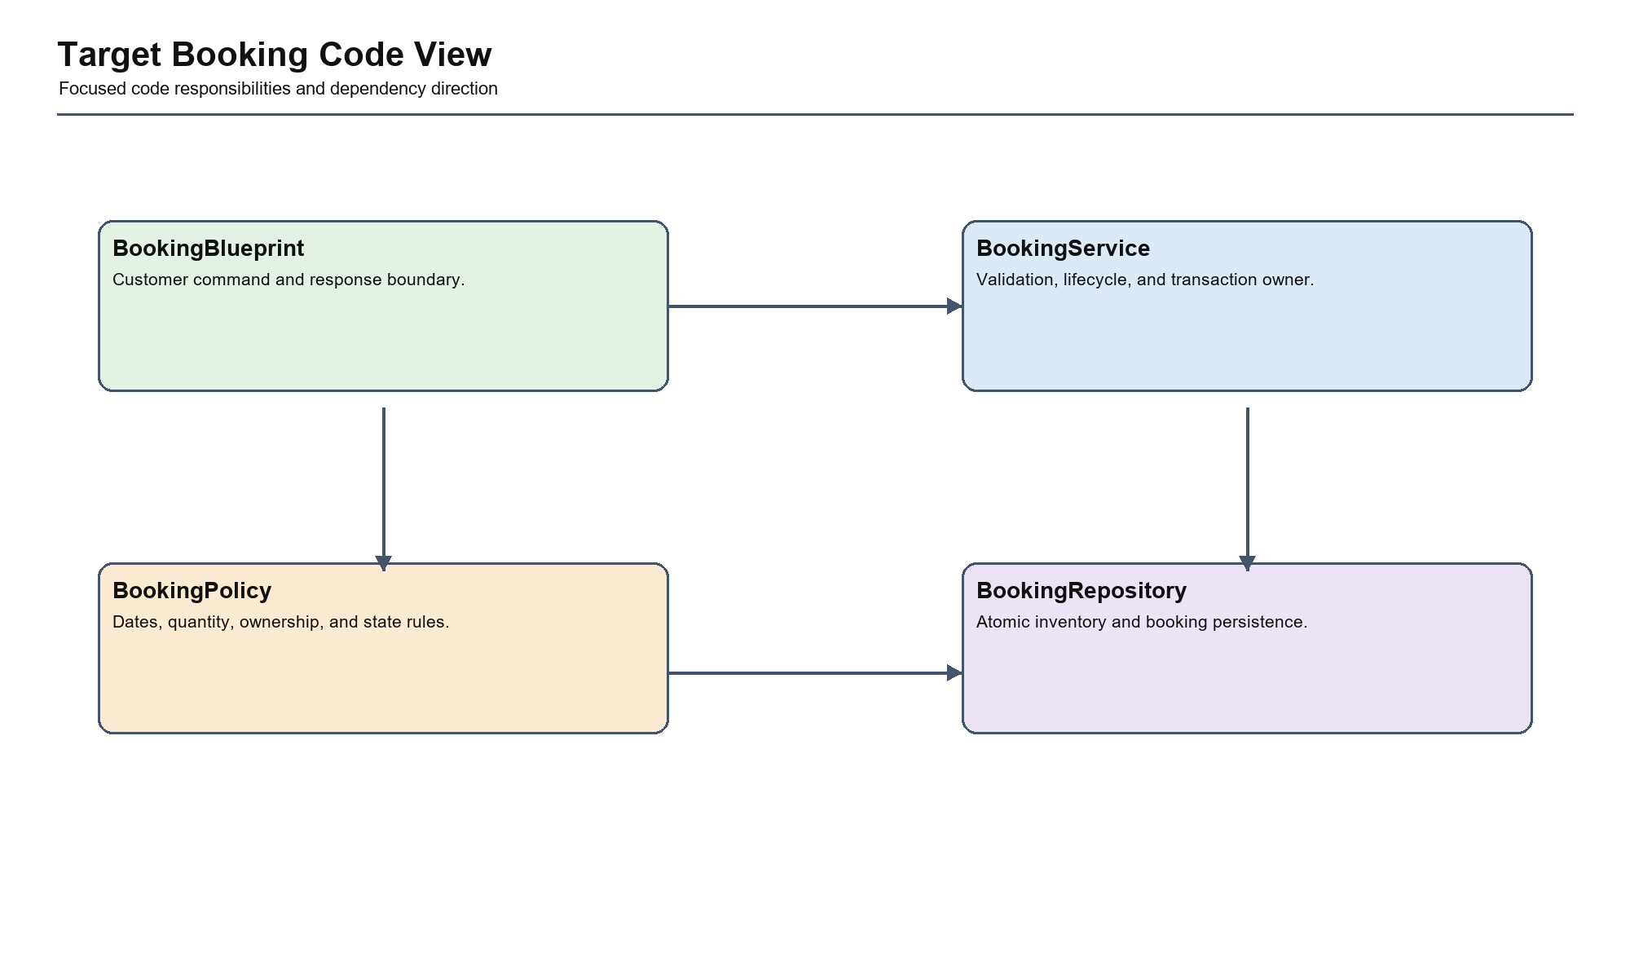
Figure 17. Target Booking Code View
4.10.1 Main Responsibility
Make the classes and data structures that own business rules, transactions, and provider translation explicit enough to guide implementation and testing.
4.10.2 Key Components
Focused service, repository, policy, adapter, entity, and state classes associated with the selected authentication, booking, payment, or AI capability.
4.10.3 Dependency Direction
Services coordinate policies and repositories. Provider-specific classes remain at the edge, while domain rules remain independent of Flask, SQLAlchemy request context, and provider query formats.
4.10.4 Current Risk
The target view can become documentation-only if dependency rules are not enforced by module structure, tests, code review, and migration ownership.
4.10.5 Target Improvement
Validate the target with architecture fitness tests, service-level regression tests, dependency review, and traceability from ADRs to implementation tasks.
Detailed analysis of Target Booking Code View
Analysis Area: Responsibility Hanoi Booking Interpretation: Make the classes and data structures that own business rules, transactions, and provider translation explicit enough to guide implementation and testing. Evidence or Control: Diagram boundary and source structure
Analysis Area: Dependencies Hanoi Booking Interpretation: Services coordinate policies and repositories. Provider-specific classes remain at the edge, while domain rules remain independent of Flask, SQLAlchemy request context, and provider query formats. Evidence or Control: Module dependency rules and adapter contracts
Analysis Area: Risk Hanoi Booking Interpretation: The target view can become documentation-only if dependency rules are not enforced by module structure, tests, code review, and migration ownership. Evidence or Control: Verified defects, route concentration, and review
Analysis Area: Improvement Hanoi Booking Interpretation: Validate the target with architecture fitness tests, service-level regression tests, dependency review, and traceability from ADRs to implementation tasks. Evidence or Control: ADR, migration task, and regression evidence

4.11 Target Payment Code View
PaymentService and VNPayAdapter separate untrusted provider verification from transactional finalization.
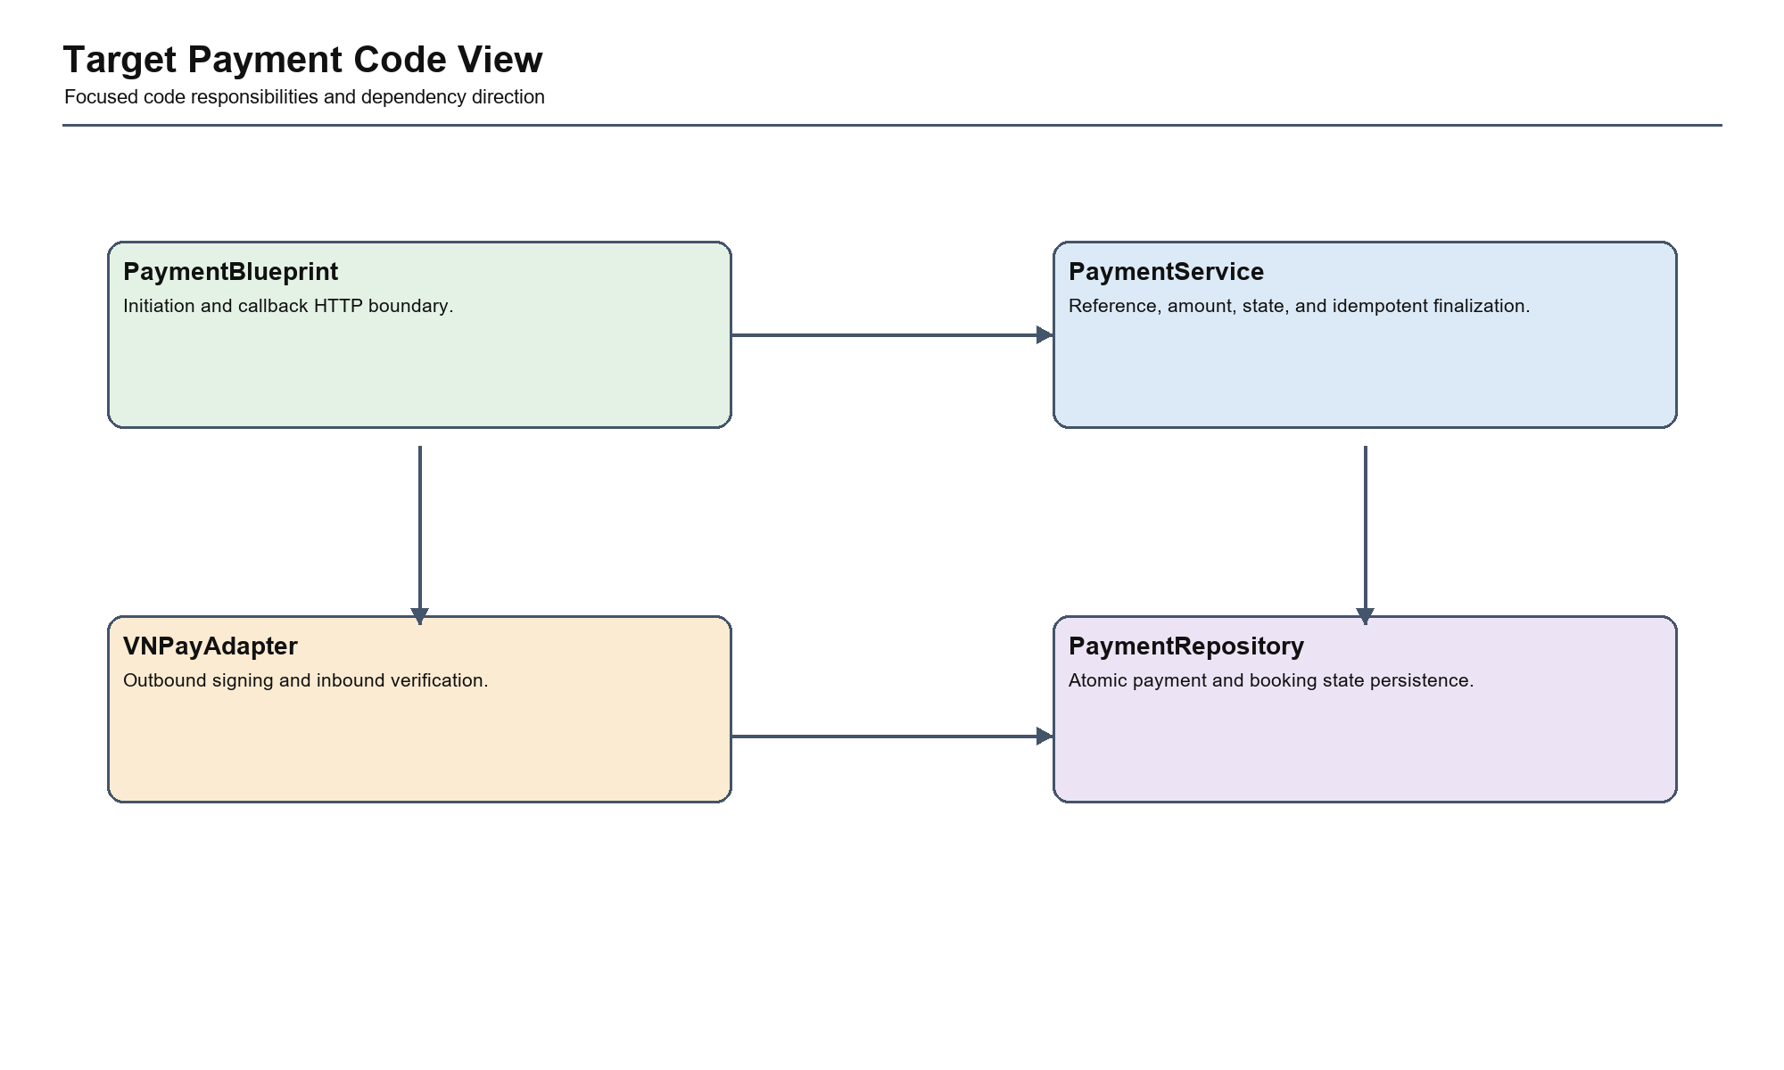
Figure 18. Target Payment Code View
4.11.1 Main Responsibility
Make the classes and data structures that own business rules, transactions, and provider translation explicit enough to guide implementation and testing.
4.11.2 Key Components
Focused service, repository, policy, adapter, entity, and state classes associated with the selected authentication, booking, payment, or AI capability.
4.11.3 Dependency Direction
Services coordinate policies and repositories. Provider-specific classes remain at the edge, while domain rules remain independent of Flask, SQLAlchemy request context, and provider query formats.
4.11.4 Current Risk
The target view can become documentation-only if dependency rules are not enforced by module structure, tests, code review, and migration ownership.
4.11.5 Target Improvement
Validate the target with architecture fitness tests, service-level regression tests, dependency review, and traceability from ADRs to implementation tasks.
Detailed analysis of Target Payment Code View
Analysis Area: Responsibility Hanoi Booking Interpretation: Make the classes and data structures that own business rules, transactions, and provider translation explicit enough to guide implementation and testing. Evidence or Control: Diagram boundary and source structure
Analysis Area: Dependencies Hanoi Booking Interpretation: Services coordinate policies and repositories. Provider-specific classes remain at the edge, while domain rules remain independent of Flask, SQLAlchemy request context, and provider query formats. Evidence or Control: Module dependency rules and adapter contracts
Analysis Area: Risk Hanoi Booking Interpretation: The target view can become documentation-only if dependency rules are not enforced by module structure, tests, code review, and migration ownership. Evidence or Control: Verified defects, route concentration, and review
Analysis Area: Improvement Hanoi Booking Interpretation: Validate the target with architecture fitness tests, service-level regression tests, dependency review, and traceability from ADRs to implementation tasks. Evidence or Control: ADR, migration task, and regression evidence

4.12 Target AI Code View
The AI subsystem remains tool-driven and cannot directly bypass deterministic business services.
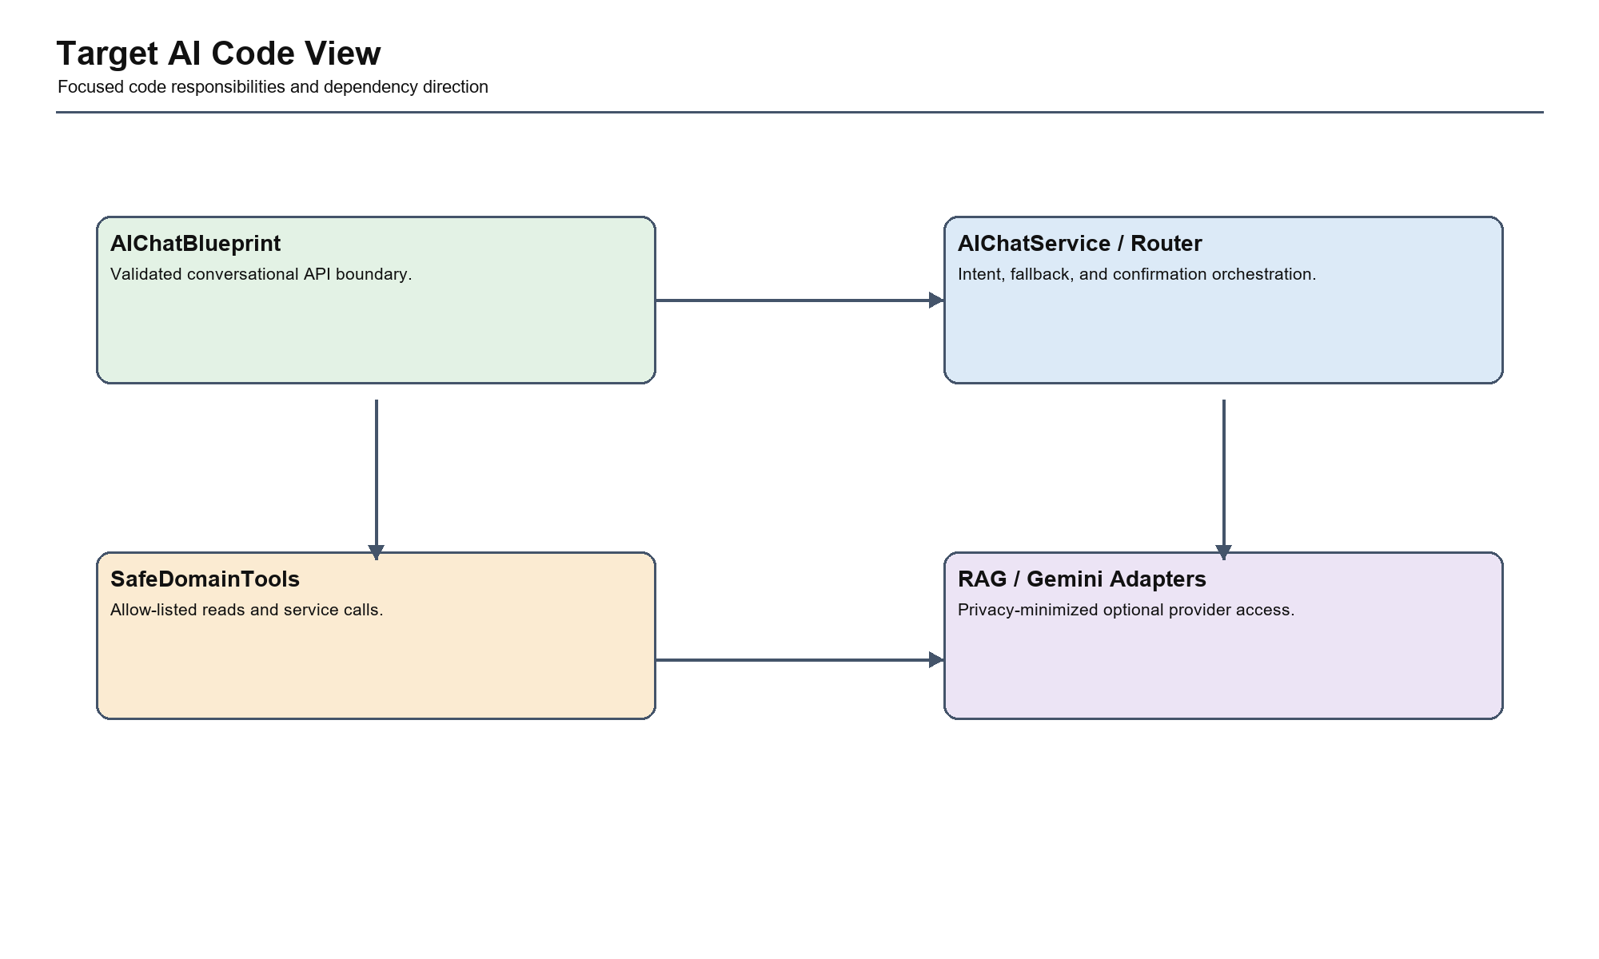
Figure 19. Target AI Code View
4.12.1 Main Responsibility
Make the classes and data structures that own business rules, transactions, and provider translation explicit enough to guide implementation and testing.
4.12.2 Key Components
Focused service, repository, policy, adapter, entity, and state classes associated with the selected authentication, booking, payment, or AI capability.
4.12.3 Dependency Direction
Services coordinate policies and repositories. Provider-specific classes remain at the edge, while domain rules remain independent of Flask, SQLAlchemy request context, and provider query formats.
4.12.4 Current Risk
The target view can become documentation-only if dependency rules are not enforced by module structure, tests, code review, and migration ownership.
4.12.5 Target Improvement
Validate the target with architecture fitness tests, service-level regression tests, dependency review, and traceability from ADRs to implementation tasks.
Detailed analysis of Target AI Code View
Analysis Area: Responsibility Hanoi Booking Interpretation: Make the classes and data structures that own business rules, transactions, and provider translation explicit enough to guide implementation and testing. Evidence or Control: Diagram boundary and source structure
Analysis Area: Dependencies Hanoi Booking Interpretation: Services coordinate policies and repositories. Provider-specific classes remain at the edge, while domain rules remain independent of Flask, SQLAlchemy request context, and provider query formats. Evidence or Control: Module dependency rules and adapter contracts
Analysis Area: Risk Hanoi Booking Interpretation: The target view can become documentation-only if dependency rules are not enforced by module structure, tests, code review, and migration ownership. Evidence or Control: Verified defects, route concentration, and review
Analysis Area: Improvement Hanoi Booking Interpretation: Validate the target with architecture fitness tests, service-level regression tests, dependency review, and traceability from ADRs to implementation tasks. Evidence or Control: ADR, migration task, and regression evidence

4.13 Diagram Summary Table
Table 13. C4 current-versus-target comparison
Level | Current View | Target View | Main Improvement
Context | Flask app and external services | Explicit trust and failure boundaries | External dependency control
Container | Monolith, MySQL, ChromaDB | Modular monolith, adapters, jobs | Cleaner integration and operations
Component | app.py-centered responsibilities | Services, repositories, policies | Maintainability and testability
Code | Mixed routes, helpers, and entities | Focused domain/application classes | Transaction and policy clarity

4.14 C4 Level Comparison: Current vs Target
The target C4 model does not imply immediate microservices. Its primary purpose is to show stronger internal boundaries within one deployment. The largest improvement occurs at Component and Code levels, where current route-centric orchestration becomes focused application services and provider adapters.

4.15 C4 Model Limitations
C4 diagrams communicate static responsibility and dependency views but do not fully express state transitions, transaction boundaries, concurrency, or runtime failure behavior. This report therefore supplements C4 with sequence diagrams, state machines, deployment analysis, ADRs, and actual test evidence.

5. Architecture Decisions
Architecture Decision Records capture choices that materially affect structure, quality attributes, and future migration. They prevent proposed designs from being interpreted as arbitrary diagrams.

5.1 ADR-01: Keep a Modular Monolith
ADR-01: Keep a Modular Monolith
Field: Context Description: The team needs simple deployment and relational transactions, while app.py has become too broad.
Field: Decision Description: Retain one deployable Flask application but enforce domain modules and dependency rules.
Field: Alternatives Description: Microservices now; keep current unstructured monolith.
Field: Consequences Description: Preserves deployment simplicity and transaction locality; requires disciplined internal boundaries.
Field: Status Description: Accepted
5.1.1 Decision Drivers
The decision to keep a modular monolith is driven by verified Hanoi Booking risks, the small-team operating model, the need to preserve existing route contracts, and the requirement to improve testability without introducing unnecessary distributed-system complexity.
5.1.2 Constraints and Trade-offs
ADR-01: Keep a Modular Monolith constraints and trade-offs
Constraint: Existing Flask routes and templates Architectural Effect: Migration must preserve browser and API behavior Trade-off: Incremental extraction takes longer than replacement
Constraint: Relational booking/payment consistency Architectural Effect: Transactional work remains inside one deployment and database boundary Trade-off: Independent scaling is deferred
Constraint: Limited executed test coverage Architectural Effect: Characterization and regression tests are required before structural change Trade-off: Migration speed depends on evidence quality
Constraint: Small academic team Architectural Effect: Operational simplicity and clear ownership are prioritized Trade-off: Some abstractions remain selective rather than universal
5.1.3 Alternatives Evaluation
ADR-01: Keep a Modular Monolith alternatives evaluation
Option: Selected decision Benefit: Retain one deployable Flask application but enforce domain modules and dependency rules. Risk: Preserves deployment simplicity and transaction locality; requires disciplined internal boundaries. Decision Result: Adopt through phased migration
Option: Alternative approaches Benefit: Microservices now; keep current unstructured monolith. Risk: May preserve current coupling or add excessive operational complexity Decision Result: Rejected for current project constraints
Option: Defer decision Benefit: Avoids immediate refactoring cost Risk: Verified security and consistency risks remain unresolved Decision Result: Not acceptable for P0 risks
5.1.4 Implementation and Validation
Implementation begins with characterization tests around the existing behavior, introduces the selected boundary behind unchanged routes, migrates one vertical workflow, and removes duplicate orchestration only after regression evidence passes.
ADR-01: Keep a Modular Monolith validation criteria
Validation Area: Behavior Required Evidence: Existing successful workflows remain compatible
Validation Area: Risk reduction Required Evidence: Mapped failed or proposed regression tests pass
Validation Area: Structure Required Evidence: Responsibility and dependency direction match the target C4 view
Validation Area: Operations Required Evidence: Logs, errors, rollback, and provider failure behavior are controlled

5.2 ADR-02: Introduce an Application Service Layer
ADR-02: Introduce an Application Service Layer
Field: Context Description: Routes currently coordinate validation, persistence, provider calls, and responses.
Field: Decision Description: Move complete business use cases into focused application services.
Field: Alternatives Description: Keep logic in routes; use only utility functions.
Field: Consequences Description: Improves reuse and tests; requires incremental extraction.
Field: Status Description: Proposed
5.2.1 Decision Drivers
The decision to introduce an application service layer is driven by verified Hanoi Booking risks, the small-team operating model, the need to preserve existing route contracts, and the requirement to improve testability without introducing unnecessary distributed-system complexity.
5.2.2 Constraints and Trade-offs
ADR-02: Introduce an Application Service Layer constraints and trade-offs
Constraint: Existing Flask routes and templates Architectural Effect: Migration must preserve browser and API behavior Trade-off: Incremental extraction takes longer than replacement
Constraint: Relational booking/payment consistency Architectural Effect: Transactional work remains inside one deployment and database boundary Trade-off: Independent scaling is deferred
Constraint: Limited executed test coverage Architectural Effect: Characterization and regression tests are required before structural change Trade-off: Migration speed depends on evidence quality
Constraint: Small academic team Architectural Effect: Operational simplicity and clear ownership are prioritized Trade-off: Some abstractions remain selective rather than universal
5.2.3 Alternatives Evaluation
ADR-02: Introduce an Application Service Layer alternatives evaluation
Option: Selected decision Benefit: Move complete business use cases into focused application services. Risk: Improves reuse and tests; requires incremental extraction. Decision Result: Adopt through phased migration
Option: Alternative approaches Benefit: Keep logic in routes; use only utility functions. Risk: May preserve current coupling or add excessive operational complexity Decision Result: Rejected for current project constraints
Option: Defer decision Benefit: Avoids immediate refactoring cost Risk: Verified security and consistency risks remain unresolved Decision Result: Not acceptable for P0 risks
5.2.4 Implementation and Validation
Implementation begins with characterization tests around the existing behavior, introduces the selected boundary behind unchanged routes, migrates one vertical workflow, and removes duplicate orchestration only after regression evidence passes.
ADR-02: Introduce an Application Service Layer validation criteria
Validation Area: Behavior Required Evidence: Existing successful workflows remain compatible
Validation Area: Risk reduction Required Evidence: Mapped failed or proposed regression tests pass
Validation Area: Structure Required Evidence: Responsibility and dependency direction match the target C4 view
Validation Area: Operations Required Evidence: Logs, errors, rollback, and provider failure behavior are controlled

5.3 ADR-03: Use Repositories Selectively
ADR-03: Use Repositories Selectively
Field: Context Description: Consistency-sensitive queries are distributed across routes and tools.
Field: Decision Description: Create repositories for booking, payment, owner scope, and complex query models.
Field: Alternatives Description: Wrap every ORM operation; keep all direct ORM queries.
Field: Consequences Description: Improves transaction ownership without excessive boilerplate.
Field: Status Description: Proposed
5.3.1 Decision Drivers
The decision to use repositories selectively is driven by verified Hanoi Booking risks, the small-team operating model, the need to preserve existing route contracts, and the requirement to improve testability without introducing unnecessary distributed-system complexity.
5.3.2 Constraints and Trade-offs
ADR-03: Use Repositories Selectively constraints and trade-offs
Constraint: Existing Flask routes and templates Architectural Effect: Migration must preserve browser and API behavior Trade-off: Incremental extraction takes longer than replacement
Constraint: Relational booking/payment consistency Architectural Effect: Transactional work remains inside one deployment and database boundary Trade-off: Independent scaling is deferred
Constraint: Limited executed test coverage Architectural Effect: Characterization and regression tests are required before structural change Trade-off: Migration speed depends on evidence quality
Constraint: Small academic team Architectural Effect: Operational simplicity and clear ownership are prioritized Trade-off: Some abstractions remain selective rather than universal
5.3.3 Alternatives Evaluation
ADR-03: Use Repositories Selectively alternatives evaluation
Option: Selected decision Benefit: Create repositories for booking, payment, owner scope, and complex query models. Risk: Improves transaction ownership without excessive boilerplate. Decision Result: Adopt through phased migration
Option: Alternative approaches Benefit: Wrap every ORM operation; keep all direct ORM queries. Risk: May preserve current coupling or add excessive operational complexity Decision Result: Rejected for current project constraints
Option: Defer decision Benefit: Avoids immediate refactoring cost Risk: Verified security and consistency risks remain unresolved Decision Result: Not acceptable for P0 risks
5.3.4 Implementation and Validation
Implementation begins with characterization tests around the existing behavior, introduces the selected boundary behind unchanged routes, migrates one vertical workflow, and removes duplicate orchestration only after regression evidence passes.
ADR-03: Use Repositories Selectively validation criteria
Validation Area: Behavior Required Evidence: Existing successful workflows remain compatible
Validation Area: Risk reduction Required Evidence: Mapped failed or proposed regression tests pass
Validation Area: Structure Required Evidence: Responsibility and dependency direction match the target C4 view
Validation Area: Operations Required Evidence: Logs, errors, rollback, and provider failure behavior are controlled

5.4 ADR-04: Centralize Authorization
ADR-04: Centralize Authorization
Field: Context Description: Role and ownership checks are distributed and can be inconsistent.
Field: Decision Description: Use deny-by-default authorization policies at application-service boundaries.
Field: Alternatives Description: Route-only decorators; provider-specific checks.
Field: Consequences Description: Improves auditability and cross-tenant safety.
Field: Status Description: Proposed
5.4.1 Decision Drivers
The decision to centralize authorization is driven by verified Hanoi Booking risks, the small-team operating model, the need to preserve existing route contracts, and the requirement to improve testability without introducing unnecessary distributed-system complexity.
5.4.2 Constraints and Trade-offs
ADR-04: Centralize Authorization constraints and trade-offs
Constraint: Existing Flask routes and templates Architectural Effect: Migration must preserve browser and API behavior Trade-off: Incremental extraction takes longer than replacement
Constraint: Relational booking/payment consistency Architectural Effect: Transactional work remains inside one deployment and database boundary Trade-off: Independent scaling is deferred
Constraint: Limited executed test coverage Architectural Effect: Characterization and regression tests are required before structural change Trade-off: Migration speed depends on evidence quality
Constraint: Small academic team Architectural Effect: Operational simplicity and clear ownership are prioritized Trade-off: Some abstractions remain selective rather than universal
5.4.3 Alternatives Evaluation
ADR-04: Centralize Authorization alternatives evaluation
Option: Selected decision Benefit: Use deny-by-default authorization policies at application-service boundaries. Risk: Improves auditability and cross-tenant safety. Decision Result: Adopt through phased migration
Option: Alternative approaches Benefit: Route-only decorators; provider-specific checks. Risk: May preserve current coupling or add excessive operational complexity Decision Result: Rejected for current project constraints
Option: Defer decision Benefit: Avoids immediate refactoring cost Risk: Verified security and consistency risks remain unresolved Decision Result: Not acceptable for P0 risks
5.4.4 Implementation and Validation
Implementation begins with characterization tests around the existing behavior, introduces the selected boundary behind unchanged routes, migrates one vertical workflow, and removes duplicate orchestration only after regression evidence passes.
ADR-04: Centralize Authorization validation criteria
Validation Area: Behavior Required Evidence: Existing successful workflows remain compatible
Validation Area: Risk reduction Required Evidence: Mapped failed or proposed regression tests pass
Validation Area: Structure Required Evidence: Responsibility and dependency direction match the target C4 view
Validation Area: Operations Required Evidence: Logs, errors, rollback, and provider failure behavior are controlled

5.5 ADR-05: Add a Payment Adapter
ADR-05: Add a Payment Adapter
Field: Context Description: VNPay signing and callback behavior are mixed with route orchestration.
Field: Decision Description: Create a VNPay adapter that signs outbound requests and verifies inbound callbacks.
Field: Alternatives Description: Keep direct VNPay logic; replace provider.
Field: Consequences Description: Localizes provider details and supports verified, idempotent processing.
Field: Status Description: Proposed
5.5.1 Decision Drivers
The decision to add a payment adapter is driven by verified Hanoi Booking risks, the small-team operating model, the need to preserve existing route contracts, and the requirement to improve testability without introducing unnecessary distributed-system complexity.
5.5.2 Constraints and Trade-offs
ADR-05: Add a Payment Adapter constraints and trade-offs
Constraint: Existing Flask routes and templates Architectural Effect: Migration must preserve browser and API behavior Trade-off: Incremental extraction takes longer than replacement
Constraint: Relational booking/payment consistency Architectural Effect: Transactional work remains inside one deployment and database boundary Trade-off: Independent scaling is deferred
Constraint: Limited executed test coverage Architectural Effect: Characterization and regression tests are required before structural change Trade-off: Migration speed depends on evidence quality
Constraint: Small academic team Architectural Effect: Operational simplicity and clear ownership are prioritized Trade-off: Some abstractions remain selective rather than universal
5.5.3 Alternatives Evaluation
ADR-05: Add a Payment Adapter alternatives evaluation
Option: Selected decision Benefit: Create a VNPay adapter that signs outbound requests and verifies inbound callbacks. Risk: Localizes provider details and supports verified, idempotent processing. Decision Result: Adopt through phased migration
Option: Alternative approaches Benefit: Keep direct VNPay logic; replace provider. Risk: May preserve current coupling or add excessive operational complexity Decision Result: Rejected for current project constraints
Option: Defer decision Benefit: Avoids immediate refactoring cost Risk: Verified security and consistency risks remain unresolved Decision Result: Not acceptable for P0 risks
5.5.4 Implementation and Validation
Implementation begins with characterization tests around the existing behavior, introduces the selected boundary behind unchanged routes, migrates one vertical workflow, and removes duplicate orchestration only after regression evidence passes.
ADR-05: Add a Payment Adapter validation criteria
Validation Area: Behavior Required Evidence: Existing successful workflows remain compatible
Validation Area: Risk reduction Required Evidence: Mapped failed or proposed regression tests pass
Validation Area: Structure Required Evidence: Responsibility and dependency direction match the target C4 view
Validation Area: Operations Required Evidence: Logs, errors, rollback, and provider failure behavior are controlled

5.6 ADR-06: Add a Booking Transaction Boundary
ADR-06: Add a Booking Transaction Boundary
Field: Context Description: Room inventory and booking state can be inconsistent under insufficient or concurrent requests.
Field: Decision Description: BookingService owns an atomic transaction using row locking or conditional inventory update.
Field: Alternatives Description: Application-level read-modify-write; distributed commits.
Field: Consequences Description: Prevents overbooking; requires database-aware integration tests.
Field: Status Description: Proposed
5.6.1 Decision Drivers
The decision to add a booking transaction boundary is driven by verified Hanoi Booking risks, the small-team operating model, the need to preserve existing route contracts, and the requirement to improve testability without introducing unnecessary distributed-system complexity.
5.6.2 Constraints and Trade-offs
ADR-06: Add a Booking Transaction Boundary constraints and trade-offs
Constraint: Existing Flask routes and templates Architectural Effect: Migration must preserve browser and API behavior Trade-off: Incremental extraction takes longer than replacement
Constraint: Relational booking/payment consistency Architectural Effect: Transactional work remains inside one deployment and database boundary Trade-off: Independent scaling is deferred
Constraint: Limited executed test coverage Architectural Effect: Characterization and regression tests are required before structural change Trade-off: Migration speed depends on evidence quality
Constraint: Small academic team Architectural Effect: Operational simplicity and clear ownership are prioritized Trade-off: Some abstractions remain selective rather than universal
5.6.3 Alternatives Evaluation
ADR-06: Add a Booking Transaction Boundary alternatives evaluation
Option: Selected decision Benefit: BookingService owns an atomic transaction using row locking or conditional inventory update. Risk: Prevents overbooking; requires database-aware integration tests. Decision Result: Adopt through phased migration
Option: Alternative approaches Benefit: Application-level read-modify-write; distributed commits. Risk: May preserve current coupling or add excessive operational complexity Decision Result: Rejected for current project constraints
Option: Defer decision Benefit: Avoids immediate refactoring cost Risk: Verified security and consistency risks remain unresolved Decision Result: Not acceptable for P0 risks
5.6.4 Implementation and Validation
Implementation begins with characterization tests around the existing behavior, introduces the selected boundary behind unchanged routes, migrates one vertical workflow, and removes duplicate orchestration only after regression evidence passes.
ADR-06: Add a Booking Transaction Boundary validation criteria
Validation Area: Behavior Required Evidence: Existing successful workflows remain compatible
Validation Area: Risk reduction Required Evidence: Mapped failed or proposed regression tests pass
Validation Area: Structure Required Evidence: Responsibility and dependency direction match the target C4 view
Validation Area: Operations Required Evidence: Logs, errors, rollback, and provider failure behavior are controlled

5.7 ADR-07: Add an AI Safety Layer
ADR-07: Add an AI Safety Layer
Field: Context Description: AI assists booking and accesses domain tools but generates probabilistic responses.
Field: Decision Description: Allow AI to call constrained tools only; require explicit confirmation for mutation; minimize personal data.
Field: Alternatives Description: Allow direct AI actions; disable AI booking assistance.
Field: Consequences Description: Preserves useful AI capability while protecting transactional integrity.
Field: Status Description: Accepted in principle
5.7.1 Decision Drivers
The decision to add an ai safety layer is driven by verified Hanoi Booking risks, the small-team operating model, the need to preserve existing route contracts, and the requirement to improve testability without introducing unnecessary distributed-system complexity.
5.7.2 Constraints and Trade-offs
ADR-07: Add an AI Safety Layer constraints and trade-offs
Constraint: Existing Flask routes and templates Architectural Effect: Migration must preserve browser and API behavior Trade-off: Incremental extraction takes longer than replacement
Constraint: Relational booking/payment consistency Architectural Effect: Transactional work remains inside one deployment and database boundary Trade-off: Independent scaling is deferred
Constraint: Limited executed test coverage Architectural Effect: Characterization and regression tests are required before structural change Trade-off: Migration speed depends on evidence quality
Constraint: Small academic team Architectural Effect: Operational simplicity and clear ownership are prioritized Trade-off: Some abstractions remain selective rather than universal
5.7.3 Alternatives Evaluation
ADR-07: Add an AI Safety Layer alternatives evaluation
Option: Selected decision Benefit: Allow AI to call constrained tools only; require explicit confirmation for mutation; minimize personal data. Risk: Preserves useful AI capability while protecting transactional integrity. Decision Result: Adopt through phased migration
Option: Alternative approaches Benefit: Allow direct AI actions; disable AI booking assistance. Risk: May preserve current coupling or add excessive operational complexity Decision Result: Rejected for current project constraints
Option: Defer decision Benefit: Avoids immediate refactoring cost Risk: Verified security and consistency risks remain unresolved Decision Result: Not acceptable for P0 risks
5.7.4 Implementation and Validation
Implementation begins with characterization tests around the existing behavior, introduces the selected boundary behind unchanged routes, migrates one vertical workflow, and removes duplicate orchestration only after regression evidence passes.
ADR-07: Add an AI Safety Layer validation criteria
Validation Area: Behavior Required Evidence: Existing successful workflows remain compatible
Validation Area: Risk reduction Required Evidence: Mapped failed or proposed regression tests pass
Validation Area: Structure Required Evidence: Responsibility and dependency direction match the target C4 view
Validation Area: Operations Required Evidence: Logs, errors, rollback, and provider failure behavior are controlled
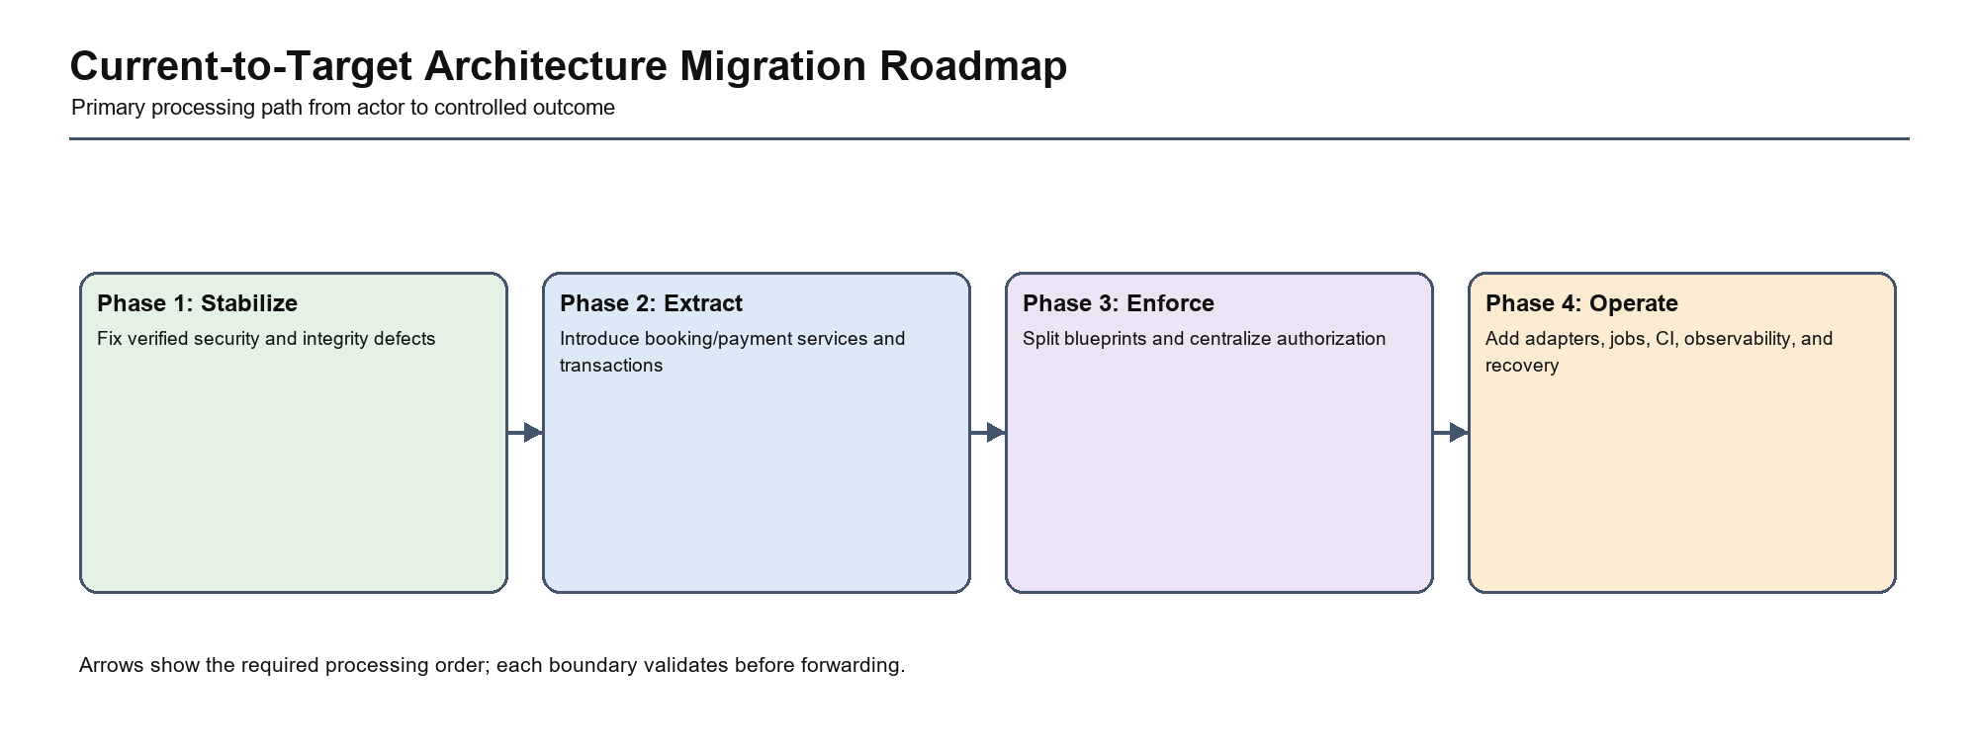
Figure 20. Architecture Decision Implementation Roadmap

5.8 ADR Traceability and Interaction Analysis
Table 14. ADR-to-risk, evidence, and migration traceability
ADR | Primary Module | Risk or Defect Addressed | Validation Evidence | Migration Phase
ADR-01 Modular Monolith | All modules and deployment | Unstructured monolith without adding operational complexity | Dependency review, route/service tests, deployment evidence | All phases
ADR-02 Application Service Layer | Booking, Payment, Auth, Management, AI | Route-centric orchestration and duplicated business rules | Service characterization and regression tests | Phase 2–3
ADR-03 Selective Repositories | Booking, Payment, Owner/Admin | Distributed consistency-sensitive queries | Transaction, ownership, and query integration tests | Phase 2–3
ADR-04 Central Authorization | Auth, User Portal, Owner/Admin | Distributed role checks and cross-tenant exposure | Endpoint-role/resource matrix and denial audit | Phase 3
ADR-05 Payment Adapter | Payment | Unverified provider callback and provider coupling | Tamper, amount, reference, replay, and failure tests | Phase 1–2
ADR-06 Booking Transaction Boundary | Booking and Room | Insufficient-stock acceptance and concurrency risk | Stock, rollback, cancellation, and parallel booking tests | Phase 1–2
ADR-07 AI Safety Layer | AI Assistant and domain services | Unsafe probabilistic mutation, privacy, and provider outage | Confirmation, prompt-injection, fallback, and tool-policy tests | Phase 3–4

5.9 Decision Interaction and Sequencing
The decisions are intentionally interdependent. The modular-monolith decision defines the operating boundary; application services establish use-case ownership; selective repositories and provider adapters implement outward dependencies; authorization and AI safety policies protect entry points; booking and payment transaction decisions protect the most critical state changes. Implementing a later decision without its prerequisite can preserve the appearance of layering while leaving the original risk unresolved.
Table 15. Architecture decision interaction and sequencing
Decision Interaction | Required Sequence | Failure if Applied in Isolation
ADR-02 with ADR-06 | Define BookingService while introducing the atomic transaction boundary | A service class may merely relocate the same unsafe read-modify-write logic
ADR-02 with ADR-05 | Extract PaymentService together with VNPayAdapter verification | Provider-specific trust logic remains mixed with orchestration
ADR-03 with ADR-04 | Apply ownership policy before repository/report query execution | A repository can efficiently return cross-tenant data
ADR-07 with ADR-02/04 | AI tools call authorized application services only | AI creates an alternative path that bypasses deterministic policy
ADR-01 with all decisions | Enforce internal boundaries through tests and review | The target architecture remains documentation without executable controls

6. System Architecture

6.1 Architectural Overview
Hanoi Booking currently uses one Flask runtime and relational source of truth. The target remains a modular monolith, with clear presentation, application, domain, infrastructure, integration, and AI responsibilities.
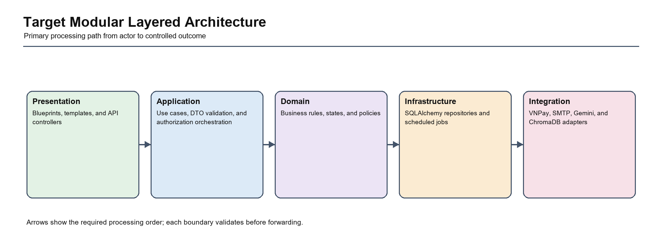
Figure 21. Target Modular Layered Architecture
The layered view establishes inward dependency direction while retaining one deployable Flask application. Presentation translates HTTP requests, application services own use cases, domain policies protect business decisions, and repositories/adapters isolate persistence and provider details.

6.2 Layer Responsibilities
Table 16. Target layer responsibilities
Layer | Responsibility | Dependency Rule
Presentation | Blueprints, templates, API controllers | Depends on application interfaces
Application | Use cases, DTO validation, authorization orchestration | Depends on domain and abstractions
Domain | Business rules, states, policies | Does not depend on Flask or provider details
Infrastructure | SQLAlchemy repositories and scheduled jobs | Implements application/domain interfaces
Integration | VNPay, SMTP, Gemini, and ChromaDB adapters | Translates provider-specific contracts

6.3 Authentication Module
6.3.1 Responsibility
Manage identity, credentials, sessions, verification, and reset workflows.
6.3.2 Current Implementation
Routes and utilities use Flask-Login and Werkzeug hashing; policy is distributed.
6.3.3 Target Design
AuthService, AuthRepository, rate limiting, audit events, and secure configuration.
6.3.4 Main Components
Authentication module components
Component: AuthBlueprint Responsibility: HTTP/session boundary
Component: AuthService Responsibility: Identity use cases
Component: AuthRepository Responsibility: User and security persistence
Component: AuthorizationPolicy Responsibility: Role and ownership decisions
6.3.5 Data Dependencies
User and UserSecurity.
6.3.6 External Dependencies
SMTP for verification and reset.
6.3.7 Risks
Credential abuse, unsafe secret fallback, inconsistent authorization.
6.3.8 Improvement Plan
Extract login/register/reset flows behind tests; add rate limiting and audit logging.
6.3.9 Inputs, Outputs, and Business Rules
Authentication inputs, outputs, and business rules
Area: Inputs Module Analysis: Validated HTTP/API data, authenticated identity, and identifiers required by the Authentication capability.
Area: Outputs Module Analysis: Controlled HTML, redirect, JSON, persisted state, or domain result without exposing internal exceptions.
Area: Business rules Module Analysis: Rules owned by Authentication must execute once in the application/domain boundary and must not be duplicated by routes, templates, AI tools, or provider adapters.
Area: Authorization Module Analysis: Public behavior is explicit; all protected operations enforce role and resource ownership before querying or mutation.
6.3.10 Failure Modes and Recovery
The Authentication module must distinguish validation rejection, authorization denial, missing data, state conflict, database failure, and external-provider failure. Expected failures return controlled results; unexpected failures are logged with correlation context and roll back any incomplete transaction. Optional dependencies must not make unrelated core booking behavior unavailable.
Authentication failure and recovery analysis
Failure Mode: Invalid or incomplete input Required Response: Reject before persistence and identify the invalid field or request Verification: Negative-path unit/API test
Failure Mode: Unauthorized or cross-owner request Required Response: Deny without protected-data disclosure Verification: Role and ownership matrix test
Failure Mode: Database/state conflict Required Response: Rollback and return a controlled conflict result Verification: Integration and rollback test
Failure Mode: External dependency unavailable Required Response: Apply timeout, fallback, retry, or explicit failure policy Verification: Provider-failure test
6.3.11 Transaction and Dependency Ownership
The target Authentication application service owns use-case orchestration and defines where commit or rollback occurs. Domain rules do not depend on Flask request context or provider formats. Repositories own persistence mechanics, while adapters own translation to external contracts. This direction prevents routes from becoming an alternative business layer.
6.3.12 Security and Testability Strategy
Authentication security and testability strategy
Concern: Identity and authorization Target Control: Central policy and server-derived identity Evidence: Role/resource matrix
Concern: Input and state safety Target Control: DTO validation and domain policy Evidence: Boundary and state-transition tests
Concern: Persistence consistency Target Control: Explicit transaction and repository behavior Evidence: Rollback/concurrency integration tests
Concern: Maintainability Target Control: Focused service interface and provider abstractions Evidence: Service tests and dependency review
6.3.13 Source-to-Target Migration Tasks
Migration for Authentication begins by documenting current route/helper behavior, adding characterization tests, extracting one service operation behind the existing interface, centralizing its policy and persistence boundary, and then removing duplicate logic. Completion requires the mapped regression tests and architecture controls to pass.
6.3.14 Route and Use-Case Ownership
Authentication route and use-case ownership
Current Interface: /login, /register, /logout Use Case: Credential and session lifecycle Target Owner: AuthService Required Evidence: TC-AUTH-01/02 plus route integration
Current Interface: /forgot-password, /reset-password/<token> Use Case: Time-limited reset workflow Target Owner: AuthService and SMTPAdapter Required Evidence: Token expiry, replay, and provider-failure tests
Current Interface: /verify-email/<token>, password-change routes Use Case: Identity verification and credential mutation Target Owner: AuthService and UserSecurityRepository Required Evidence: Ownership, token, lockout, and audit tests
6.3.15 Operational Scenarios
Authentication operational scenarios
Scenario: Normal Authentication request Normal Behavior: Validate, authorize, execute one service operation, and return controlled result Degraded or Failure Behavior: Not applicable Observable Signal: Latency, result status, correlation ID
Scenario: Invalid or forbidden request Normal Behavior: No state mutation Degraded or Failure Behavior: Return validation/authorization result without sensitive details Observable Signal: Validation or denial audit event
Scenario: Database or state conflict Normal Behavior: Transaction completes consistently Degraded or Failure Behavior: Rollback and return controlled conflict/failure Observable Signal: Rollback/error metric and structured log
Scenario: External dependency failure Normal Behavior: Adapter returns expected result Degraded or Failure Behavior: Timeout/fallback/retry policy protects core behavior Observable Signal: Provider error, timeout, and fallback metric
6.3.16 Architecture Controls and Fitness Evidence
Authentication architecture controls
Architecture Rule: Authentication routes do not own business transactions Why It Matters: Prevents duplicate orchestration and inconsistent behavior Fitness Evidence: Route/service characterization and review
Architecture Rule: Domain rules do not depend on Flask or provider formats Why It Matters: Keeps rules reusable and deterministic Fitness Evidence: Unit tests and dependency inspection
Architecture Rule: Protected resources use centralized policy Why It Matters: Prevents role and ownership drift Fitness Evidence: Endpoint-role/resource matrix
Architecture Rule: Failures are controlled and observable Why It Matters: Supports recovery without information leakage Fitness Evidence: Negative-path tests, logs, and metrics
Architecture Rule: Migration removes duplicate current logic Why It Matters: Avoids two competing implementations Fitness Evidence: Code review and regression suite
6.3.17 Module-Specific Rationale
The target boundary for Authentication is justified by the combination of current route concentration, the data and provider dependencies identified above, and the need for independently reviewable business and security behavior. The module remains part of one deployable Flask application, but its service interface becomes the single entry point for its use cases. This provides meaningful modularity without requiring network calls or distributed transactions.

6.4 Hotel and Room Module
6.4.1 Responsibility
Provide hotel discovery, room details, services, images, and availability views.
6.4.2 Current Implementation
Search and detail routes combine queries and presentation transformations.
6.4.3 Target Design
Read-oriented query service and repositories separate discovery from booking transactions.
6.4.4 Main Components
Hotel and Room module components
Component: HotelBlueprint Responsibility: Public page/API boundary
Component: HotelQueryService Responsibility: Discovery and detail queries
Component: HotelRepository Responsibility: Hotel/location access
Component: RoomRepository Responsibility: Room/service/image access
6.4.5 Data Dependencies
Hotel, HotelLocation, Room, Service, HotelImage, RoomImage.
6.4.6 External Dependencies
Static asset storage.
6.4.7 Risks
Slow queries, inconsistent availability display, presentation coupling.
6.4.8 Improvement Plan
Add pagination/query profiling and stable response DTOs.
6.4.9 Inputs, Outputs, and Business Rules
Hotel and Room inputs, outputs, and business rules
Area: Inputs Module Analysis: Validated HTTP/API data, authenticated identity, and identifiers required by the Hotel and Room capability.
Area: Outputs Module Analysis: Controlled HTML, redirect, JSON, persisted state, or domain result without exposing internal exceptions.
Area: Business rules Module Analysis: Rules owned by Hotel and Room must execute once in the application/domain boundary and must not be duplicated by routes, templates, AI tools, or provider adapters.
Area: Authorization Module Analysis: Public behavior is explicit; all protected operations enforce role and resource ownership before querying or mutation.
6.4.10 Failure Modes and Recovery
The Hotel and Room module must distinguish validation rejection, authorization denial, missing data, state conflict, database failure, and external-provider failure. Expected failures return controlled results; unexpected failures are logged with correlation context and roll back any incomplete transaction. Optional dependencies must not make unrelated core booking behavior unavailable.
Hotel and Room failure and recovery analysis
Failure Mode: Invalid or incomplete input Required Response: Reject before persistence and identify the invalid field or request Verification: Negative-path unit/API test
Failure Mode: Unauthorized or cross-owner request Required Response: Deny without protected-data disclosure Verification: Role and ownership matrix test
Failure Mode: Database/state conflict Required Response: Rollback and return a controlled conflict result Verification: Integration and rollback test
Failure Mode: External dependency unavailable Required Response: Apply timeout, fallback, retry, or explicit failure policy Verification: Provider-failure test
6.4.11 Transaction and Dependency Ownership
The target Hotel and Room application service owns use-case orchestration and defines where commit or rollback occurs. Domain rules do not depend on Flask request context or provider formats. Repositories own persistence mechanics, while adapters own translation to external contracts. This direction prevents routes from becoming an alternative business layer.
6.4.12 Security and Testability Strategy
Hotel and Room security and testability strategy
Concern: Identity and authorization Target Control: Central policy and server-derived identity Evidence: Role/resource matrix
Concern: Input and state safety Target Control: DTO validation and domain policy Evidence: Boundary and state-transition tests
Concern: Persistence consistency Target Control: Explicit transaction and repository behavior Evidence: Rollback/concurrency integration tests
Concern: Maintainability Target Control: Focused service interface and provider abstractions Evidence: Service tests and dependency review
6.4.13 Source-to-Target Migration Tasks
Migration for Hotel and Room begins by documenting current route/helper behavior, adding characterization tests, extracting one service operation behind the existing interface, centralizing its policy and persistence boundary, and then removing duplicate logic. Completion requires the mapped regression tests and architecture controls to pass.
6.4.14 Route and Use-Case Ownership
Hotel and Room route and use-case ownership
Current Interface: /, /search, /search-by-name Use Case: Public hotel discovery Target Owner: HotelQueryService Required Evidence: UI/search, empty-result, pagination, and query tests
Current Interface: /hotel/<id>, room image/service APIs Use Case: Hotel and room read models Target Owner: Hotel/Room repositories Required Evidence: Missing-resource and response-contract tests
Current Interface: Availability queries Use Case: Expose bookable inventory without owning mutation Target Owner: RoomQueryRepository Required Evidence: Filtering and performance tests
6.4.15 Operational Scenarios
Hotel and Room operational scenarios
Scenario: Normal Hotel and Room request Normal Behavior: Validate, authorize, execute one service operation, and return controlled result Degraded or Failure Behavior: Not applicable Observable Signal: Latency, result status, correlation ID
Scenario: Invalid or forbidden request Normal Behavior: No state mutation Degraded or Failure Behavior: Return validation/authorization result without sensitive details Observable Signal: Validation or denial audit event
Scenario: Database or state conflict Normal Behavior: Transaction completes consistently Degraded or Failure Behavior: Rollback and return controlled conflict/failure Observable Signal: Rollback/error metric and structured log
Scenario: External dependency failure Normal Behavior: Adapter returns expected result Degraded or Failure Behavior: Timeout/fallback/retry policy protects core behavior Observable Signal: Provider error, timeout, and fallback metric
6.4.16 Architecture Controls and Fitness Evidence
Hotel and Room architecture controls
Architecture Rule: Hotel and Room routes do not own business transactions Why It Matters: Prevents duplicate orchestration and inconsistent behavior Fitness Evidence: Route/service characterization and review
Architecture Rule: Domain rules do not depend on Flask or provider formats Why It Matters: Keeps rules reusable and deterministic Fitness Evidence: Unit tests and dependency inspection
Architecture Rule: Protected resources use centralized policy Why It Matters: Prevents role and ownership drift Fitness Evidence: Endpoint-role/resource matrix
Architecture Rule: Failures are controlled and observable Why It Matters: Supports recovery without information leakage Fitness Evidence: Negative-path tests, logs, and metrics
Architecture Rule: Migration removes duplicate current logic Why It Matters: Avoids two competing implementations Fitness Evidence: Code review and regression suite
6.4.17 Module-Specific Rationale
The target boundary for Hotel and Room is justified by the combination of current route concentration, the data and provider dependencies identified above, and the need for independently reviewable business and security behavior. The module remains part of one deployable Flask application, but its service interface becomes the single entry point for its use cases. This provides meaningful modularity without requiring network calls or distributed transactions.

6.5 Booking Module
6.5.1 Responsibility
Create, inspect, cancel, expire, and confirm reservations while preserving inventory.
6.5.2 Current Implementation
Booking behavior is spread across routes, utilities, request cleanup, and AI tools.
6.5.3 Target Design
BookingService owns validation, state transitions, atomic inventory, and transaction boundaries.
6.5.4 Main Components
Booking module components
Component: BookingBlueprint Responsibility: Customer commands and views
Component: BookingService Responsibility: Reservation lifecycle
Component: BookingPolicy Responsibility: Date, ownership, and state rules
Component: BookingRepository Responsibility: Atomic persistence and locking
6.5.5 Data Dependencies
Booking, Room, User.
6.5.6 External Dependencies
Payment service and notification service.
6.5.7 Risks
Verified insufficient-stock and concurrency failures.
6.5.8 Improvement Plan
Fix critical defects first, then consolidate overlapping booking routes.
6.5.9 Inputs, Outputs, and Business Rules
Booking inputs, outputs, and business rules
Area: Inputs Module Analysis: Validated HTTP/API data, authenticated identity, and identifiers required by the Booking capability.
Area: Outputs Module Analysis: Controlled HTML, redirect, JSON, persisted state, or domain result without exposing internal exceptions.
Area: Business rules Module Analysis: Rules owned by Booking must execute once in the application/domain boundary and must not be duplicated by routes, templates, AI tools, or provider adapters.
Area: Authorization Module Analysis: Public behavior is explicit; all protected operations enforce role and resource ownership before querying or mutation.
6.5.10 Failure Modes and Recovery
The Booking module must distinguish validation rejection, authorization denial, missing data, state conflict, database failure, and external-provider failure. Expected failures return controlled results; unexpected failures are logged with correlation context and roll back any incomplete transaction. Optional dependencies must not make unrelated core booking behavior unavailable.
Booking failure and recovery analysis
Failure Mode: Invalid or incomplete input Required Response: Reject before persistence and identify the invalid field or request Verification: Negative-path unit/API test
Failure Mode: Unauthorized or cross-owner request Required Response: Deny without protected-data disclosure Verification: Role and ownership matrix test
Failure Mode: Database/state conflict Required Response: Rollback and return a controlled conflict result Verification: Integration and rollback test
Failure Mode: External dependency unavailable Required Response: Apply timeout, fallback, retry, or explicit failure policy Verification: Provider-failure test
6.5.11 Transaction and Dependency Ownership
The target Booking application service owns use-case orchestration and defines where commit or rollback occurs. Domain rules do not depend on Flask request context or provider formats. Repositories own persistence mechanics, while adapters own translation to external contracts. This direction prevents routes from becoming an alternative business layer.
6.5.12 Security and Testability Strategy
Booking security and testability strategy
Concern: Identity and authorization Target Control: Central policy and server-derived identity Evidence: Role/resource matrix
Concern: Input and state safety Target Control: DTO validation and domain policy Evidence: Boundary and state-transition tests
Concern: Persistence consistency Target Control: Explicit transaction and repository behavior Evidence: Rollback/concurrency integration tests
Concern: Maintainability Target Control: Focused service interface and provider abstractions Evidence: Service tests and dependency review
6.5.13 Source-to-Target Migration Tasks
Migration for Booking begins by documenting current route/helper behavior, adding characterization tests, extracting one service operation behind the existing interface, centralizing its policy and persistence boundary, and then removing duplicate logic. Completion requires the mapped regression tests and architecture controls to pass.
6.5.14 Route and Use-Case Ownership
Booking route and use-case ownership
Current Interface: /book/<room_id>, /book_and_pay/<room_id> Use Case: Create and reserve inventory Target Owner: BookingService Required Evidence: Stock, price, rollback, and concurrency tests
Current Interface: /booking/<id>, /user/my-bookings Use Case: Owned booking reads Target Owner: BookingQueryService Required Evidence: Ownership and privacy tests
Current Interface: DELETE booking routes and confirmation Use Case: Cancel/confirm state transition Target Owner: BookingService and BookingPolicy Required Evidence: Idempotency and inventory-restoration tests
6.5.15 Operational Scenarios
Booking operational scenarios
Scenario: Normal Booking request Normal Behavior: Validate, authorize, execute one service operation, and return controlled result Degraded or Failure Behavior: Not applicable Observable Signal: Latency, result status, correlation ID
Scenario: Invalid or forbidden request Normal Behavior: No state mutation Degraded or Failure Behavior: Return validation/authorization result without sensitive details Observable Signal: Validation or denial audit event
Scenario: Database or state conflict Normal Behavior: Transaction completes consistently Degraded or Failure Behavior: Rollback and return controlled conflict/failure Observable Signal: Rollback/error metric and structured log
Scenario: External dependency failure Normal Behavior: Adapter returns expected result Degraded or Failure Behavior: Timeout/fallback/retry policy protects core behavior Observable Signal: Provider error, timeout, and fallback metric
6.5.16 Architecture Controls and Fitness Evidence
Booking architecture controls
Architecture Rule: Booking routes do not own business transactions Why It Matters: Prevents duplicate orchestration and inconsistent behavior Fitness Evidence: Route/service characterization and review
Architecture Rule: Domain rules do not depend on Flask or provider formats Why It Matters: Keeps rules reusable and deterministic Fitness Evidence: Unit tests and dependency inspection
Architecture Rule: Protected resources use centralized policy Why It Matters: Prevents role and ownership drift Fitness Evidence: Endpoint-role/resource matrix
Architecture Rule: Failures are controlled and observable Why It Matters: Supports recovery without information leakage Fitness Evidence: Negative-path tests, logs, and metrics
Architecture Rule: Migration removes duplicate current logic Why It Matters: Avoids two competing implementations Fitness Evidence: Code review and regression suite
6.5.17 Module-Specific Rationale
The target boundary for Booking is justified by the combination of current route concentration, the data and provider dependencies identified above, and the need for independently reviewable business and security behavior. The module remains part of one deployable Flask application, but its service interface becomes the single entry point for its use cases. This provides meaningful modularity without requiring network calls or distributed transactions.

6.6 Payment Module
6.6.1 Responsibility
Initiate VNPay payment and safely synchronize provider outcomes.
6.6.2 Current Implementation
Outbound signing exists; callback route directly mutates Payment and Booking.
6.6.3 Target Design
PaymentService and VNPayAdapter verify untrusted callback data before idempotent finalization.
6.6.4 Main Components
Payment module components
Component: PaymentBlueprint Responsibility: Payment HTTP boundary
Component: PaymentService Responsibility: Payment lifecycle
Component: VNPayAdapter Responsibility: Provider signing and verification
Component: PaymentRepository Responsibility: Idempotent transaction access
6.6.5 Data Dependencies
Payment and Booking.
6.6.6 External Dependencies
VNPay and notification/email services.
6.6.7 Risks
Forged callback, replay, amount mismatch, partial commits.
6.6.8 Improvement Plan
Add callback verification, unique transaction reference, and terminal-state guards.
6.6.9 Inputs, Outputs, and Business Rules
Payment inputs, outputs, and business rules
Area: Inputs Module Analysis: Validated HTTP/API data, authenticated identity, and identifiers required by the Payment capability.
Area: Outputs Module Analysis: Controlled HTML, redirect, JSON, persisted state, or domain result without exposing internal exceptions.
Area: Business rules Module Analysis: Rules owned by Payment must execute once in the application/domain boundary and must not be duplicated by routes, templates, AI tools, or provider adapters.
Area: Authorization Module Analysis: Public behavior is explicit; all protected operations enforce role and resource ownership before querying or mutation.
6.6.10 Failure Modes and Recovery
The Payment module must distinguish validation rejection, authorization denial, missing data, state conflict, database failure, and external-provider failure. Expected failures return controlled results; unexpected failures are logged with correlation context and roll back any incomplete transaction. Optional dependencies must not make unrelated core booking behavior unavailable.
Payment failure and recovery analysis
Failure Mode: Invalid or incomplete input Required Response: Reject before persistence and identify the invalid field or request Verification: Negative-path unit/API test
Failure Mode: Unauthorized or cross-owner request Required Response: Deny without protected-data disclosure Verification: Role and ownership matrix test
Failure Mode: Database/state conflict Required Response: Rollback and return a controlled conflict result Verification: Integration and rollback test
Failure Mode: External dependency unavailable Required Response: Apply timeout, fallback, retry, or explicit failure policy Verification: Provider-failure test
6.6.11 Transaction and Dependency Ownership
The target Payment application service owns use-case orchestration and defines where commit or rollback occurs. Domain rules do not depend on Flask request context or provider formats. Repositories own persistence mechanics, while adapters own translation to external contracts. This direction prevents routes from becoming an alternative business layer.
6.6.12 Security and Testability Strategy
Payment security and testability strategy
Concern: Identity and authorization Target Control: Central policy and server-derived identity Evidence: Role/resource matrix
Concern: Input and state safety Target Control: DTO validation and domain policy Evidence: Boundary and state-transition tests
Concern: Persistence consistency Target Control: Explicit transaction and repository behavior Evidence: Rollback/concurrency integration tests
Concern: Maintainability Target Control: Focused service interface and provider abstractions Evidence: Service tests and dependency review
6.6.13 Source-to-Target Migration Tasks
Migration for Payment begins by documenting current route/helper behavior, adding characterization tests, extracting one service operation behind the existing interface, centralizing its policy and persistence boundary, and then removing duplicate logic. Completion requires the mapped regression tests and architecture controls to pass.
6.6.14 Route and Use-Case Ownership
Payment route and use-case ownership
Current Interface: /vnpay_pay Use Case: Initiate signed provider request Target Owner: PaymentService and VNPayAdapter Required Evidence: Reference, amount, ownership, and signing tests
Current Interface: /vnpay_return Use Case: Verify and finalize provider result Target Owner: VNPayAdapter and PaymentService Required Evidence: Tamper, replay, mismatch, and transaction tests
Current Interface: /payment/<booking_id>, transaction APIs Use Case: Owned payment display/history Target Owner: PaymentQueryService Required Evidence: Scope and data-minimization tests
6.6.15 Operational Scenarios
Payment operational scenarios
Scenario: Normal Payment request Normal Behavior: Validate, authorize, execute one service operation, and return controlled result Degraded or Failure Behavior: Not applicable Observable Signal: Latency, result status, correlation ID
Scenario: Invalid or forbidden request Normal Behavior: No state mutation Degraded or Failure Behavior: Return validation/authorization result without sensitive details Observable Signal: Validation or denial audit event
Scenario: Database or state conflict Normal Behavior: Transaction completes consistently Degraded or Failure Behavior: Rollback and return controlled conflict/failure Observable Signal: Rollback/error metric and structured log
Scenario: External dependency failure Normal Behavior: Adapter returns expected result Degraded or Failure Behavior: Timeout/fallback/retry policy protects core behavior Observable Signal: Provider error, timeout, and fallback metric
6.6.16 Architecture Controls and Fitness Evidence
Payment architecture controls
Architecture Rule: Payment routes do not own business transactions Why It Matters: Prevents duplicate orchestration and inconsistent behavior Fitness Evidence: Route/service characterization and review
Architecture Rule: Domain rules do not depend on Flask or provider formats Why It Matters: Keeps rules reusable and deterministic Fitness Evidence: Unit tests and dependency inspection
Architecture Rule: Protected resources use centralized policy Why It Matters: Prevents role and ownership drift Fitness Evidence: Endpoint-role/resource matrix
Architecture Rule: Failures are controlled and observable Why It Matters: Supports recovery without information leakage Fitness Evidence: Negative-path tests, logs, and metrics
Architecture Rule: Migration removes duplicate current logic Why It Matters: Avoids two competing implementations Fitness Evidence: Code review and regression suite
6.6.17 Module-Specific Rationale
The target boundary for Payment is justified by the combination of current route concentration, the data and provider dependencies identified above, and the need for independently reviewable business and security behavior. The module remains part of one deployable Flask application, but its service interface becomes the single entry point for its use cases. This provides meaningful modularity without requiring network calls or distributed transactions.

6.7 User Portal Module
6.7.1 Responsibility
Provide current-user profile, bookings, reviews, notifications, and transactions.
6.7.2 Current Implementation
HTML and JSON routes query current-user data directly.
6.7.3 Target Design
UserPortalService provides user-scoped commands and read models.
6.7.4 Main Components
User Portal module components
Component: UserBlueprint Responsibility: Portal pages and APIs
Component: UserPortalService Responsibility: Profile and history workflows
Component: UserQueryRepository Responsibility: User-scoped reads
6.7.5 Data Dependencies
User, Booking, Review, Notification, Payment.
6.7.6 External Dependencies
SMTP for account workflows.
6.7.7 Risks
Privacy exposure and inconsistent responses.
6.7.8 Improvement Plan
Centralize user scope and standardize DTOs.
6.7.9 Inputs, Outputs, and Business Rules
User Portal inputs, outputs, and business rules
Area: Inputs Module Analysis: Validated HTTP/API data, authenticated identity, and identifiers required by the User Portal capability.
Area: Outputs Module Analysis: Controlled HTML, redirect, JSON, persisted state, or domain result without exposing internal exceptions.
Area: Business rules Module Analysis: Rules owned by User Portal must execute once in the application/domain boundary and must not be duplicated by routes, templates, AI tools, or provider adapters.
Area: Authorization Module Analysis: Public behavior is explicit; all protected operations enforce role and resource ownership before querying or mutation.
6.7.10 Failure Modes and Recovery
The User Portal module must distinguish validation rejection, authorization denial, missing data, state conflict, database failure, and external-provider failure. Expected failures return controlled results; unexpected failures are logged with correlation context and roll back any incomplete transaction. Optional dependencies must not make unrelated core booking behavior unavailable.
User Portal failure and recovery analysis
Failure Mode: Invalid or incomplete input Required Response: Reject before persistence and identify the invalid field or request Verification: Negative-path unit/API test
Failure Mode: Unauthorized or cross-owner request Required Response: Deny without protected-data disclosure Verification: Role and ownership matrix test
Failure Mode: Database/state conflict Required Response: Rollback and return a controlled conflict result Verification: Integration and rollback test
Failure Mode: External dependency unavailable Required Response: Apply timeout, fallback, retry, or explicit failure policy Verification: Provider-failure test
6.7.11 Transaction and Dependency Ownership
The target User Portal application service owns use-case orchestration and defines where commit or rollback occurs. Domain rules do not depend on Flask request context or provider formats. Repositories own persistence mechanics, while adapters own translation to external contracts. This direction prevents routes from becoming an alternative business layer.
6.7.12 Security and Testability Strategy
User Portal security and testability strategy
Concern: Identity and authorization Target Control: Central policy and server-derived identity Evidence: Role/resource matrix
Concern: Input and state safety Target Control: DTO validation and domain policy Evidence: Boundary and state-transition tests
Concern: Persistence consistency Target Control: Explicit transaction and repository behavior Evidence: Rollback/concurrency integration tests
Concern: Maintainability Target Control: Focused service interface and provider abstractions Evidence: Service tests and dependency review
6.7.13 Source-to-Target Migration Tasks
Migration for User Portal begins by documenting current route/helper behavior, adding characterization tests, extracting one service operation behind the existing interface, centralizing its policy and persistence boundary, and then removing duplicate logic. Completion requires the mapped regression tests and architecture controls to pass.
6.7.14 Route and Use-Case Ownership
User Portal route and use-case ownership
Current Interface: /user and /api/user/info Use Case: Profile and account read model Target Owner: UserPortalService Required Evidence: Current-user scope and privacy tests
Current Interface: /api/user/update and password routes Use Case: Profile/credential mutation Target Owner: UserPortalService/AuthService Required Evidence: Validation, ownership, CSRF, and audit tests
Current Interface: Booking, review, notification, transaction APIs Use Case: Customer history and activity Target Owner: UserQueryRepository Required Evidence: Scope, pagination, and response-contract tests
6.7.15 Operational Scenarios
User Portal operational scenarios
Scenario: Normal User Portal request Normal Behavior: Validate, authorize, execute one service operation, and return controlled result Degraded or Failure Behavior: Not applicable Observable Signal: Latency, result status, correlation ID
Scenario: Invalid or forbidden request Normal Behavior: No state mutation Degraded or Failure Behavior: Return validation/authorization result without sensitive details Observable Signal: Validation or denial audit event
Scenario: Database or state conflict Normal Behavior: Transaction completes consistently Degraded or Failure Behavior: Rollback and return controlled conflict/failure Observable Signal: Rollback/error metric and structured log
Scenario: External dependency failure Normal Behavior: Adapter returns expected result Degraded or Failure Behavior: Timeout/fallback/retry policy protects core behavior Observable Signal: Provider error, timeout, and fallback metric
6.7.16 Architecture Controls and Fitness Evidence
User Portal architecture controls
Architecture Rule: User Portal routes do not own business transactions Why It Matters: Prevents duplicate orchestration and inconsistent behavior Fitness Evidence: Route/service characterization and review
Architecture Rule: Domain rules do not depend on Flask or provider formats Why It Matters: Keeps rules reusable and deterministic Fitness Evidence: Unit tests and dependency inspection
Architecture Rule: Protected resources use centralized policy Why It Matters: Prevents role and ownership drift Fitness Evidence: Endpoint-role/resource matrix
Architecture Rule: Failures are controlled and observable Why It Matters: Supports recovery without information leakage Fitness Evidence: Negative-path tests, logs, and metrics
Architecture Rule: Migration removes duplicate current logic Why It Matters: Avoids two competing implementations Fitness Evidence: Code review and regression suite
6.7.17 Module-Specific Rationale
The target boundary for User Portal is justified by the combination of current route concentration, the data and provider dependencies identified above, and the need for independently reviewable business and security behavior. The module remains part of one deployable Flask application, but its service interface becomes the single entry point for its use cases. This provides meaningful modularity without requiring network calls or distributed transactions.

6.8 Owner and Admin Module
6.8.1 Responsibility
Provide tenant-safe operational and administrative views.
6.8.2 Current Implementation
Owner scope checks and dashboard queries are distributed.
6.8.3 Target Design
ManagementService and centralized policy enforce deny-by-default access.
6.8.4 Main Components
Owner and Admin module components
Component: ManagementBlueprint Responsibility: Owner/admin APIs
Component: ManagementService Responsibility: Dashboard/report workflows
Component: OwnershipPolicy Responsibility: Tenant isolation
Component: ReportingRepository Responsibility: Aggregated queries
6.8.5 Data Dependencies
User, Hotel, Room, Booking, Payment.
6.8.6 External Dependencies
No required external provider.
6.8.7 Risks
Cross-tenant exposure and query complexity.
6.8.8 Improvement Plan
Test endpoint-role matrix and extract reporting queries.
6.8.9 Inputs, Outputs, and Business Rules
Owner and Admin inputs, outputs, and business rules
Area: Inputs Module Analysis: Validated HTTP/API data, authenticated identity, and identifiers required by the Owner and Admin capability.
Area: Outputs Module Analysis: Controlled HTML, redirect, JSON, persisted state, or domain result without exposing internal exceptions.
Area: Business rules Module Analysis: Rules owned by Owner and Admin must execute once in the application/domain boundary and must not be duplicated by routes, templates, AI tools, or provider adapters.
Area: Authorization Module Analysis: Public behavior is explicit; all protected operations enforce role and resource ownership before querying or mutation.
6.8.10 Failure Modes and Recovery
The Owner and Admin module must distinguish validation rejection, authorization denial, missing data, state conflict, database failure, and external-provider failure. Expected failures return controlled results; unexpected failures are logged with correlation context and roll back any incomplete transaction. Optional dependencies must not make unrelated core booking behavior unavailable.
Owner and Admin failure and recovery analysis
Failure Mode: Invalid or incomplete input Required Response: Reject before persistence and identify the invalid field or request Verification: Negative-path unit/API test
Failure Mode: Unauthorized or cross-owner request Required Response: Deny without protected-data disclosure Verification: Role and ownership matrix test
Failure Mode: Database/state conflict Required Response: Rollback and return a controlled conflict result Verification: Integration and rollback test
Failure Mode: External dependency unavailable Required Response: Apply timeout, fallback, retry, or explicit failure policy Verification: Provider-failure test
6.8.11 Transaction and Dependency Ownership
The target Owner and Admin application service owns use-case orchestration and defines where commit or rollback occurs. Domain rules do not depend on Flask request context or provider formats. Repositories own persistence mechanics, while adapters own translation to external contracts. This direction prevents routes from becoming an alternative business layer.
6.8.12 Security and Testability Strategy
Owner and Admin security and testability strategy
Concern: Identity and authorization Target Control: Central policy and server-derived identity Evidence: Role/resource matrix
Concern: Input and state safety Target Control: DTO validation and domain policy Evidence: Boundary and state-transition tests
Concern: Persistence consistency Target Control: Explicit transaction and repository behavior Evidence: Rollback/concurrency integration tests
Concern: Maintainability Target Control: Focused service interface and provider abstractions Evidence: Service tests and dependency review
6.8.13 Source-to-Target Migration Tasks
Migration for Owner and Admin begins by documenting current route/helper behavior, adding characterization tests, extracting one service operation behind the existing interface, centralizing its policy and persistence boundary, and then removing duplicate logic. Completion requires the mapped regression tests and architecture controls to pass.
6.8.14 Route and Use-Case Ownership
Owner and Admin route and use-case ownership
Current Interface: Owner dashboard and room-type APIs Use Case: Tenant-scoped operational reporting Target Owner: ManagementService Required Evidence: Cross-owner denial and aggregate-isolation tests
Current Interface: Hotel dashboard/payment APIs Use Case: Hotel-specific reporting Target Owner: ReportingRepository and OwnershipPolicy Required Evidence: Ownership-before-query tests
Current Interface: Manage users/hotels/statistics Use Case: System administration Target Owner: AdminService and AuthorizationPolicy Required Evidence: Explicit admin-role and audit tests
6.8.15 Operational Scenarios
Owner and Admin operational scenarios
Scenario: Normal Owner and Admin request Normal Behavior: Validate, authorize, execute one service operation, and return controlled result Degraded or Failure Behavior: Not applicable Observable Signal: Latency, result status, correlation ID
Scenario: Invalid or forbidden request Normal Behavior: No state mutation Degraded or Failure Behavior: Return validation/authorization result without sensitive details Observable Signal: Validation or denial audit event
Scenario: Database or state conflict Normal Behavior: Transaction completes consistently Degraded or Failure Behavior: Rollback and return controlled conflict/failure Observable Signal: Rollback/error metric and structured log
Scenario: External dependency failure Normal Behavior: Adapter returns expected result Degraded or Failure Behavior: Timeout/fallback/retry policy protects core behavior Observable Signal: Provider error, timeout, and fallback metric
6.8.16 Architecture Controls and Fitness Evidence
Owner and Admin architecture controls
Architecture Rule: Owner and Admin routes do not own business transactions Why It Matters: Prevents duplicate orchestration and inconsistent behavior Fitness Evidence: Route/service characterization and review
Architecture Rule: Domain rules do not depend on Flask or provider formats Why It Matters: Keeps rules reusable and deterministic Fitness Evidence: Unit tests and dependency inspection
Architecture Rule: Protected resources use centralized policy Why It Matters: Prevents role and ownership drift Fitness Evidence: Endpoint-role/resource matrix
Architecture Rule: Failures are controlled and observable Why It Matters: Supports recovery without information leakage Fitness Evidence: Negative-path tests, logs, and metrics
Architecture Rule: Migration removes duplicate current logic Why It Matters: Avoids two competing implementations Fitness Evidence: Code review and regression suite
6.8.17 Module-Specific Rationale
The target boundary for Owner and Admin is justified by the combination of current route concentration, the data and provider dependencies identified above, and the need for independently reviewable business and security behavior. The module remains part of one deployable Flask application, but its service interface becomes the single entry point for its use cases. This provides meaningful modularity without requiring network calls or distributed transactions.

6.9 Review Module
6.9.1 Responsibility
Accept and display customer feedback associated with hotels.
6.9.2 Current Implementation
Review creation uses utility and route logic.
6.9.3 Target Design
ReviewService validates identity, rating, content, and duplicate policy.
6.9.4 Main Components
Review module components
Component: ReviewBlueprint Responsibility: Review boundary
Component: ReviewService Responsibility: Validation and submission
Component: ReviewRepository Responsibility: Review persistence
6.9.5 Data Dependencies
Review, User, Hotel.
6.9.6 External Dependencies
Optional moderation service in future.
6.9.7 Risks
Stored content abuse and inconsistent rating aggregation.
6.9.8 Improvement Plan
Define validation, moderation, and aggregation policy.
6.9.9 Inputs, Outputs, and Business Rules
Review inputs, outputs, and business rules
Area: Inputs Module Analysis: Validated HTTP/API data, authenticated identity, and identifiers required by the Review capability.
Area: Outputs Module Analysis: Controlled HTML, redirect, JSON, persisted state, or domain result without exposing internal exceptions.
Area: Business rules Module Analysis: Rules owned by Review must execute once in the application/domain boundary and must not be duplicated by routes, templates, AI tools, or provider adapters.
Area: Authorization Module Analysis: Public behavior is explicit; all protected operations enforce role and resource ownership before querying or mutation.
6.9.10 Failure Modes and Recovery
The Review module must distinguish validation rejection, authorization denial, missing data, state conflict, database failure, and external-provider failure. Expected failures return controlled results; unexpected failures are logged with correlation context and roll back any incomplete transaction. Optional dependencies must not make unrelated core booking behavior unavailable.
Review failure and recovery analysis
Failure Mode: Invalid or incomplete input Required Response: Reject before persistence and identify the invalid field or request Verification: Negative-path unit/API test
Failure Mode: Unauthorized or cross-owner request Required Response: Deny without protected-data disclosure Verification: Role and ownership matrix test
Failure Mode: Database/state conflict Required Response: Rollback and return a controlled conflict result Verification: Integration and rollback test
Failure Mode: External dependency unavailable Required Response: Apply timeout, fallback, retry, or explicit failure policy Verification: Provider-failure test
6.9.11 Transaction and Dependency Ownership
The target Review application service owns use-case orchestration and defines where commit or rollback occurs. Domain rules do not depend on Flask request context or provider formats. Repositories own persistence mechanics, while adapters own translation to external contracts. This direction prevents routes from becoming an alternative business layer.
6.9.12 Security and Testability Strategy
Review security and testability strategy
Concern: Identity and authorization Target Control: Central policy and server-derived identity Evidence: Role/resource matrix
Concern: Input and state safety Target Control: DTO validation and domain policy Evidence: Boundary and state-transition tests
Concern: Persistence consistency Target Control: Explicit transaction and repository behavior Evidence: Rollback/concurrency integration tests
Concern: Maintainability Target Control: Focused service interface and provider abstractions Evidence: Service tests and dependency review
6.9.13 Source-to-Target Migration Tasks
Migration for Review begins by documenting current route/helper behavior, adding characterization tests, extracting one service operation behind the existing interface, centralizing its policy and persistence boundary, and then removing duplicate logic. Completion requires the mapped regression tests and architecture controls to pass.
6.9.14 Route and Use-Case Ownership
Review route and use-case ownership
Current Interface: /hotel/<id>/review Use Case: Submit customer feedback Target Owner: ReviewService Required Evidence: Identity, rating, content, duplicate-policy tests
Current Interface: /user/my-reviews Use Case: Owned review history Target Owner: ReviewQueryRepository Required Evidence: Current-user scope and pagination tests
Current Interface: Hotel detail review display Use Case: Public moderated read model Target Owner: HotelQueryService Required Evidence: Content-safety and aggregation tests
6.9.15 Operational Scenarios
Review operational scenarios
Scenario: Normal Review request Normal Behavior: Validate, authorize, execute one service operation, and return controlled result Degraded or Failure Behavior: Not applicable Observable Signal: Latency, result status, correlation ID
Scenario: Invalid or forbidden request Normal Behavior: No state mutation Degraded or Failure Behavior: Return validation/authorization result without sensitive details Observable Signal: Validation or denial audit event
Scenario: Database or state conflict Normal Behavior: Transaction completes consistently Degraded or Failure Behavior: Rollback and return controlled conflict/failure Observable Signal: Rollback/error metric and structured log
Scenario: External dependency failure Normal Behavior: Adapter returns expected result Degraded or Failure Behavior: Timeout/fallback/retry policy protects core behavior Observable Signal: Provider error, timeout, and fallback metric
6.9.16 Architecture Controls and Fitness Evidence
Review architecture controls
Architecture Rule: Review routes do not own business transactions Why It Matters: Prevents duplicate orchestration and inconsistent behavior Fitness Evidence: Route/service characterization and review
Architecture Rule: Domain rules do not depend on Flask or provider formats Why It Matters: Keeps rules reusable and deterministic Fitness Evidence: Unit tests and dependency inspection
Architecture Rule: Protected resources use centralized policy Why It Matters: Prevents role and ownership drift Fitness Evidence: Endpoint-role/resource matrix
Architecture Rule: Failures are controlled and observable Why It Matters: Supports recovery without information leakage Fitness Evidence: Negative-path tests, logs, and metrics
Architecture Rule: Migration removes duplicate current logic Why It Matters: Avoids two competing implementations Fitness Evidence: Code review and regression suite
6.9.17 Module-Specific Rationale
The target boundary for Review is justified by the combination of current route concentration, the data and provider dependencies identified above, and the need for independently reviewable business and security behavior. The module remains part of one deployable Flask application, but its service interface becomes the single entry point for its use cases. This provides meaningful modularity without requiring network calls or distributed transactions.

6.10 Notification Module
6.10.1 Responsibility
Record and display user-visible booking, payment, and account events.
6.10.2 Current Implementation
Notifications are created directly in business flows.
6.10.3 Target Design
NotificationService consumes explicit domain/application events.
6.10.4 Main Components
Notification module components
Component: NotificationBlueprint Responsibility: Notification API
Component: NotificationService Responsibility: Create and retrieve notifications
Component: NotificationRepository Responsibility: Persistence and read state
6.10.5 Data Dependencies
Notification and User.
6.10.6 External Dependencies
SMTP may deliver selected external messages.
6.10.7 Risks
Duplicate notifications and tight coupling to transaction routes.
6.10.8 Improvement Plan
Create notifications after successful transaction completion with idempotency.
6.10.9 Inputs, Outputs, and Business Rules
Notification inputs, outputs, and business rules
Area: Inputs Module Analysis: Validated HTTP/API data, authenticated identity, and identifiers required by the Notification capability.
Area: Outputs Module Analysis: Controlled HTML, redirect, JSON, persisted state, or domain result without exposing internal exceptions.
Area: Business rules Module Analysis: Rules owned by Notification must execute once in the application/domain boundary and must not be duplicated by routes, templates, AI tools, or provider adapters.
Area: Authorization Module Analysis: Public behavior is explicit; all protected operations enforce role and resource ownership before querying or mutation.
6.10.10 Failure Modes and Recovery
The Notification module must distinguish validation rejection, authorization denial, missing data, state conflict, database failure, and external-provider failure. Expected failures return controlled results; unexpected failures are logged with correlation context and roll back any incomplete transaction. Optional dependencies must not make unrelated core booking behavior unavailable.
Notification failure and recovery analysis
Failure Mode: Invalid or incomplete input Required Response: Reject before persistence and identify the invalid field or request Verification: Negative-path unit/API test
Failure Mode: Unauthorized or cross-owner request Required Response: Deny without protected-data disclosure Verification: Role and ownership matrix test
Failure Mode: Database/state conflict Required Response: Rollback and return a controlled conflict result Verification: Integration and rollback test
Failure Mode: External dependency unavailable Required Response: Apply timeout, fallback, retry, or explicit failure policy Verification: Provider-failure test
6.10.11 Transaction and Dependency Ownership
The target Notification application service owns use-case orchestration and defines where commit or rollback occurs. Domain rules do not depend on Flask request context or provider formats. Repositories own persistence mechanics, while adapters own translation to external contracts. This direction prevents routes from becoming an alternative business layer.
6.10.12 Security and Testability Strategy
Notification security and testability strategy
Concern: Identity and authorization Target Control: Central policy and server-derived identity Evidence: Role/resource matrix
Concern: Input and state safety Target Control: DTO validation and domain policy Evidence: Boundary and state-transition tests
Concern: Persistence consistency Target Control: Explicit transaction and repository behavior Evidence: Rollback/concurrency integration tests
Concern: Maintainability Target Control: Focused service interface and provider abstractions Evidence: Service tests and dependency review
6.10.13 Source-to-Target Migration Tasks
Migration for Notification begins by documenting current route/helper behavior, adding characterization tests, extracting one service operation behind the existing interface, centralizing its policy and persistence boundary, and then removing duplicate logic. Completion requires the mapped regression tests and architecture controls to pass.
6.10.14 Route and Use-Case Ownership
Notification route and use-case ownership
Current Interface: /api/user/notifications Use Case: Retrieve owned notification stream Target Owner: NotificationService Required Evidence: Scope, ordering, pagination, read-state tests
Current Interface: Booking/payment/account events Use Case: Create notification after committed outcome Target Owner: NotificationService Required Evidence: Post-commit and duplicate-delivery tests
Current Interface: SMTP delivery Use Case: Optional external message Target Owner: SMTPAdapter Required Evidence: Timeout, retry, and fallback tests
6.10.15 Operational Scenarios
Notification operational scenarios
Scenario: Normal Notification request Normal Behavior: Validate, authorize, execute one service operation, and return controlled result Degraded or Failure Behavior: Not applicable Observable Signal: Latency, result status, correlation ID
Scenario: Invalid or forbidden request Normal Behavior: No state mutation Degraded or Failure Behavior: Return validation/authorization result without sensitive details Observable Signal: Validation or denial audit event
Scenario: Database or state conflict Normal Behavior: Transaction completes consistently Degraded or Failure Behavior: Rollback and return controlled conflict/failure Observable Signal: Rollback/error metric and structured log
Scenario: External dependency failure Normal Behavior: Adapter returns expected result Degraded or Failure Behavior: Timeout/fallback/retry policy protects core behavior Observable Signal: Provider error, timeout, and fallback metric
6.10.16 Architecture Controls and Fitness Evidence
Notification architecture controls
Architecture Rule: Notification routes do not own business transactions Why It Matters: Prevents duplicate orchestration and inconsistent behavior Fitness Evidence: Route/service characterization and review
Architecture Rule: Domain rules do not depend on Flask or provider formats Why It Matters: Keeps rules reusable and deterministic Fitness Evidence: Unit tests and dependency inspection
Architecture Rule: Protected resources use centralized policy Why It Matters: Prevents role and ownership drift Fitness Evidence: Endpoint-role/resource matrix
Architecture Rule: Failures are controlled and observable Why It Matters: Supports recovery without information leakage Fitness Evidence: Negative-path tests, logs, and metrics
Architecture Rule: Migration removes duplicate current logic Why It Matters: Avoids two competing implementations Fitness Evidence: Code review and regression suite
6.10.17 Module-Specific Rationale
The target boundary for Notification is justified by the combination of current route concentration, the data and provider dependencies identified above, and the need for independently reviewable business and security behavior. The module remains part of one deployable Flask application, but its service interface becomes the single entry point for its use cases. This provides meaningful modularity without requiring network calls or distributed transactions.

6.11 AI Assistant Module
6.11.1 Responsibility
Route conversational requests and provide safe domain assistance.
6.11.2 Current Implementation
LangGraph nodes and tools access domain data and optional Gemini/ChromaDB.
6.11.3 Target Design
AIChatService constrains tool access, privacy, confirmation, and fallback behavior.
6.11.4 Main Components
AI Assistant module components
Component: AIChatBlueprint Responsibility: Chat API boundary
Component: LangGraphRouter Responsibility: Intent and state routing
Component: SafeDomainTools Responsibility: Constrained queries/commands
Component: RAGAdapter Responsibility: FAQ context retrieval
6.11.5 Data Dependencies
BookingState plus read access to hotel/room/booking data.
6.11.6 External Dependencies
Gemini and ChromaDB.
6.11.7 Risks
Privacy leakage, hallucination, unavailable provider, unsafe mutation.
6.11.8 Improvement Plan
Preserve explicit confirmation and route all mutation through business services.
6.11.9 Inputs, Outputs, and Business Rules
AI Assistant inputs, outputs, and business rules
Area: Inputs Module Analysis: Validated HTTP/API data, authenticated identity, and identifiers required by the AI Assistant capability.
Area: Outputs Module Analysis: Controlled HTML, redirect, JSON, persisted state, or domain result without exposing internal exceptions.
Area: Business rules Module Analysis: Rules owned by AI Assistant must execute once in the application/domain boundary and must not be duplicated by routes, templates, AI tools, or provider adapters.
Area: Authorization Module Analysis: Public behavior is explicit; all protected operations enforce role and resource ownership before querying or mutation.
6.11.10 Failure Modes and Recovery
The AI Assistant module must distinguish validation rejection, authorization denial, missing data, state conflict, database failure, and external-provider failure. Expected failures return controlled results; unexpected failures are logged with correlation context and roll back any incomplete transaction. Optional dependencies must not make unrelated core booking behavior unavailable.
AI Assistant failure and recovery analysis
Failure Mode: Invalid or incomplete input Required Response: Reject before persistence and identify the invalid field or request Verification: Negative-path unit/API test
Failure Mode: Unauthorized or cross-owner request Required Response: Deny without protected-data disclosure Verification: Role and ownership matrix test
Failure Mode: Database/state conflict Required Response: Rollback and return a controlled conflict result Verification: Integration and rollback test
Failure Mode: External dependency unavailable Required Response: Apply timeout, fallback, retry, or explicit failure policy Verification: Provider-failure test
6.11.11 Transaction and Dependency Ownership
The target AI Assistant application service owns use-case orchestration and defines where commit or rollback occurs. Domain rules do not depend on Flask request context or provider formats. Repositories own persistence mechanics, while adapters own translation to external contracts. This direction prevents routes from becoming an alternative business layer.
6.11.12 Security and Testability Strategy
AI Assistant security and testability strategy
Concern: Identity and authorization Target Control: Central policy and server-derived identity Evidence: Role/resource matrix
Concern: Input and state safety Target Control: DTO validation and domain policy Evidence: Boundary and state-transition tests
Concern: Persistence consistency Target Control: Explicit transaction and repository behavior Evidence: Rollback/concurrency integration tests
Concern: Maintainability Target Control: Focused service interface and provider abstractions Evidence: Service tests and dependency review
6.11.13 Source-to-Target Migration Tasks
Migration for AI Assistant begins by documenting current route/helper behavior, adding characterization tests, extracting one service operation behind the existing interface, centralizing its policy and persistence boundary, and then removing duplicate logic. Completion requires the mapped regression tests and architecture controls to pass.
6.11.14 Route and Use-Case Ownership
AI Assistant route and use-case ownership
Current Interface: /api/chat Use Case: Classify intent and produce safe response Target Owner: AIChatService/LangGraphRouter Required Evidence: Input, timeout, fallback, and prompt-injection tests
Current Interface: Read-only hotel/location tools Use Case: Retrieve deterministic domain facts Target Owner: SafeDomainTools Required Evidence: Authorization, accuracy, and data-minimization tests
Current Interface: Confirmed booking assistance Use Case: Request deterministic business mutation Target Owner: BookingService via constrained tool Required Evidence: Confirmation and no-bypass tests
6.11.15 Operational Scenarios
AI Assistant operational scenarios
Scenario: Normal AI Assistant request Normal Behavior: Validate, authorize, execute one service operation, and return controlled result Degraded or Failure Behavior: Not applicable Observable Signal: Latency, result status, correlation ID
Scenario: Invalid or forbidden request Normal Behavior: No state mutation Degraded or Failure Behavior: Return validation/authorization result without sensitive details Observable Signal: Validation or denial audit event
Scenario: Database or state conflict Normal Behavior: Transaction completes consistently Degraded or Failure Behavior: Rollback and return controlled conflict/failure Observable Signal: Rollback/error metric and structured log
Scenario: External dependency failure Normal Behavior: Adapter returns expected result Degraded or Failure Behavior: Timeout/fallback/retry policy protects core behavior Observable Signal: Provider error, timeout, and fallback metric
6.11.16 Architecture Controls and Fitness Evidence
AI Assistant architecture controls
Architecture Rule: AI Assistant routes do not own business transactions Why It Matters: Prevents duplicate orchestration and inconsistent behavior Fitness Evidence: Route/service characterization and review
Architecture Rule: Domain rules do not depend on Flask or provider formats Why It Matters: Keeps rules reusable and deterministic Fitness Evidence: Unit tests and dependency inspection
Architecture Rule: Protected resources use centralized policy Why It Matters: Prevents role and ownership drift Fitness Evidence: Endpoint-role/resource matrix
Architecture Rule: Failures are controlled and observable Why It Matters: Supports recovery without information leakage Fitness Evidence: Negative-path tests, logs, and metrics
Architecture Rule: Migration removes duplicate current logic Why It Matters: Avoids two competing implementations Fitness Evidence: Code review and regression suite
6.11.17 Module-Specific Rationale
The target boundary for AI Assistant is justified by the combination of current route concentration, the data and provider dependencies identified above, and the need for independently reviewable business and security behavior. The module remains part of one deployable Flask application, but its service interface becomes the single entry point for its use cases. This provides meaningful modularity without requiring network calls or distributed transactions.

6.12 Data Architecture
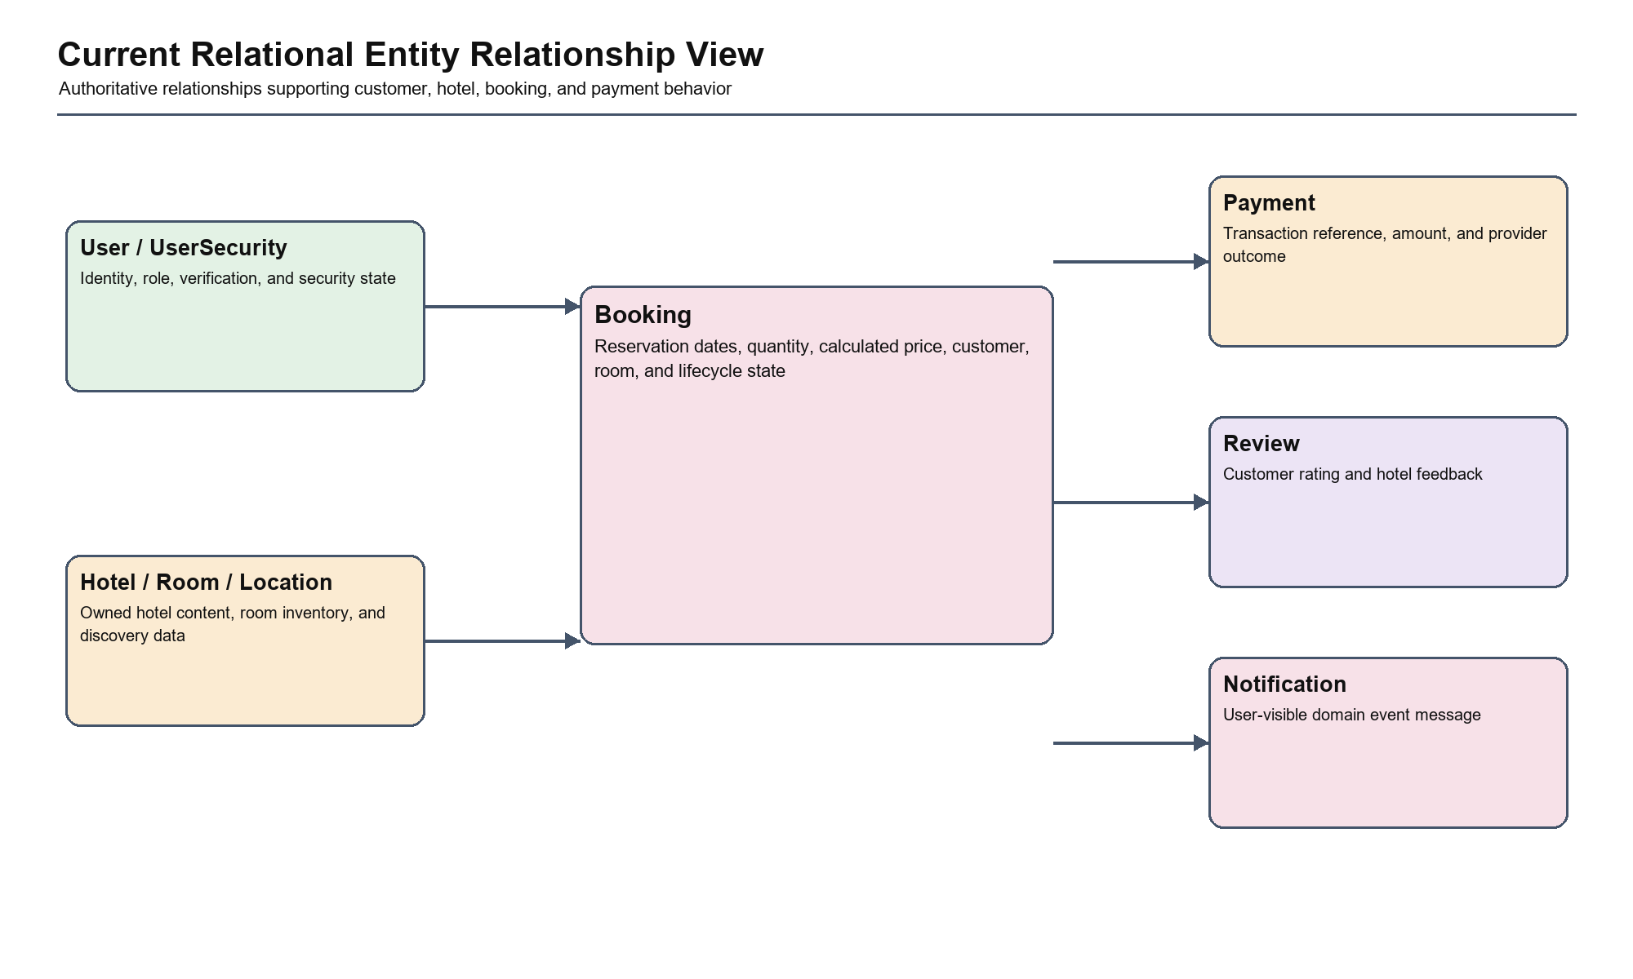
Figure 22. Current Relational Entity Relationship View
The relational view identifies Booking as the consistency-sensitive link between customer identity, room inventory, and payment outcome. The target architecture preserves MySQL as the authoritative source and places lifecycle and ownership rules above direct ORM access.

6.12.1 Entity Responsibility Table
Table 17. Entity responsibilities and risks
Entity | Responsibility | Relationships | Primary Risk
User | Account, profile, role, and ownership identity | Booking, Review, Hotel | Access control
UserSecurity | Verification, reset, attempts, and lock state | User | Credential security
Hotel | Hotel profile and owner assignment | Owner, Room, Review, Image, Location | Owner isolation
Room | Room type, price, and available inventory | Hotel, Booking, Service, Image | Overbooking
Booking | Reservation dates, quantity, price, and status | User, Room, Payment | State consistency
Payment | Transaction reference, amount, response, and status | Booking | Callback integrity
Review | Customer rating and comment | User, Hotel | Content validation
Notification | User-facing event message | User | Duplicate delivery
HotelLocation | Coordinates for nearby search | Hotel | Accuracy

6.12.2 Booking State Machine
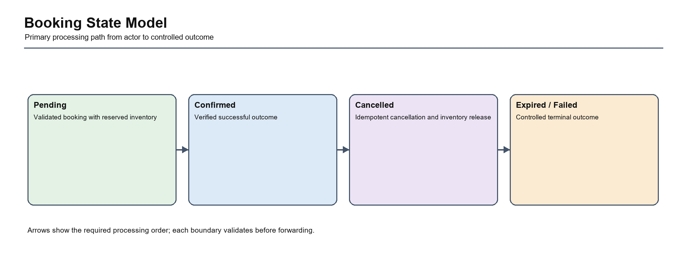
Figure 23. Booking State Model
The booking lifecycle permits only controlled transitions from a validated pending reservation to a terminal outcome. Atomic inventory handling and idempotent cancellation prevent duplicate release, negative stock, and contradictory state.

6.12.3 Payment State Machine
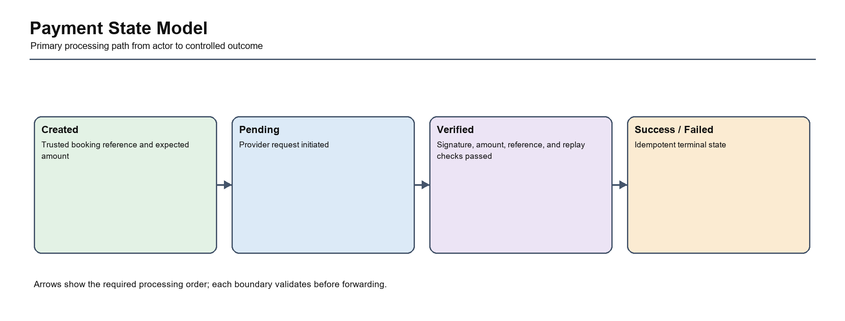
Figure 24. Payment State Model
The payment lifecycle separates an initiated provider request from a verified callback result. Payment and booking state change only after signature, reference, amount, terminal-state, and replay checks succeed.

6.12.4 Data Consistency Rules
- A booking cannot reserve more inventory than is available.
- A payment callback cannot finalize state until provider data is verified.
- Repeated callbacks and cancellations must not duplicate side effects.
- Only the owning customer can mutate a booking.
- Derived ChromaDB data never replaces relational transaction records.

6.12.5 Transaction Boundary Analysis
Table 18. Transaction boundary analysis
Use Case | Atomic Data | Required Control
Create Booking | Room inventory and Booking | Lock or conditional update in one transaction
Cancel Booking | Booking state and inventory restoration | Idempotent transition
Finalize Payment | Payment, Booking, notifications | Verified callback and idempotent finalization

6.12.6 Entity Ownership and Cardinality Analysis
Table 19. Entity ownership and cardinality analysis
Relationship | Cardinality and Ownership | Integrity Requirement
User to Booking | One customer owns many bookings | Every booking references one authenticated customer; ownership protects read and mutation
Hotel to Room | One hotel contains many room types | Room management and reporting remain inside the owning hotel scope
Room to Booking | One room type participates in many dated bookings | Inventory reservation and release must be atomic and state-aware
Booking to Payment | A booking may have payment attempts but one accepted final outcome | References, amount, terminal state, and replay behavior are controlled
User to Hotel | An owner may control multiple hotels | All owner queries apply tenant scope before aggregation
Hotel to Review | One hotel receives many customer reviews | Identity, content, rating range, and duplicate policy are validated

6.12.7 Booking and Payment Data Lifecycle
Booking and payment data lifecycle
Lifecycle Stage: Creation Booking Data: Validated dates, quantity, user, room, calculated price Payment Data: No provider outcome yet Control: Atomic inventory reservation
Lifecycle Stage: Pending Booking Data: Awaiting payment or confirmation Payment Data: Initiated reference and expected amount Control: Ownership and expiry policy
Lifecycle Stage: Provider return Booking Data: State remains protected until verification Payment Data: Untrusted callback parameters Control: Signature, amount, reference, replay verification
Lifecycle Stage: Finalization Booking Data: Confirmed or controlled failure/cancellation Payment Data: Accepted terminal status Control: Single transaction and idempotency
Lifecycle Stage: Retention Booking Data: Historical reservation record Payment Data: Financial/audit record Control: Restricted access, backup, and retention policy

6.12.8 Constraints, Indexes, and Query Design
Data constraints, indexes, and query design
Data Concern: Foreign keys Recommended Design: Enforce User, Hotel, Room, Booking, and Payment references Reason: Prevent orphan transactional records
Data Concern: Transaction reference Recommended Design: Unique indexed provider/reference key Reason: Support idempotency and fast callback lookup
Data Concern: Owner dashboards Recommended Design: Indexes aligned with hotel owner and date/status filters Reason: Avoid unbounded reporting scans
Data Concern: Availability/search Recommended Design: Indexes for hotel/location and room availability filters Reason: Keep public discovery interactive
Data Concern: Status values Recommended Design: Validated state transitions and constrained values Reason: Prevent impossible booking/payment states

6.12.9 Isolation and Concurrency Strategy
The critical concurrency scenario is two customers attempting to reserve the final available room. A read followed by an independent write is insufficient because both requests can observe the same inventory. The target transaction must use a conditional atomic update or database row lock, verify the affected row count, create the booking in the same transaction, and roll back on any failure.
Table 20. Data isolation and concurrency strategy
Scenario | Concurrency Risk | Target Strategy | Proposed Evidence
Final-room booking | Lost update and negative inventory | Conditional update or row lock | Parallel MySQL integration test
Repeated payment callback | Duplicate finalization and notifications | Unique reference and idempotent terminal-state guard | Replay callback test
Booking cancellation | Repeated inventory restoration | Idempotent transition and atomic release | Repeated cancellation test
Owner reporting during writes | Inconsistent aggregates | Defined query isolation and documented eventual/transactional expectations | Reporting consistency test

6.12.10 Data Privacy, Retention, and Recovery
Relational business data is authoritative and must be backed up, access-controlled, and recoverable. Personal data should be minimized in logs and AI prompts. Payment secrets and credential-reset material require stricter access and retention controls than public hotel content. ChromaDB contains derived retrieval data and can be rebuilt; it must never replace booking, payment, or identity records.
Data classification and retention policy
Data Class: Public content Examples: Hotel, room, service, image metadata Protection and Retention: Integrity controls and normal content lifecycle
Data Class: Personal data Examples: User profile, booking history, reviews Protection and Retention: Owner/customer scope, minimization, retention policy
Data Class: Security data Examples: Password hash, reset/verification state, audit events Protection and Retention: Restricted access, expiry, no plaintext credentials
Data Class: Financial data Examples: Payment reference, amount, provider result Protection and Retention: Auditability, restricted mutation, backup and retention
Data Class: Derived AI data Examples: FAQ vectors and conversational context Protection and Retention: Rebuildable, privacy-minimized, non-authoritative

6.12.11 Data Quality and Validation Matrix
Table 21. Data quality and validation matrix
Entity or Value | Quality Rule | Validation Boundary | Failure Handling | Verification
User identity | Unique account identity and valid role | Registration/AuthService and database constraint | Reject duplicate or invalid role | Registration and role tests
Hotel ownership | Every managed hotel has valid owner scope | ManagementService/OwnershipPolicy | Deny invalid or cross-owner operation | Tenant-isolation tests
Room inventory | Available quantity is non-negative and consistent | BookingPolicy and atomic repository mutation | Reject/rollback conflicting reservation | Stock and concurrency tests
Booking dates | Start precedes end and follows booking policy | Booking command validation | Reject before inventory mutation | Boundary-date tests
Booking price | Calculated from trusted room price, dates, and quantity | BookingService | Ignore/reject client-supplied derived value | Price-calculation tests
Payment result | Reference, amount, signature, and status are consistent | VNPayAdapter and PaymentService | Reject and audit unverified callback | Tamper/mismatch/replay tests
Review content | Valid rating, identity, hotel, and content policy | ReviewService | Reject or moderate invalid content | Review validation tests
Location data | Coordinates are in range and sufficiently accurate | HotelQueryService/location validation | Reject or omit invalid location result | Coordinate and distance tests

6.13 Cross-Module Interaction Analysis
The target modules are not independent silos. Their value comes from making cross-module collaboration explicit while preserving one owner for each decision. Authentication establishes the actor identity and session context, but it does not decide whether a customer owns a particular booking or whether an owner controls a hotel. Those resource-specific decisions belong to the authorization policy used by the relevant application service. This separation prevents authentication checks from being mistaken for complete authorization and gives route, service, and test code one consistent place to evaluate access.
The customer reservation path demonstrates the most important collaboration. Hotel and Room queries provide a read model that helps the customer choose a room, but they do not reserve inventory. BookingService receives the authenticated command, applies date, quantity, ownership, price, and state rules, and asks BookingRepository to perform the atomic inventory and booking mutation. If payment is requested, PaymentService receives the resulting trusted booking reference; it does not rebuild booking rules or accept a client-supplied amount. This sequence ensures that read-oriented discovery remains responsive while consistency-sensitive mutation remains controlled.
Payment finalization crosses an external trust boundary and therefore reverses the usual assumption that an incoming request represents user intent. VNPayAdapter first treats every callback parameter as untrusted, verifies the provider signature and normalized parameter set, and returns a verified provider result. PaymentService then checks the booking reference, expected amount, current payment and booking states, and replay conditions before committing the terminal outcome. NotificationService is invoked only after the transaction succeeds, preventing a customer from receiving a success message for a rolled-back or unverified payment.
Owner and administrator reporting interacts with the same transactional records but has different consistency and authorization requirements. ManagementService applies owner or administrator scope before ReportingRepository performs aggregation. It may read booking and payment histories, but it cannot change their state through reporting operations. The user portal follows the same principle at customer scope: profile, booking, review, notification, and transaction views use server-derived identity and return only the current user's records. These read boundaries reduce the risk that convenient dashboard queries become alternative mutation or cross-tenant access paths.
The AI assistant is deliberately positioned as a consumer of application capabilities rather than a new business authority. LangGraph routing and generated language may help identify intent or explain options, while SafeDomainTools retrieve limited domain facts. Any confirmed mutation must call the same BookingService, PaymentService, and authorization policies used by deterministic routes. Provider timeout, malformed output, unsupported intent, or prompt injection therefore cannot create a second transaction path. This interaction rule is central to preserving system integrity as AI features evolve.
Cross-module failures are handled according to transaction ownership. A failed notification or email after a committed booking is recorded and retried without reversing valid inventory state unless the business policy explicitly requires compensation. A database failure during booking or payment finalization rolls back the owning transaction before downstream events are emitted. A Gemini or ChromaDB failure returns a controlled assistant fallback while search and booking remain available. These boundaries keep recovery behavior understandable and allow regression tests, logs, and metrics to identify the module that owns each failure.

7. API Design

7.1 API Design Objectives
The API design must support existing browser workflows and JSON clients without duplicating business rules. Application services should remain the stable boundary beneath HTML and JSON interfaces.

7.2 Design Principles
- Use predictable resource and action names.
- Validate and authorize before database mutation.
- Use standard status codes and structured errors for JSON APIs.
- Do not expose internal exceptions, secrets, or password hashes.
- Treat payment callbacks and AI input as untrusted.

7.3 Consolidated API Endpoint List
Table 22. Complete Flask endpoint inventory
Method | Endpoint | Actor | Category | Description
GET | / | Public / Guest | Public | Provide the home operation within the Public capability.
GET, POST | /login | Public / Guest | Authentication | Provide the login operation within the Authentication capability.
GET, POST | /register | Public / Guest | Authentication | Provide the register operation within the Authentication capability.
GET, POST | /book/<int:room_id> | Authenticated Customer | Booking | Provide the book room operation within the Booking capability.
GET | /booking/<int:booking_id> | Authenticated Customer | Booking | Provide the booking details operation within the Booking capability.
GET | /user/my-bookings | Authenticated Customer | Booking | Provide the my bookings operation within the Booking capability.
POST | /hotel/<int:hotel_id>/review | Authenticated Customer | User Portal | Provide the review hotel operation within the User Portal capability.
GET | /hotel/<int:hotel_id> | Public / Guest | Hotel/Room | Provide the hotel details operation within the Hotel/Room capability.
GET | /logout | Authenticated Customer | Authentication | Provide the logout operation within the Authentication capability.
GET | /user | Authenticated Customer | User Portal | Provide the user profile operation within the User Portal capability.
GET | /api/room-images/<int:room_id> | Public / Guest | Hotel/Room | Provide the get room images operation within the Hotel/Room capability.
GET | /api/room-services/<int:room_id> | Public / Guest | Hotel/Room | Provide the get room services operation within the Hotel/Room capability.
GET, POST | /booking | Authenticated Customer | Booking | Provide the booking operation within the Booking capability.
POST | /payment | Authenticated Customer | Payment | Provide the create payment operation within the Payment capability.
GET | /booking/confirmation/<int:booking_id> | Authenticated Customer | Booking | Provide the booking confirmation operation within the Booking capability.
POST | /search | Public / Guest | Hotel/Room | Provide the search hotels operation within the Hotel/Room capability.
GET | /search-by-name | Public / Guest | Hotel/Room | Provide the search hotels by name operation within the Hotel/Room capability.
GET | /manage-hotels | Administrator / Owner | Owner/Admin | Provide the manage hotels operation within the Owner/Admin capability.
GET | /manage-users | Administrator / Owner | Owner/Admin | Provide the manage users operation within the Owner/Admin capability.
GET | /payment/<int:booking_id> | Authenticated Customer | Payment | Provide the payment operation within the Payment capability.
GET, POST | /hotel/edit/<int:hotel_id> | Public / Guest | Hotel/Room | Provide the edit hotel operation within the Hotel/Room capability.
GET | /statistics | Administrator / Owner | Owner/Admin | Provide the statistics operation within the Owner/Admin capability.
GET, POST | /forgot-password | Public / Guest | Authentication | Provide the forgot password operation within the Authentication capability.
GET, POST | /reset-password/<token> | Public / Guest | Authentication | Provide the reset password operation within the Authentication capability.
GET | /verify-email/<token> | Public / Guest | Authentication | Provide the verify email operation within the Authentication capability.
GET | /user/my-reviews | Authenticated Customer | User Portal | Provide the my reviews operation within the User Portal capability.
GET | /user/account-settings | Authenticated Customer | User Portal | Provide the account settings operation within the User Portal capability.
POST | /user/update-profile | Authenticated Customer | User Portal | Provide the update profile operation within the User Portal capability.
GET, POST | /user/change-password | Authenticated Customer | Authentication | Provide the change password operation within the Authentication capability.
POST | /vnpay_pay | Public / Guest | Payment | Provide the vnpay pay operation within the Payment capability.
GET | /vnpay_return | VNPay Gateway | Payment | Provide the vnpay return operation within the Payment capability.
GET | /api/user/info | Authenticated Customer | User Portal | Provide the api user info operation within the User Portal capability.
GET | /api/user/bookings | Authenticated Customer | Booking | Provide the api user bookings operation within the Booking capability.
GET, POST | /booking/<int:hotel_id>/<int:room_id> | Authenticated Customer | Booking | Provide the booking hotel room operation within the Booking capability.
POST | /api/user/update | Authenticated Customer | User Portal | Provide the api user update operation within the User Portal capability.
GET | /api/user/notifications | Authenticated Customer | User Portal | Provide the api user notifications operation within the User Portal capability.
GET | /api/user/transactions | Authenticated Customer | User Portal | Provide the api user transactions operation within the User Portal capability.
POST | /book_and_pay/<int:room_id> | Authenticated Customer | Booking | Provide the book and pay operation within the Booking capability.
GET | /debug/session | Public / Guest | Public | Provide the debug session operation within the Public capability.
GET | /api/owner/booking-history | Hotel Owner | Booking | Provide the api owner booking history operation within the Booking capability.
GET | /api/owner/room-types | Hotel Owner | Owner/Admin | Provide the api owner room types operation within the Owner/Admin capability.
GET | /api/owner/dashboard | Hotel Owner | Owner/Admin | Provide the owner dashboard operation within the Owner/Admin capability.
GET | /api/hotel/<int:hotel_id>/dashboard | Hotel Owner | Owner/Admin | Provide the hotel dashboard operation within the Owner/Admin capability.
GET | /api/hotel/<int:hotel_id>/payments | Hotel Owner | Payment | Provide the hotel payments operation within the Payment capability.
POST | /api/user/change-password | Authenticated Customer | Authentication | Provide the api change password operation within the Authentication capability.
DELETE | /api/user/booking/<int:booking_id> | Authenticated Customer | Booking | Provide the api delete booking operation within the Booking capability.
DELETE | /booking/<int:booking_id> | Authenticated Customer | Booking | Provide the delete booking operation within the Booking capability.
POST | /api/chat | User / Guest | AI Assistant | Provide the api chat operation within the AI Assistant capability.

7.4 Detailed API Specification
7.4.1 GET /
Detailed API specification: GET /
Field: Function Description: home
Field: Business Category Description: Public
Field: Actor Description: Public / Guest
Field: Purpose Description: Provide the home operation within the Public capability.
Field: Request Description: Path/query parameters and authenticated session when required.
Field: Successful Response Description: Rendered HTML page, redirect, or controlled error.
Field: Authorization Rule Description: Public only when explicitly intended; otherwise enforce Public / Guest role and resource ownership.
Field: Data Entities Description: No direct entity access identified
Field: Error Scenarios Description: Invalid input, unauthenticated request, forbidden resource, missing record, state conflict, or provider/database failure.
The current route function `home` belongs to the Public capability. In the target architecture, the route should remain a thin interface boundary: it parses and validates input, invokes one application-service operation, and translates the result into HTML, redirect, or JSON.
Security review for this endpoint must confirm actor and ownership behavior before any mutation of No direct entity access identified. Error handling should use a controlled response and log internal details with a correlation identifier.
7.4.2 GET, POST /login
Detailed API specification: GET, POST /login
Field: Function Description: login
Field: Business Category Description: Authentication
Field: Actor Description: Public / Guest
Field: Purpose Description: Provide the login operation within the Authentication capability.
Field: Request Description: Validated HTML form or JSON payload appropriate to the operation.
Field: Successful Response Description: Rendered HTML page, redirect, or controlled error.
Field: Authorization Rule Description: Public only when explicitly intended; otherwise enforce Public / Guest role and resource ownership.
Field: Data Entities Description: User
Field: Error Scenarios Description: Invalid input, unauthenticated request, forbidden resource, missing record, state conflict, or provider/database failure.
The current route function `login` belongs to the Authentication capability. In the target architecture, the route should remain a thin interface boundary: it parses and validates input, invokes one application-service operation, and translates the result into HTML, redirect, or JSON.
Security review for this endpoint must confirm actor and ownership behavior before any mutation of User. Error handling should use a controlled response and log internal details with a correlation identifier.
7.4.3 GET, POST /register
Detailed API specification: GET, POST /register
Field: Function Description: register
Field: Business Category Description: Authentication
Field: Actor Description: Public / Guest
Field: Purpose Description: Provide the register operation within the Authentication capability.
Field: Request Description: Validated HTML form or JSON payload appropriate to the operation.
Field: Successful Response Description: Rendered HTML page, redirect, or controlled error.
Field: Authorization Rule Description: Public only when explicitly intended; otherwise enforce Public / Guest role and resource ownership.
Field: Data Entities Description: User
Field: Error Scenarios Description: Invalid input, unauthenticated request, forbidden resource, missing record, state conflict, or provider/database failure.
The current route function `register` belongs to the Authentication capability. In the target architecture, the route should remain a thin interface boundary: it parses and validates input, invokes one application-service operation, and translates the result into HTML, redirect, or JSON.
Security review for this endpoint must confirm actor and ownership behavior before any mutation of User. Error handling should use a controlled response and log internal details with a correlation identifier.
7.4.4 GET, POST /book/<int:room_id>
Detailed API specification: GET, POST /book/<int:room_id>
Field: Function Description: book_room
Field: Business Category Description: Booking
Field: Actor Description: Authenticated Customer
Field: Purpose Description: Provide the book room operation within the Booking capability.
Field: Request Description: Validated HTML form or JSON payload appropriate to the operation.
Field: Successful Response Description: Rendered HTML page, redirect, or controlled error.
Field: Authorization Rule Description: Public only when explicitly intended; otherwise enforce Authenticated Customer role and resource ownership.
Field: Data Entities Description: Hotel, Service, Review, Booking
Field: Error Scenarios Description: Invalid input, unauthenticated request, forbidden resource, missing record, state conflict, or provider/database failure.
The current route function `book_room` belongs to the Booking capability. In the target architecture, the route should remain a thin interface boundary: it parses and validates input, invokes one application-service operation, and translates the result into HTML, redirect, or JSON.
Security review for this endpoint must confirm actor and ownership behavior before any mutation of Hotel, Service, Review, Booking. Error handling should use a controlled response and log internal details with a correlation identifier.
7.4.5 GET /booking/<int:booking_id>
Detailed API specification: GET /booking/<int:booking_id>
Field: Function Description: booking_details
Field: Business Category Description: Booking
Field: Actor Description: Authenticated Customer
Field: Purpose Description: Provide the booking details operation within the Booking capability.
Field: Request Description: Path/query parameters and authenticated session when required.
Field: Successful Response Description: Rendered HTML page, redirect, or controlled error.
Field: Authorization Rule Description: Public only when explicitly intended; otherwise enforce Authenticated Customer role and resource ownership.
Field: Data Entities Description: User
Field: Error Scenarios Description: Invalid input, unauthenticated request, forbidden resource, missing record, state conflict, or provider/database failure.
The current route function `booking_details` belongs to the Booking capability. In the target architecture, the route should remain a thin interface boundary: it parses and validates input, invokes one application-service operation, and translates the result into HTML, redirect, or JSON.
Security review for this endpoint must confirm actor and ownership behavior before any mutation of User. Error handling should use a controlled response and log internal details with a correlation identifier.
7.4.6 GET /user/my-bookings
Detailed API specification: GET /user/my-bookings
Field: Function Description: my_bookings
Field: Business Category Description: Booking
Field: Actor Description: Authenticated Customer
Field: Purpose Description: Provide the my bookings operation within the Booking capability.
Field: Request Description: Path/query parameters and authenticated session when required.
Field: Successful Response Description: Rendered HTML page, redirect, or controlled error.
Field: Authorization Rule Description: Public only when explicitly intended; otherwise enforce Authenticated Customer role and resource ownership.
Field: Data Entities Description: Booking
Field: Error Scenarios Description: Invalid input, unauthenticated request, forbidden resource, missing record, state conflict, or provider/database failure.
The current route function `my_bookings` belongs to the Booking capability. In the target architecture, the route should remain a thin interface boundary: it parses and validates input, invokes one application-service operation, and translates the result into HTML, redirect, or JSON.
Security review for this endpoint must confirm actor and ownership behavior before any mutation of Booking. Error handling should use a controlled response and log internal details with a correlation identifier.
7.4.7 POST /hotel/<int:hotel_id>/review
Detailed API specification: POST /hotel/<int:hotel_id>/review
Field: Function Description: review_hotel
Field: Business Category Description: User Portal
Field: Actor Description: Authenticated Customer
Field: Purpose Description: Provide the review hotel operation within the User Portal capability.
Field: Request Description: Validated HTML form or JSON payload appropriate to the operation.
Field: Successful Response Description: Rendered HTML page, redirect, or controlled error.
Field: Authorization Rule Description: Public only when explicitly intended; otherwise enforce Authenticated Customer role and resource ownership.
Field: Data Entities Description: No direct entity access identified
Field: Error Scenarios Description: Invalid input, unauthenticated request, forbidden resource, missing record, state conflict, or provider/database failure.
The current route function `review_hotel` belongs to the User Portal capability. In the target architecture, the route should remain a thin interface boundary: it parses and validates input, invokes one application-service operation, and translates the result into HTML, redirect, or JSON.
Security review for this endpoint must confirm actor and ownership behavior before any mutation of No direct entity access identified. Error handling should use a controlled response and log internal details with a correlation identifier.
7.4.8 GET /hotel/<int:hotel_id>
Detailed API specification: GET /hotel/<int:hotel_id>
Field: Function Description: hotel_details
Field: Business Category Description: Hotel/Room
Field: Actor Description: Public / Guest
Field: Purpose Description: Provide the hotel details operation within the Hotel/Room capability.
Field: Request Description: Path/query parameters and authenticated session when required.
Field: Successful Response Description: Rendered HTML page, redirect, or controlled error.
Field: Authorization Rule Description: Public only when explicitly intended; otherwise enforce Public / Guest role and resource ownership.
Field: Data Entities Description: Hotel, Room, Review, Service, HotelLocation
Field: Error Scenarios Description: Invalid input, unauthenticated request, forbidden resource, missing record, state conflict, or provider/database failure.
The current route function `hotel_details` belongs to the Hotel/Room capability. In the target architecture, the route should remain a thin interface boundary: it parses and validates input, invokes one application-service operation, and translates the result into HTML, redirect, or JSON.
Security review for this endpoint must confirm actor and ownership behavior before any mutation of Hotel, Room, Review, Service, HotelLocation. Error handling should use a controlled response and log internal details with a correlation identifier.
7.4.9 GET /logout
Detailed API specification: GET /logout
Field: Function Description: logout
Field: Business Category Description: Authentication
Field: Actor Description: Authenticated Customer
Field: Purpose Description: Provide the logout operation within the Authentication capability.
Field: Request Description: Path/query parameters and authenticated session when required.
Field: Successful Response Description: Rendered HTML page, redirect, or controlled error.
Field: Authorization Rule Description: Public only when explicitly intended; otherwise enforce Authenticated Customer role and resource ownership.
Field: Data Entities Description: No direct entity access identified
Field: Error Scenarios Description: Invalid input, unauthenticated request, forbidden resource, missing record, state conflict, or provider/database failure.
The current route function `logout` belongs to the Authentication capability. In the target architecture, the route should remain a thin interface boundary: it parses and validates input, invokes one application-service operation, and translates the result into HTML, redirect, or JSON.
Security review for this endpoint must confirm actor and ownership behavior before any mutation of No direct entity access identified. Error handling should use a controlled response and log internal details with a correlation identifier.
7.4.10 GET /user
Detailed API specification: GET /user
Field: Function Description: user_profile
Field: Business Category Description: User Portal
Field: Actor Description: Authenticated Customer
Field: Purpose Description: Provide the user profile operation within the User Portal capability.
Field: Request Description: Path/query parameters and authenticated session when required.
Field: Successful Response Description: Rendered HTML page, redirect, or controlled error.
Field: Authorization Rule Description: Public only when explicitly intended; otherwise enforce Authenticated Customer role and resource ownership.
Field: Data Entities Description: Booking, Payment
Field: Error Scenarios Description: Invalid input, unauthenticated request, forbidden resource, missing record, state conflict, or provider/database failure.
The current route function `user_profile` belongs to the User Portal capability. In the target architecture, the route should remain a thin interface boundary: it parses and validates input, invokes one application-service operation, and translates the result into HTML, redirect, or JSON.
Security review for this endpoint must confirm actor and ownership behavior before any mutation of Booking, Payment. Error handling should use a controlled response and log internal details with a correlation identifier.
7.4.11 GET /api/room-images/<int:room_id>
Detailed API specification: GET /api/room-images/<int:room_id>
Field: Function Description: get_room_images
Field: Business Category Description: Hotel/Room
Field: Actor Description: Public / Guest
Field: Purpose Description: Provide the get room images operation within the Hotel/Room capability.
Field: Request Description: Path/query parameters and authenticated session when required.
Field: Successful Response Description: JSON resource, result, or structured error response.
Field: Authorization Rule Description: Public only when explicitly intended; otherwise enforce Public / Guest role and resource ownership.
Field: Data Entities Description: No direct entity access identified
Field: Error Scenarios Description: Invalid input, unauthenticated request, forbidden resource, missing record, state conflict, or provider/database failure.
The current route function `get_room_images` belongs to the Hotel/Room capability. In the target architecture, the route should remain a thin interface boundary: it parses and validates input, invokes one application-service operation, and translates the result into HTML, redirect, or JSON.
Security review for this endpoint must confirm actor and ownership behavior before any mutation of No direct entity access identified. Error handling should use a controlled response and log internal details with a correlation identifier.
7.4.12 GET /api/room-services/<int:room_id>
Detailed API specification: GET /api/room-services/<int:room_id>
Field: Function Description: get_room_services
Field: Business Category Description: Hotel/Room
Field: Actor Description: Public / Guest
Field: Purpose Description: Provide the get room services operation within the Hotel/Room capability.
Field: Request Description: Path/query parameters and authenticated session when required.
Field: Successful Response Description: JSON resource, result, or structured error response.
Field: Authorization Rule Description: Public only when explicitly intended; otherwise enforce Public / Guest role and resource ownership.
Field: Data Entities Description: Service, Room
Field: Error Scenarios Description: Invalid input, unauthenticated request, forbidden resource, missing record, state conflict, or provider/database failure.
The current route function `get_room_services` belongs to the Hotel/Room capability. In the target architecture, the route should remain a thin interface boundary: it parses and validates input, invokes one application-service operation, and translates the result into HTML, redirect, or JSON.
Security review for this endpoint must confirm actor and ownership behavior before any mutation of Service, Room. Error handling should use a controlled response and log internal details with a correlation identifier.
7.4.13 GET, POST /booking
Detailed API specification: GET, POST /booking
Field: Function Description: booking
Field: Business Category Description: Booking
Field: Actor Description: Authenticated Customer
Field: Purpose Description: Provide the booking operation within the Booking capability.
Field: Request Description: Validated HTML form or JSON payload appropriate to the operation.
Field: Successful Response Description: Rendered HTML page, redirect, or controlled error.
Field: Authorization Rule Description: Public only when explicitly intended; otherwise enforce Authenticated Customer role and resource ownership.
Field: Data Entities Description: No direct entity access identified
Field: Error Scenarios Description: Invalid input, unauthenticated request, forbidden resource, missing record, state conflict, or provider/database failure.
The current route function `booking` belongs to the Booking capability. In the target architecture, the route should remain a thin interface boundary: it parses and validates input, invokes one application-service operation, and translates the result into HTML, redirect, or JSON.
Security review for this endpoint must confirm actor and ownership behavior before any mutation of No direct entity access identified. Error handling should use a controlled response and log internal details with a correlation identifier.
7.4.14 POST /payment
Detailed API specification: POST /payment
Field: Function Description: create_payment
Field: Business Category Description: Payment
Field: Actor Description: Authenticated Customer
Field: Purpose Description: Provide the create payment operation within the Payment capability.
Field: Request Description: Validated HTML form or JSON payload appropriate to the operation.
Field: Successful Response Description: Rendered HTML page, redirect, or controlled error.
Field: Authorization Rule Description: Public only when explicitly intended; otherwise enforce Authenticated Customer role and resource ownership.
Field: Data Entities Description: Room, Booking
Field: Error Scenarios Description: Invalid input, unauthenticated request, forbidden resource, missing record, state conflict, or provider/database failure.
The current route function `create_payment` belongs to the Payment capability. In the target architecture, the route should remain a thin interface boundary: it parses and validates input, invokes one application-service operation, and translates the result into HTML, redirect, or JSON.
Security review for this endpoint must confirm actor and ownership behavior before any mutation of Room, Booking. Error handling should use a controlled response and log internal details with a correlation identifier.
7.4.15 GET /booking/confirmation/<int:booking_id>
Detailed API specification: GET /booking/confirmation/<int:booking_id>
Field: Function Description: booking_confirmation
Field: Business Category Description: Booking
Field: Actor Description: Authenticated Customer
Field: Purpose Description: Provide the booking confirmation operation within the Booking capability.
Field: Request Description: Path/query parameters and authenticated session when required.
Field: Successful Response Description: Rendered HTML page, redirect, or controlled error.
Field: Authorization Rule Description: Public only when explicitly intended; otherwise enforce Authenticated Customer role and resource ownership.
Field: Data Entities Description: Booking
Field: Error Scenarios Description: Invalid input, unauthenticated request, forbidden resource, missing record, state conflict, or provider/database failure.
The current route function `booking_confirmation` belongs to the Booking capability. In the target architecture, the route should remain a thin interface boundary: it parses and validates input, invokes one application-service operation, and translates the result into HTML, redirect, or JSON.
Security review for this endpoint must confirm actor and ownership behavior before any mutation of Booking. Error handling should use a controlled response and log internal details with a correlation identifier.
7.4.16 POST /search
Detailed API specification: POST /search
Field: Function Description: search_hotels
Field: Business Category Description: Hotel/Room
Field: Actor Description: Public / Guest
Field: Purpose Description: Provide the search hotels operation within the Hotel/Room capability.
Field: Request Description: Validated HTML form or JSON payload appropriate to the operation.
Field: Successful Response Description: Rendered HTML page, redirect, or controlled error.
Field: Authorization Rule Description: Public only when explicitly intended; otherwise enforce Public / Guest role and resource ownership.
Field: Data Entities Description: Hotel
Field: Error Scenarios Description: Invalid input, unauthenticated request, forbidden resource, missing record, state conflict, or provider/database failure.
The current route function `search_hotels` belongs to the Hotel/Room capability. In the target architecture, the route should remain a thin interface boundary: it parses and validates input, invokes one application-service operation, and translates the result into HTML, redirect, or JSON.
Security review for this endpoint must confirm actor and ownership behavior before any mutation of Hotel. Error handling should use a controlled response and log internal details with a correlation identifier.
7.4.17 GET /search-by-name
Detailed API specification: GET /search-by-name
Field: Function Description: search_hotels_by_name
Field: Business Category Description: Hotel/Room
Field: Actor Description: Public / Guest
Field: Purpose Description: Provide the search hotels by name operation within the Hotel/Room capability.
Field: Request Description: Path/query parameters and authenticated session when required.
Field: Successful Response Description: Rendered HTML page, redirect, or controlled error.
Field: Authorization Rule Description: Public only when explicitly intended; otherwise enforce Public / Guest role and resource ownership.
Field: Data Entities Description: No direct entity access identified
Field: Error Scenarios Description: Invalid input, unauthenticated request, forbidden resource, missing record, state conflict, or provider/database failure.
The current route function `search_hotels_by_name` belongs to the Hotel/Room capability. In the target architecture, the route should remain a thin interface boundary: it parses and validates input, invokes one application-service operation, and translates the result into HTML, redirect, or JSON.
Security review for this endpoint must confirm actor and ownership behavior before any mutation of No direct entity access identified. Error handling should use a controlled response and log internal details with a correlation identifier.
7.4.18 GET /manage-hotels
Detailed API specification: GET /manage-hotels
Field: Function Description: manage_hotels
Field: Business Category Description: Owner/Admin
Field: Actor Description: Administrator / Owner
Field: Purpose Description: Provide the manage hotels operation within the Owner/Admin capability.
Field: Request Description: Path/query parameters and authenticated session when required.
Field: Successful Response Description: Rendered HTML page, redirect, or controlled error.
Field: Authorization Rule Description: Public only when explicitly intended; otherwise enforce Administrator / Owner role and resource ownership.
Field: Data Entities Description: Hotel
Field: Error Scenarios Description: Invalid input, unauthenticated request, forbidden resource, missing record, state conflict, or provider/database failure.
The current route function `manage_hotels` belongs to the Owner/Admin capability. In the target architecture, the route should remain a thin interface boundary: it parses and validates input, invokes one application-service operation, and translates the result into HTML, redirect, or JSON.
Security review for this endpoint must confirm actor and ownership behavior before any mutation of Hotel. Error handling should use a controlled response and log internal details with a correlation identifier.
7.4.19 GET /manage-users
Detailed API specification: GET /manage-users
Field: Function Description: manage_users
Field: Business Category Description: Owner/Admin
Field: Actor Description: Administrator / Owner
Field: Purpose Description: Provide the manage users operation within the Owner/Admin capability.
Field: Request Description: Path/query parameters and authenticated session when required.
Field: Successful Response Description: Rendered HTML page, redirect, or controlled error.
Field: Authorization Rule Description: Public only when explicitly intended; otherwise enforce Administrator / Owner role and resource ownership.
Field: Data Entities Description: User
Field: Error Scenarios Description: Invalid input, unauthenticated request, forbidden resource, missing record, state conflict, or provider/database failure.
The current route function `manage_users` belongs to the Owner/Admin capability. In the target architecture, the route should remain a thin interface boundary: it parses and validates input, invokes one application-service operation, and translates the result into HTML, redirect, or JSON.
Security review for this endpoint must confirm actor and ownership behavior before any mutation of User. Error handling should use a controlled response and log internal details with a correlation identifier.
7.4.20 GET /payment/<int:booking_id>
Detailed API specification: GET /payment/<int:booking_id>
Field: Function Description: payment
Field: Business Category Description: Payment
Field: Actor Description: Authenticated Customer
Field: Purpose Description: Provide the payment operation within the Payment capability.
Field: Request Description: Path/query parameters and authenticated session when required.
Field: Successful Response Description: Rendered HTML page, redirect, or controlled error.
Field: Authorization Rule Description: Public only when explicitly intended; otherwise enforce Authenticated Customer role and resource ownership.
Field: Data Entities Description: Booking
Field: Error Scenarios Description: Invalid input, unauthenticated request, forbidden resource, missing record, state conflict, or provider/database failure.
The current route function `payment` belongs to the Payment capability. In the target architecture, the route should remain a thin interface boundary: it parses and validates input, invokes one application-service operation, and translates the result into HTML, redirect, or JSON.
Security review for this endpoint must confirm actor and ownership behavior before any mutation of Booking. Error handling should use a controlled response and log internal details with a correlation identifier.
7.4.21 GET, POST /hotel/edit/<int:hotel_id>
Detailed API specification: GET, POST /hotel/edit/<int:hotel_id>
Field: Function Description: edit_hotel
Field: Business Category Description: Hotel/Room
Field: Actor Description: Public / Guest
Field: Purpose Description: Provide the edit hotel operation within the Hotel/Room capability.
Field: Request Description: Validated HTML form or JSON payload appropriate to the operation.
Field: Successful Response Description: Rendered HTML page, redirect, or controlled error.
Field: Authorization Rule Description: Public only when explicitly intended; otherwise enforce Public / Guest role and resource ownership.
Field: Data Entities Description: Hotel
Field: Error Scenarios Description: Invalid input, unauthenticated request, forbidden resource, missing record, state conflict, or provider/database failure.
The current route function `edit_hotel` belongs to the Hotel/Room capability. In the target architecture, the route should remain a thin interface boundary: it parses and validates input, invokes one application-service operation, and translates the result into HTML, redirect, or JSON.
Security review for this endpoint must confirm actor and ownership behavior before any mutation of Hotel. Error handling should use a controlled response and log internal details with a correlation identifier.
7.4.22 GET /statistics
Detailed API specification: GET /statistics
Field: Function Description: statistics
Field: Business Category Description: Owner/Admin
Field: Actor Description: Administrator / Owner
Field: Purpose Description: Provide the statistics operation within the Owner/Admin capability.
Field: Request Description: Path/query parameters and authenticated session when required.
Field: Successful Response Description: Rendered HTML page, redirect, or controlled error.
Field: Authorization Rule Description: Public only when explicitly intended; otherwise enforce Administrator / Owner role and resource ownership.
Field: Data Entities Description: User, Hotel, Booking, Room
Field: Error Scenarios Description: Invalid input, unauthenticated request, forbidden resource, missing record, state conflict, or provider/database failure.
The current route function `statistics` belongs to the Owner/Admin capability. In the target architecture, the route should remain a thin interface boundary: it parses and validates input, invokes one application-service operation, and translates the result into HTML, redirect, or JSON.
Security review for this endpoint must confirm actor and ownership behavior before any mutation of User, Hotel, Booking, Room. Error handling should use a controlled response and log internal details with a correlation identifier.
7.4.23 GET, POST /forgot-password
Detailed API specification: GET, POST /forgot-password
Field: Function Description: forgot_password
Field: Business Category Description: Authentication
Field: Actor Description: Public / Guest
Field: Purpose Description: Provide the forgot password operation within the Authentication capability.
Field: Request Description: Validated HTML form or JSON payload appropriate to the operation.
Field: Successful Response Description: Rendered HTML page, redirect, or controlled error.
Field: Authorization Rule Description: Public only when explicitly intended; otherwise enforce Public / Guest role and resource ownership.
Field: Data Entities Description: User, UserSecurity
Field: Error Scenarios Description: Invalid input, unauthenticated request, forbidden resource, missing record, state conflict, or provider/database failure.
The current route function `forgot_password` belongs to the Authentication capability. In the target architecture, the route should remain a thin interface boundary: it parses and validates input, invokes one application-service operation, and translates the result into HTML, redirect, or JSON.
Security review for this endpoint must confirm actor and ownership behavior before any mutation of User, UserSecurity. Error handling should use a controlled response and log internal details with a correlation identifier.
7.4.24 GET, POST /reset-password/<token>
Detailed API specification: GET, POST /reset-password/<token>
Field: Function Description: reset_password
Field: Business Category Description: Authentication
Field: Actor Description: Public / Guest
Field: Purpose Description: Provide the reset password operation within the Authentication capability.
Field: Request Description: Validated HTML form or JSON payload appropriate to the operation.
Field: Successful Response Description: Rendered HTML page, redirect, or controlled error.
Field: Authorization Rule Description: Public only when explicitly intended; otherwise enforce Public / Guest role and resource ownership.
Field: Data Entities Description: UserSecurity
Field: Error Scenarios Description: Invalid input, unauthenticated request, forbidden resource, missing record, state conflict, or provider/database failure.
The current route function `reset_password` belongs to the Authentication capability. In the target architecture, the route should remain a thin interface boundary: it parses and validates input, invokes one application-service operation, and translates the result into HTML, redirect, or JSON.
Security review for this endpoint must confirm actor and ownership behavior before any mutation of UserSecurity. Error handling should use a controlled response and log internal details with a correlation identifier.
7.4.25 GET /verify-email/<token>
Detailed API specification: GET /verify-email/<token>
Field: Function Description: verify_email
Field: Business Category Description: Authentication
Field: Actor Description: Public / Guest
Field: Purpose Description: Provide the verify email operation within the Authentication capability.
Field: Request Description: Path/query parameters and authenticated session when required.
Field: Successful Response Description: Rendered HTML page, redirect, or controlled error.
Field: Authorization Rule Description: Public only when explicitly intended; otherwise enforce Public / Guest role and resource ownership.
Field: Data Entities Description: UserSecurity
Field: Error Scenarios Description: Invalid input, unauthenticated request, forbidden resource, missing record, state conflict, or provider/database failure.
The current route function `verify_email` belongs to the Authentication capability. In the target architecture, the route should remain a thin interface boundary: it parses and validates input, invokes one application-service operation, and translates the result into HTML, redirect, or JSON.
Security review for this endpoint must confirm actor and ownership behavior before any mutation of UserSecurity. Error handling should use a controlled response and log internal details with a correlation identifier.
7.4.26 GET /user/my-reviews
Detailed API specification: GET /user/my-reviews
Field: Function Description: my_reviews
Field: Business Category Description: User Portal
Field: Actor Description: Authenticated Customer
Field: Purpose Description: Provide the my reviews operation within the User Portal capability.
Field: Request Description: Path/query parameters and authenticated session when required.
Field: Successful Response Description: Rendered HTML page, redirect, or controlled error.
Field: Authorization Rule Description: Public only when explicitly intended; otherwise enforce Authenticated Customer role and resource ownership.
Field: Data Entities Description: Review
Field: Error Scenarios Description: Invalid input, unauthenticated request, forbidden resource, missing record, state conflict, or provider/database failure.
The current route function `my_reviews` belongs to the User Portal capability. In the target architecture, the route should remain a thin interface boundary: it parses and validates input, invokes one application-service operation, and translates the result into HTML, redirect, or JSON.
Security review for this endpoint must confirm actor and ownership behavior before any mutation of Review. Error handling should use a controlled response and log internal details with a correlation identifier.
7.4.27 GET /user/account-settings
Detailed API specification: GET /user/account-settings
Field: Function Description: account_settings
Field: Business Category Description: User Portal
Field: Actor Description: Authenticated Customer
Field: Purpose Description: Provide the account settings operation within the User Portal capability.
Field: Request Description: Path/query parameters and authenticated session when required.
Field: Successful Response Description: Rendered HTML page, redirect, or controlled error.
Field: Authorization Rule Description: Public only when explicitly intended; otherwise enforce Authenticated Customer role and resource ownership.
Field: Data Entities Description: No direct entity access identified
Field: Error Scenarios Description: Invalid input, unauthenticated request, forbidden resource, missing record, state conflict, or provider/database failure.
The current route function `account_settings` belongs to the User Portal capability. In the target architecture, the route should remain a thin interface boundary: it parses and validates input, invokes one application-service operation, and translates the result into HTML, redirect, or JSON.
Security review for this endpoint must confirm actor and ownership behavior before any mutation of No direct entity access identified. Error handling should use a controlled response and log internal details with a correlation identifier.
7.4.28 POST /user/update-profile
Detailed API specification: POST /user/update-profile
Field: Function Description: update_profile
Field: Business Category Description: User Portal
Field: Actor Description: Authenticated Customer
Field: Purpose Description: Provide the update profile operation within the User Portal capability.
Field: Request Description: Validated HTML form or JSON payload appropriate to the operation.
Field: Successful Response Description: Rendered HTML page, redirect, or controlled error.
Field: Authorization Rule Description: Public only when explicitly intended; otherwise enforce Authenticated Customer role and resource ownership.
Field: Data Entities Description: No direct entity access identified
Field: Error Scenarios Description: Invalid input, unauthenticated request, forbidden resource, missing record, state conflict, or provider/database failure.
The current route function `update_profile` belongs to the User Portal capability. In the target architecture, the route should remain a thin interface boundary: it parses and validates input, invokes one application-service operation, and translates the result into HTML, redirect, or JSON.
Security review for this endpoint must confirm actor and ownership behavior before any mutation of No direct entity access identified. Error handling should use a controlled response and log internal details with a correlation identifier.
7.4.29 GET, POST /user/change-password
Detailed API specification: GET, POST /user/change-password
Field: Function Description: change_password
Field: Business Category Description: Authentication
Field: Actor Description: Authenticated Customer
Field: Purpose Description: Provide the change password operation within the Authentication capability.
Field: Request Description: Validated HTML form or JSON payload appropriate to the operation.
Field: Successful Response Description: Rendered HTML page, redirect, or controlled error.
Field: Authorization Rule Description: Public only when explicitly intended; otherwise enforce Authenticated Customer role and resource ownership.
Field: Data Entities Description: No direct entity access identified
Field: Error Scenarios Description: Invalid input, unauthenticated request, forbidden resource, missing record, state conflict, or provider/database failure.
The current route function `change_password` belongs to the Authentication capability. In the target architecture, the route should remain a thin interface boundary: it parses and validates input, invokes one application-service operation, and translates the result into HTML, redirect, or JSON.
Security review for this endpoint must confirm actor and ownership behavior before any mutation of No direct entity access identified. Error handling should use a controlled response and log internal details with a correlation identifier.
7.4.30 POST /vnpay_pay
Detailed API specification: POST /vnpay_pay
Field: Function Description: vnpay_pay
Field: Business Category Description: Payment
Field: Actor Description: Public / Guest
Field: Purpose Description: Provide the vnpay pay operation within the Payment capability.
Field: Request Description: Form: booking_id.
Field: Successful Response Description: Redirect to a signed VNPay sandbox URL.
Field: Authorization Rule Description: Public only when explicitly intended; otherwise enforce Public / Guest role and resource ownership.
Field: Data Entities Description: Booking, Room, Payment
Field: Error Scenarios Description: Invalid input, unauthenticated request, forbidden resource, missing record, state conflict, or provider/database failure.
The current route function `vnpay_pay` belongs to the Payment capability. In the target architecture, the route should remain a thin interface boundary: it parses and validates input, invokes one application-service operation, and translates the result into HTML, redirect, or JSON.
Security review for this endpoint must confirm actor and ownership behavior before any mutation of Booking, Room, Payment. Error handling should use a controlled response and log internal details with a correlation identifier.
7.4.31 GET /vnpay_return
Detailed API specification: GET /vnpay_return
Field: Function Description: vnpay_return
Field: Business Category Description: Payment
Field: Actor Description: VNPay Gateway
Field: Purpose Description: Provide the vnpay return operation within the Payment capability.
Field: Request Description: Path/query parameters and authenticated session when required.
Field: Successful Response Description: Payment result page/script after state synchronization.
Field: Authorization Rule Description: Public only when explicitly intended; otherwise enforce VNPay Gateway role and resource ownership.
Field: Data Entities Description: Payment, Booking, Room, User, Hotel, Notification
Field: Error Scenarios Description: Invalid input, unauthenticated request, forbidden resource, missing record, state conflict, or provider/database failure.
The current route function `vnpay_return` belongs to the Payment capability. In the target architecture, the route should remain a thin interface boundary: it parses and validates input, invokes one application-service operation, and translates the result into HTML, redirect, or JSON.
Security review for this endpoint must confirm actor and ownership behavior before any mutation of Payment, Booking, Room, User, Hotel, Notification. Error handling should use a controlled response and log internal details with a correlation identifier.
7.4.32 GET /api/user/info
Detailed API specification: GET /api/user/info
Field: Function Description: api_user_info
Field: Business Category Description: User Portal
Field: Actor Description: Authenticated Customer
Field: Purpose Description: Provide the api user info operation within the User Portal capability.
Field: Request Description: Path/query parameters and authenticated session when required.
Field: Successful Response Description: JSON resource, result, or structured error response.
Field: Authorization Rule Description: Public only when explicitly intended; otherwise enforce Authenticated Customer role and resource ownership.
Field: Data Entities Description: No direct entity access identified
Field: Error Scenarios Description: Invalid input, unauthenticated request, forbidden resource, missing record, state conflict, or provider/database failure.
The current route function `api_user_info` belongs to the User Portal capability. In the target architecture, the route should remain a thin interface boundary: it parses and validates input, invokes one application-service operation, and translates the result into HTML, redirect, or JSON.
Security review for this endpoint must confirm actor and ownership behavior before any mutation of No direct entity access identified. Error handling should use a controlled response and log internal details with a correlation identifier.
7.4.33 GET /api/user/bookings
Detailed API specification: GET /api/user/bookings
Field: Function Description: api_user_bookings
Field: Business Category Description: Booking
Field: Actor Description: Authenticated Customer
Field: Purpose Description: Provide the api user bookings operation within the Booking capability.
Field: Request Description: Path/query parameters and authenticated session when required.
Field: Successful Response Description: JSON resource, result, or structured error response.
Field: Authorization Rule Description: Public only when explicitly intended; otherwise enforce Authenticated Customer role and resource ownership.
Field: Data Entities Description: Booking, Room, Hotel, Payment
Field: Error Scenarios Description: Invalid input, unauthenticated request, forbidden resource, missing record, state conflict, or provider/database failure.
The current route function `api_user_bookings` belongs to the Booking capability. In the target architecture, the route should remain a thin interface boundary: it parses and validates input, invokes one application-service operation, and translates the result into HTML, redirect, or JSON.
Security review for this endpoint must confirm actor and ownership behavior before any mutation of Booking, Room, Hotel, Payment. Error handling should use a controlled response and log internal details with a correlation identifier.
7.4.34 GET, POST /booking/<int:hotel_id>/<int:room_id>
Detailed API specification: GET, POST /booking/<int:hotel_id>/<int:room_id>
Field: Function Description: booking_hotel_room
Field: Business Category Description: Booking
Field: Actor Description: Authenticated Customer
Field: Purpose Description: Provide the booking hotel room operation within the Booking capability.
Field: Request Description: Validated HTML form or JSON payload appropriate to the operation.
Field: Successful Response Description: Rendered HTML page, redirect, or controlled error.
Field: Authorization Rule Description: Public only when explicitly intended; otherwise enforce Authenticated Customer role and resource ownership.
Field: Data Entities Description: Hotel, Room
Field: Error Scenarios Description: Invalid input, unauthenticated request, forbidden resource, missing record, state conflict, or provider/database failure.
The current route function `booking_hotel_room` belongs to the Booking capability. In the target architecture, the route should remain a thin interface boundary: it parses and validates input, invokes one application-service operation, and translates the result into HTML, redirect, or JSON.
Security review for this endpoint must confirm actor and ownership behavior before any mutation of Hotel, Room. Error handling should use a controlled response and log internal details with a correlation identifier.
7.4.35 POST /api/user/update
Detailed API specification: POST /api/user/update
Field: Function Description: api_user_update
Field: Business Category Description: User Portal
Field: Actor Description: Authenticated Customer
Field: Purpose Description: Provide the api user update operation within the User Portal capability.
Field: Request Description: Validated HTML form or JSON payload appropriate to the operation.
Field: Successful Response Description: JSON resource, result, or structured error response.
Field: Authorization Rule Description: Public only when explicitly intended; otherwise enforce Authenticated Customer role and resource ownership.
Field: Data Entities Description: User
Field: Error Scenarios Description: Invalid input, unauthenticated request, forbidden resource, missing record, state conflict, or provider/database failure.
The current route function `api_user_update` belongs to the User Portal capability. In the target architecture, the route should remain a thin interface boundary: it parses and validates input, invokes one application-service operation, and translates the result into HTML, redirect, or JSON.
Security review for this endpoint must confirm actor and ownership behavior before any mutation of User. Error handling should use a controlled response and log internal details with a correlation identifier.
7.4.36 GET /api/user/notifications
Detailed API specification: GET /api/user/notifications
Field: Function Description: api_user_notifications
Field: Business Category Description: User Portal
Field: Actor Description: Authenticated Customer
Field: Purpose Description: Provide the api user notifications operation within the User Portal capability.
Field: Request Description: Path/query parameters and authenticated session when required.
Field: Successful Response Description: JSON resource, result, or structured error response.
Field: Authorization Rule Description: Public only when explicitly intended; otherwise enforce Authenticated Customer role and resource ownership.
Field: Data Entities Description: Notification
Field: Error Scenarios Description: Invalid input, unauthenticated request, forbidden resource, missing record, state conflict, or provider/database failure.
The current route function `api_user_notifications` belongs to the User Portal capability. In the target architecture, the route should remain a thin interface boundary: it parses and validates input, invokes one application-service operation, and translates the result into HTML, redirect, or JSON.
Security review for this endpoint must confirm actor and ownership behavior before any mutation of Notification. Error handling should use a controlled response and log internal details with a correlation identifier.
7.4.37 GET /api/user/transactions
Detailed API specification: GET /api/user/transactions
Field: Function Description: api_user_transactions
Field: Business Category Description: User Portal
Field: Actor Description: Authenticated Customer
Field: Purpose Description: Provide the api user transactions operation within the User Portal capability.
Field: Request Description: Path/query parameters and authenticated session when required.
Field: Successful Response Description: JSON resource, result, or structured error response.
Field: Authorization Rule Description: Public only when explicitly intended; otherwise enforce Authenticated Customer role and resource ownership.
Field: Data Entities Description: Payment, Booking, Room, Hotel
Field: Error Scenarios Description: Invalid input, unauthenticated request, forbidden resource, missing record, state conflict, or provider/database failure.
The current route function `api_user_transactions` belongs to the User Portal capability. In the target architecture, the route should remain a thin interface boundary: it parses and validates input, invokes one application-service operation, and translates the result into HTML, redirect, or JSON.
Security review for this endpoint must confirm actor and ownership behavior before any mutation of Payment, Booking, Room, Hotel. Error handling should use a controlled response and log internal details with a correlation identifier.
7.4.38 POST /book_and_pay/<int:room_id>
Detailed API specification: POST /book_and_pay/<int:room_id>
Field: Function Description: book_and_pay
Field: Business Category Description: Booking
Field: Actor Description: Authenticated Customer
Field: Purpose Description: Provide the book and pay operation within the Booking capability.
Field: Request Description: Validated HTML form or JSON payload appropriate to the operation.
Field: Successful Response Description: Rendered HTML page, redirect, or controlled error.
Field: Authorization Rule Description: Public only when explicitly intended; otherwise enforce Authenticated Customer role and resource ownership.
Field: Data Entities Description: Room, Booking
Field: Error Scenarios Description: Invalid input, unauthenticated request, forbidden resource, missing record, state conflict, or provider/database failure.
The current route function `book_and_pay` belongs to the Booking capability. In the target architecture, the route should remain a thin interface boundary: it parses and validates input, invokes one application-service operation, and translates the result into HTML, redirect, or JSON.
Security review for this endpoint must confirm actor and ownership behavior before any mutation of Room, Booking. Error handling should use a controlled response and log internal details with a correlation identifier.
7.4.39 GET /debug/session
Detailed API specification: GET /debug/session
Field: Function Description: debug_session
Field: Business Category Description: Public
Field: Actor Description: Public / Guest
Field: Purpose Description: Provide the debug session operation within the Public capability.
Field: Request Description: Path/query parameters and authenticated session when required.
Field: Successful Response Description: Rendered HTML page, redirect, or controlled error.
Field: Authorization Rule Description: Public only when explicitly intended; otherwise enforce Public / Guest role and resource ownership.
Field: Data Entities Description: No direct entity access identified
Field: Error Scenarios Description: Invalid input, unauthenticated request, forbidden resource, missing record, state conflict, or provider/database failure.
The current route function `debug_session` belongs to the Public capability. In the target architecture, the route should remain a thin interface boundary: it parses and validates input, invokes one application-service operation, and translates the result into HTML, redirect, or JSON.
Security review for this endpoint must confirm actor and ownership behavior before any mutation of No direct entity access identified. Error handling should use a controlled response and log internal details with a correlation identifier.
7.4.40 GET /api/owner/booking-history
Detailed API specification: GET /api/owner/booking-history
Field: Function Description: api_owner_booking_history
Field: Business Category Description: Booking
Field: Actor Description: Hotel Owner
Field: Purpose Description: Provide the api owner booking history operation within the Booking capability.
Field: Request Description: Path/query parameters and authenticated session when required.
Field: Successful Response Description: JSON resource, result, or structured error response.
Field: Authorization Rule Description: Public only when explicitly intended; otherwise enforce Hotel Owner role and resource ownership.
Field: Data Entities Description: Booking, User, Payment
Field: Error Scenarios Description: Invalid input, unauthenticated request, forbidden resource, missing record, state conflict, or provider/database failure.
The current route function `api_owner_booking_history` belongs to the Booking capability. In the target architecture, the route should remain a thin interface boundary: it parses and validates input, invokes one application-service operation, and translates the result into HTML, redirect, or JSON.
Security review for this endpoint must confirm actor and ownership behavior before any mutation of Booking, User, Payment. Error handling should use a controlled response and log internal details with a correlation identifier.
7.4.41 GET /api/owner/room-types
Detailed API specification: GET /api/owner/room-types
Field: Function Description: api_owner_room_types
Field: Business Category Description: Owner/Admin
Field: Actor Description: Hotel Owner
Field: Purpose Description: Provide the api owner room types operation within the Owner/Admin capability.
Field: Request Description: Path/query parameters and authenticated session when required.
Field: Successful Response Description: JSON resource, result, or structured error response.
Field: Authorization Rule Description: Public only when explicitly intended; otherwise enforce Hotel Owner role and resource ownership.
Field: Data Entities Description: Booking
Field: Error Scenarios Description: Invalid input, unauthenticated request, forbidden resource, missing record, state conflict, or provider/database failure.
The current route function `api_owner_room_types` belongs to the Owner/Admin capability. In the target architecture, the route should remain a thin interface boundary: it parses and validates input, invokes one application-service operation, and translates the result into HTML, redirect, or JSON.
Security review for this endpoint must confirm actor and ownership behavior before any mutation of Booking. Error handling should use a controlled response and log internal details with a correlation identifier.
7.4.42 GET /api/owner/dashboard
Detailed API specification: GET /api/owner/dashboard
Field: Function Description: owner_dashboard
Field: Business Category Description: Owner/Admin
Field: Actor Description: Hotel Owner
Field: Purpose Description: Provide the owner dashboard operation within the Owner/Admin capability.
Field: Request Description: Path/query parameters and authenticated session when required.
Field: Successful Response Description: JSON resource, result, or structured error response.
Field: Authorization Rule Description: Public only when explicitly intended; otherwise enforce Hotel Owner role and resource ownership.
Field: Data Entities Description: Booking, Payment
Field: Error Scenarios Description: Invalid input, unauthenticated request, forbidden resource, missing record, state conflict, or provider/database failure.
The current route function `owner_dashboard` belongs to the Owner/Admin capability. In the target architecture, the route should remain a thin interface boundary: it parses and validates input, invokes one application-service operation, and translates the result into HTML, redirect, or JSON.
Security review for this endpoint must confirm actor and ownership behavior before any mutation of Booking, Payment. Error handling should use a controlled response and log internal details with a correlation identifier.
7.4.43 GET /api/hotel/<int:hotel_id>/dashboard
Detailed API specification: GET /api/hotel/<int:hotel_id>/dashboard
Field: Function Description: hotel_dashboard
Field: Business Category Description: Owner/Admin
Field: Actor Description: Hotel Owner
Field: Purpose Description: Provide the hotel dashboard operation within the Owner/Admin capability.
Field: Request Description: Path/query parameters and authenticated session when required.
Field: Successful Response Description: JSON resource, result, or structured error response.
Field: Authorization Rule Description: Public only when explicitly intended; otherwise enforce Hotel Owner role and resource ownership.
Field: Data Entities Description: Hotel, Room, Booking, Payment
Field: Error Scenarios Description: Invalid input, unauthenticated request, forbidden resource, missing record, state conflict, or provider/database failure.
The current route function `hotel_dashboard` belongs to the Owner/Admin capability. In the target architecture, the route should remain a thin interface boundary: it parses and validates input, invokes one application-service operation, and translates the result into HTML, redirect, or JSON.
Security review for this endpoint must confirm actor and ownership behavior before any mutation of Hotel, Room, Booking, Payment. Error handling should use a controlled response and log internal details with a correlation identifier.
7.4.44 GET /api/hotel/<int:hotel_id>/payments
Detailed API specification: GET /api/hotel/<int:hotel_id>/payments
Field: Function Description: hotel_payments
Field: Business Category Description: Payment
Field: Actor Description: Hotel Owner
Field: Purpose Description: Provide the hotel payments operation within the Payment capability.
Field: Request Description: Path/query parameters and authenticated session when required.
Field: Successful Response Description: JSON resource, result, or structured error response.
Field: Authorization Rule Description: Public only when explicitly intended; otherwise enforce Hotel Owner role and resource ownership.
Field: Data Entities Description: Hotel, Booking, Room, Payment, User
Field: Error Scenarios Description: Invalid input, unauthenticated request, forbidden resource, missing record, state conflict, or provider/database failure.
The current route function `hotel_payments` belongs to the Payment capability. In the target architecture, the route should remain a thin interface boundary: it parses and validates input, invokes one application-service operation, and translates the result into HTML, redirect, or JSON.
Security review for this endpoint must confirm actor and ownership behavior before any mutation of Hotel, Booking, Room, Payment, User. Error handling should use a controlled response and log internal details with a correlation identifier.
7.4.45 POST /api/user/change-password
Detailed API specification: POST /api/user/change-password
Field: Function Description: api_change_password
Field: Business Category Description: Authentication
Field: Actor Description: Authenticated Customer
Field: Purpose Description: Provide the api change password operation within the Authentication capability.
Field: Request Description: Validated HTML form or JSON payload appropriate to the operation.
Field: Successful Response Description: JSON resource, result, or structured error response.
Field: Authorization Rule Description: Public only when explicitly intended; otherwise enforce Authenticated Customer role and resource ownership.
Field: Data Entities Description: No direct entity access identified
Field: Error Scenarios Description: Invalid input, unauthenticated request, forbidden resource, missing record, state conflict, or provider/database failure.
The current route function `api_change_password` belongs to the Authentication capability. In the target architecture, the route should remain a thin interface boundary: it parses and validates input, invokes one application-service operation, and translates the result into HTML, redirect, or JSON.
Security review for this endpoint must confirm actor and ownership behavior before any mutation of No direct entity access identified. Error handling should use a controlled response and log internal details with a correlation identifier.
7.4.46 DELETE /api/user/booking/<int:booking_id>
Detailed API specification: DELETE /api/user/booking/<int:booking_id>
Field: Function Description: api_delete_booking
Field: Business Category Description: Booking
Field: Actor Description: Authenticated Customer
Field: Purpose Description: Provide the api delete booking operation within the Booking capability.
Field: Request Description: Path resource identifier and authenticated ownership context.
Field: Successful Response Description: JSON resource, result, or structured error response.
Field: Authorization Rule Description: Public only when explicitly intended; otherwise enforce Authenticated Customer role and resource ownership.
Field: Data Entities Description: Booking, Payment, Room
Field: Error Scenarios Description: Invalid input, unauthenticated request, forbidden resource, missing record, state conflict, or provider/database failure.
The current route function `api_delete_booking` belongs to the Booking capability. In the target architecture, the route should remain a thin interface boundary: it parses and validates input, invokes one application-service operation, and translates the result into HTML, redirect, or JSON.
Security review for this endpoint must confirm actor and ownership behavior before any mutation of Booking, Payment, Room. Error handling should use a controlled response and log internal details with a correlation identifier.
7.4.47 DELETE /booking/<int:booking_id>
Detailed API specification: DELETE /booking/<int:booking_id>
Field: Function Description: delete_booking
Field: Business Category Description: Booking
Field: Actor Description: Authenticated Customer
Field: Purpose Description: Provide the delete booking operation within the Booking capability.
Field: Request Description: Path resource identifier and authenticated ownership context.
Field: Successful Response Description: Rendered HTML page, redirect, or controlled error.
Field: Authorization Rule Description: Public only when explicitly intended; otherwise enforce Authenticated Customer role and resource ownership.
Field: Data Entities Description: Booking, Payment, Room
Field: Error Scenarios Description: Invalid input, unauthenticated request, forbidden resource, missing record, state conflict, or provider/database failure.
The current route function `delete_booking` belongs to the Booking capability. In the target architecture, the route should remain a thin interface boundary: it parses and validates input, invokes one application-service operation, and translates the result into HTML, redirect, or JSON.
Security review for this endpoint must confirm actor and ownership behavior before any mutation of Booking, Payment, Room. Error handling should use a controlled response and log internal details with a correlation identifier.
7.4.48 POST /api/chat
Detailed API specification: POST /api/chat
Field: Function Description: api_chat
Field: Business Category Description: AI Assistant
Field: Actor Description: User / Guest
Field: Purpose Description: Provide the api chat operation within the AI Assistant capability.
Field: Request Description: JSON: message, optional history, latitude, and longitude.
Field: Successful Response Description: JSON resource, result, or structured error response.
Field: Authorization Rule Description: Public only when explicitly intended; otherwise enforce User / Guest role and resource ownership.
Field: Data Entities Description: No direct entity access identified
Field: Error Scenarios Description: Invalid input, unauthenticated request, forbidden resource, missing record, state conflict, or provider/database failure.
The current route function `api_chat` belongs to the AI Assistant capability. In the target architecture, the route should remain a thin interface boundary: it parses and validates input, invokes one application-service operation, and translates the result into HTML, redirect, or JSON.
Security review for this endpoint must confirm actor and ownership behavior before any mutation of No direct entity access identified. Error handling should use a controlled response and log internal details with a correlation identifier.

7.5 API Request and Response Examples
Table 23. Representative API request and response examples
Field | Description
POST /api/chat request | {"message": "Find a hotel near me", "latitude": 21.02, "longitude": 105.85}
POST /api/chat response | {"reply": "Domain-safe assistant response"}
JSON error | {"error": "forbidden", "message": "Insufficient permission", "correlation_id": "..."}

7.6 API Error Response Standard
Table 24. API error response standard
Status | Meaning | Required Behavior
400 | Invalid input | Return field or request validation message
401 | Unauthenticated | Require login without leaking details
403 | Forbidden | Deny role or ownership violation
404 | Not found | Do not reveal unrelated protected resources
409 | State conflict | Reject invalid booking/payment transition
500 | Unexpected failure | Rollback and return generic message
503 | Optional provider unavailable | Return controlled fallback

7.7 API Security Rules
- Use CSRF protection for browser state-changing requests.
- Apply rate limits to login, reset, chat, and expensive search endpoints.
- Verify VNPay callbacks before mutation.
- Centralize role and ownership policy.
- Limit payload sizes and avoid sending unnecessary personal data to AI providers.

8. Security and Quality Attributes

8.1 Threat Model Summary
Table 25. Threat model summary
Threat | Asset | Current Exposure | Target Mitigation
Forged VNPay callback | Payment and Booking | Incoming signature verification not visible | Verify signature, amount, reference, and idempotency
CSRF | Authenticated state changes | No control identified | CSRF token strategy
Credential abuse | User account | No rate limit identified | Rate limiting, lockout, audit events
Cross-tenant access | Owner hotel data | Distributed checks | Central deny-by-default policy
Overbooking | Room inventory | Read-modify-write flow | Atomic inventory transaction
AI data leakage | Personal/domain data | Provider prompt boundary | Data minimization and constrained tools

8.2 Security Control Matrix
Table 26. Security control matrix
Risk | Current State | Target Control | Verification
CSRF | Missing | Flask-WTF or equivalent token | Security regression test
Rate limiting | Missing | Flask-Limiter or equivalent | Repeated-request test
Secret fallback | Unsafe default | Required environment secret | Startup/configuration test
VNPay callback | Not verified | Recompute and compare secure hash | Tampered callback test
Overbooking | Possible | Atomic inventory update | Concurrent final-room test

8.3 Quality Attribute Scenario Table
Table 27. Quality attribute scenarios
Attribute | Stimulus | Response | Measure
Performance | Concurrent hotel searches | Return paginated results | 95th percentile under agreed target
Security | Owner requests another owner's hotel | Deny access | Zero protected data disclosed
Integrity | Two users request final room | Only one succeeds | No negative inventory
Availability | Gemini unavailable | Core booking remains available | Controlled fallback returned
Maintainability | Add booking rule | Change localized to service/policy | Regression tests pass

8.4 Risk Register
Table 28. Architecture risk register
Risk | Likelihood | Impact | Priority | Treatment
Overbooking | High | Critical | P0 | Atomic transaction
Forged payment callback | Medium | Critical | P0 | Verified idempotent callback
Cross-tenant access | Medium | High | P0 | Central authorization
Credential abuse | High | High | P1 | Rate limits and audit
Optional AI outage | High | Medium | P1 | Timeout and fallback
Regression after change | High | High | P1 | CI suite and traceability

8.5 Trust Boundary Analysis
Table 29. Hanoi Booking trust boundary analysis
Boundary | Untrusted Input or Event | Protected Asset | Required Control
Browser to Flask | Forms, JSON, cookies, identifiers | Session and business data | Authentication, CSRF, validation, authorization, rate limit
VNPay to callback route | Internet callback query parameters | Payment and booking state | Secure-hash verification, amount/reference match, replay protection
Flask to SMTP/Gemini | Provider response, timeout, error | Availability and privacy | Timeout, minimization, fallback, safe logging
AI model to domain tools | Generated intent and tool arguments | Domain data and mutation authority | Allow-list, validation, explicit confirmation, service reuse
Owner API to tenant data | Hotel/room identifiers and filters | Other owners' operational data | Deny-by-default ownership policy

8.6 Authentication and Authorization Matrix
Table 30. Authentication and authorization matrix
Capability | Guest | Customer | Owner | Administrator | Policy
Search and hotel details | Allowed | Allowed | Allowed | Allowed | Public read-only data only
Create/cancel own booking | Denied | Owned resources | Denied unless customer workflow | Administrative exception only | Session identity and booking ownership
Payment initiation/history | Denied | Owned booking/payment | Owned operational reporting only | System-wide reporting | Reference and resource scope
Owner dashboard | Denied | Denied | Owned hotels only | Allowed | Hotel ownership before query
User/hotel administration | Denied | Denied | Denied | Allowed | Explicit administrator role
AI-assisted mutation | Denied | Confirmed owned action | Role-appropriate confirmed action | Restricted | Constrained tools and service policy

8.7 Security Control Design Details
Table 31. Security control implementation and verification
Control | Current Evidence | Target Behavior | Verification Status
Secret management | Predictable fallback test failed | Production startup rejects absent/weak required secrets | Failed; regression required
CSRF | Configuration test failed | Every browser state-changing request requires valid token | Failed; regression required
Rate limiting | Configuration test failed | Login, reset, chat, and expensive endpoints have explicit limits | Failed; regression required
Session cookie | HTTPOnly configuration test passed | Retain HTTPOnly and add Secure/SameSite production policy | Partially verified
VNPay callback | Incoming verification test failed | Verify signature, amount, reference, status, and replay before mutation | Failed; regression required
Authorization | Distributed route checks | Central policy at service boundary with audit denial | Proposed

8.8 Quality Attribute Trade-off Analysis
Table 32. Quality attribute trade-offs
Decision | Improves | Potential Cost | Accepted Position
Modular monolith | Maintainability and transaction consistency | Requires internal dependency discipline | Accepted for current scale
Atomic booking transaction | Integrity and reliability | Lock/contention complexity | Required for final-room correctness
Verified idempotent payment callback | Security and auditability | Additional state and verification logic | Required for financial integrity
Optional-service fallback | Core availability | May reduce AI/email functionality during outage | Core booking takes priority
Central authorization | Security and reviewability | Policy migration effort | Required for tenant isolation

8.9 Residual Risk and Ownership
Table 33. Residual risk ownership and monitoring
Residual Risk | Owner | Monitoring or Review | Escalation Trigger
Booking contention under load | Booking module owner | Conflict rate and booking failure metrics | Sustained conflicts or negative inventory
Provider outage or contract change | Integration owner | Timeout/error metrics and sandbox verification | Repeated callback/payment failures
Cross-tenant authorization regression | Security/management owner | Denied-access audit and role matrix CI | Any protected-data disclosure
AI unsafe response | AI module owner | Tool audit, fallback rate, privacy review | Unauthorized action or sensitive-data exposure
Backup/recovery gap | Operations owner | Restore rehearsal and backup age | Missed backup or failed restore test

8.10 Security Incident Response Expectations
Security controls reduce likelihood but do not eliminate incidents. Hanoi Booking therefore needs an explicit response path that preserves evidence, limits further mutation, protects customer and owner data, and supports recovery. Incident handling must distinguish a provider outage from a forged payment event, an authorization disclosure, credential abuse, and a data-consistency defect because containment and recovery actions differ.
Security incident response expectations
Incident Type: Forged or suspicious payment callback Immediate Containment: Reject mutation and isolate affected reference Investigation Evidence: Callback parameters, signature result, correlation ID, state history Recovery and Prevention: Verify records, rotate secret if required, strengthen adapter tests
Incident Type: Cross-tenant data disclosure Immediate Containment: Disable affected endpoint/role path and preserve logs Investigation Evidence: Actor, resource, policy decision, response scope Recovery and Prevention: Correct centralized policy, notify stakeholders, add regression matrix
Incident Type: Credential abuse Immediate Containment: Rate-limit/lock account and invalidate risky sessions Investigation Evidence: Authentication attempts, IP/context, audit trail Recovery and Prevention: Reset credential, review secret/session policy, tune controls
Incident Type: Inventory inconsistency Immediate Containment: Stop unsafe booking mutation and reconcile affected room Investigation Evidence: Booking/payment transitions and transaction logs Recovery and Prevention: Repair records, enforce atomic boundary, add concurrency gate
Incident Type: AI privacy or unsafe-tool event Immediate Containment: Disable affected tool/provider path Investigation Evidence: Prompt/tool audit with minimized sensitive data Recovery and Prevention: Correct allow-list/policy, review exposure, add safety test

8.11 Quality Attribute Measurement Plan
Table 34. Quality attribute measurement plan
Quality Attribute | Operational Measure | Verification Method | Acceptance Direction
Security | Denied unauthorized access, callback verification failures, credential-abuse events | Security regression and audit review | No protected-data disclosure or unverified financial mutation
Reliability | Booking/payment conflict and rollback outcomes | State-transition and concurrency integration tests | Consistent terminal state and non-negative inventory
Availability | Core request success during optional-provider outage | Mocked failure and recovery tests | Search/booking remain usable with controlled fallback
Performance | Search/API latency, query count, conflict rate | Profiling and controlled load tests | Meet agreed percentile targets without unbounded queries
Maintainability | Route responsibility, service coverage, dependency violations | Code review, architecture fitness checks, regression suite | Changes remain localized to owned module boundaries
Recoverability | Backup age, restore duration, restored-data integrity | Scheduled restore rehearsal | Meet defined RPO/RTO with verified records

These measures are intentionally tied to business outcomes rather than generic infrastructure statistics. For Hanoi Booking, a low server error rate is not sufficient if two customers can reserve the final room, a forged callback can change financial state, or an owner can retrieve another owner's report. Integrity, authorization, and payment verification therefore act as release gates. Latency and availability remain important, but they cannot justify weakening the controls that protect reservation and financial correctness.
Measurement also distinguishes core and optional capabilities. Search, authentication, booking, payment-state protection, and owned-data access form the core service boundary. Email delivery, Gemini generation, and retrieval assistance may degrade under provider failure without making the core transaction path unavailable. Operational dashboards should show this distinction so that an optional-provider outage is visible and recoverable without being misclassified as complete system failure.
The measurement plan becomes actionable only when every signal has an owner and a response threshold. Booking conflicts belong to the booking module owner; callback verification failures belong to the payment integration owner; authorization denials and disclosures belong to the security and management owners; backup and restore evidence belongs to operations. During migration, these signals provide evidence that structural changes reduce actual risk instead of merely moving code into new folders.

9. Testing and Verification

9.1 Test Strategy
The verification strategy combines isolated unit/core tests, executable static security checks, UI smoke evidence, integration planning, and architecture traceability. Passed and failed statuses are reported only for tests that actually executed.

9.2 Test Environment
Table 35. Actual test environment
Component | Actual Configuration
Runtime | Python 3.11.9
Framework | pytest and pytest-cov
Database | In-memory SQLite for isolated tests
UI Evidence | Local Flask server and headless Microsoft Edge
External Services | Live VNPay/SMTP/Gemini not configured

9.3 Test Case Summary
Table 36. Actual executed test summary
Metric | Actual Result
Executed tests | 15
Passed | 9
Failed | 6
Targeted coverage | 82.1%
UI smoke result | HTTP 200 and rendered pages
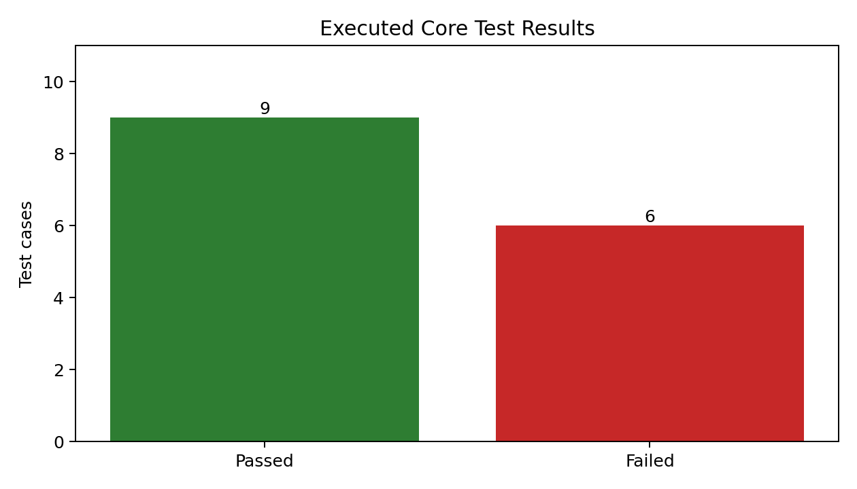
Figure 25. Actual Automated Test Result Summary

9.4 Executed Test Results
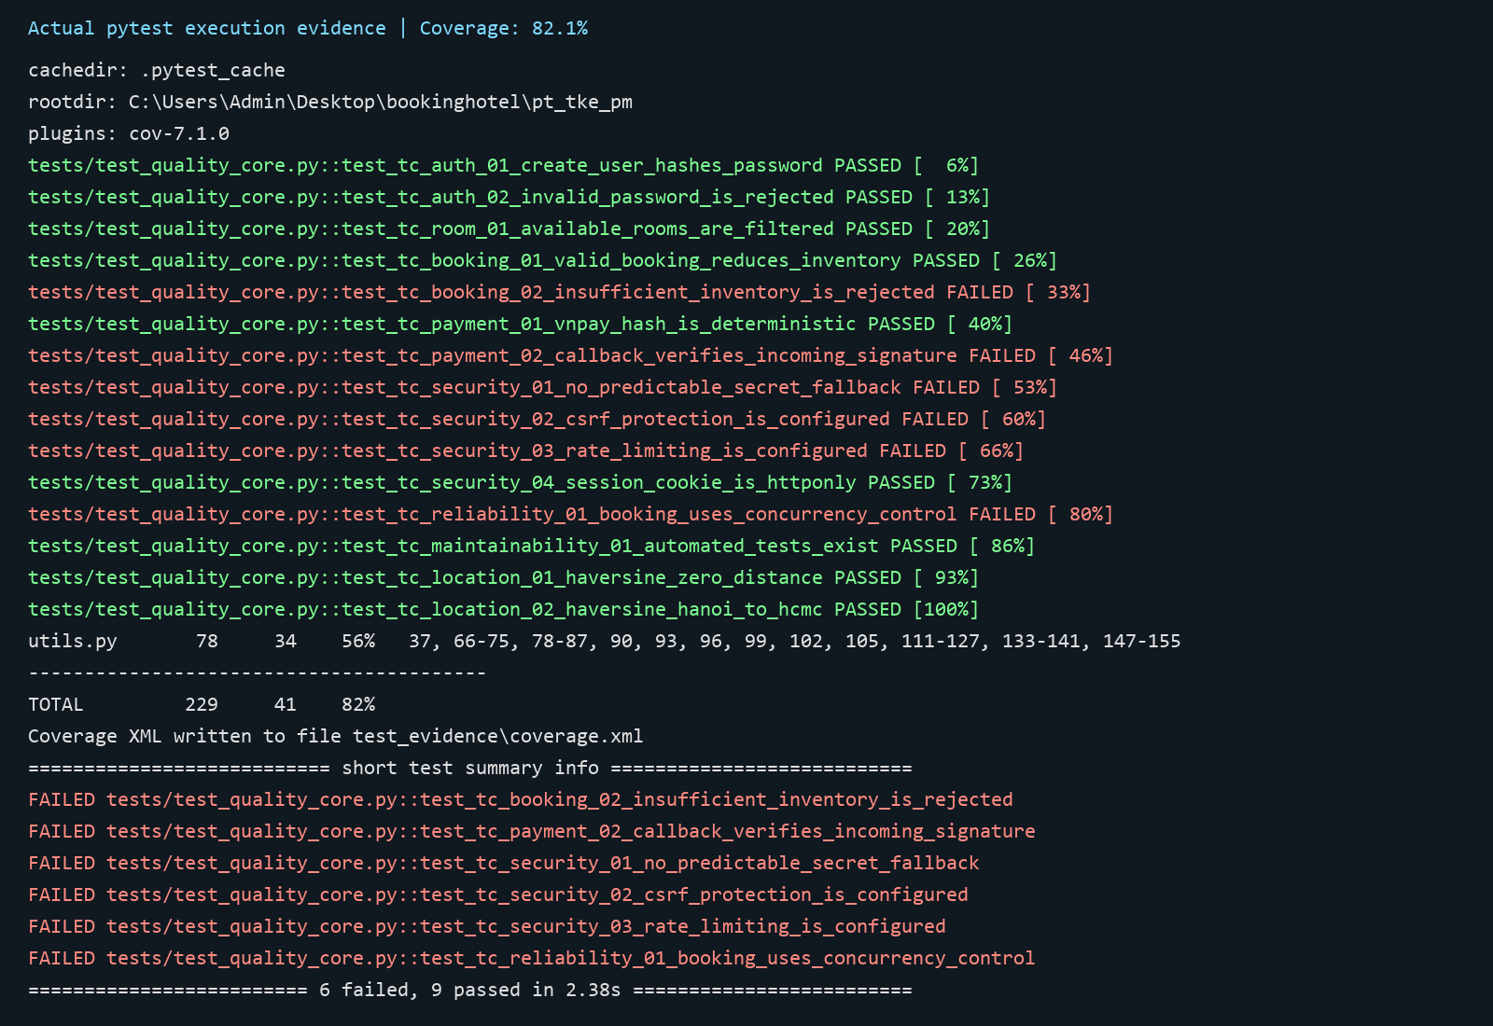
Figure 26. Actual Pytest Execution Evidence

9.5 Blocked and Not Executed Tests
Table 37. Blocked and not executed tests
Scenario | Status | Reason
Controlled load and capacity | Blocked | No controlled load environment
Live VNPay settlement | Not Executed | No live test credentials
Live Gemini and SMTP outage behavior | Not Executed | External services not configured
Complete owner/admin end-to-end workflow | Not Executed | Seeded role environment not prepared

9.6 Defect Summary
Table 38. Verified defect summary
Verified Failure | Architecture Impact
Insufficient inventory accepted | Booking validation and transaction boundary are incomplete
Callback signature not verified | Payment trust boundary is incomplete
Unsafe secret fallback | Production configuration is not fail-safe
CSRF missing | Browser mutation boundary is unprotected
Rate limiting missing | Abuse resistance is incomplete
Concurrency control missing | Inventory consistency is not guaranteed
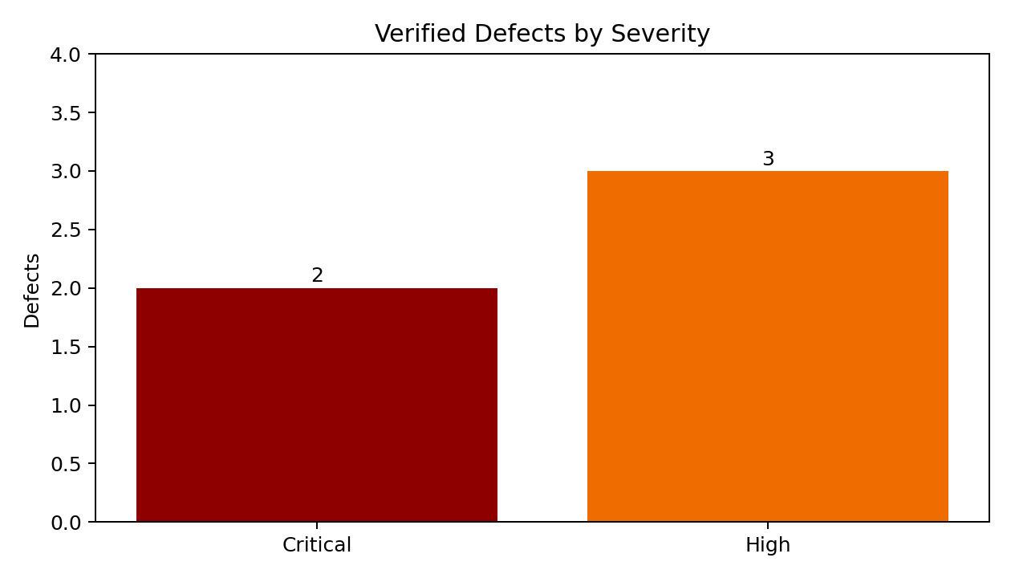
Figure 27. Verified Defects by Severity

9.7 Architecture Impact of Test Results
The failed tests justify structural changes rather than isolated documentation recommendations. BookingService, PaymentService, VNPayAdapter, centralized policy, and secure configuration become necessary architecture elements because they directly address verified failures.

9.8 Regression Test Plan
- Convert all six failed tests into mandatory CI gates after fixes.
- Add route-level authorization matrix tests.
- Add concurrent booking integration test against test MySQL.
- Add tampered and repeated VNPay callback tests.
- Add optional-service failure and recovery tests.

9.9 Executed Evidence Ledger
Table 39. Executed test evidence ledger
Test Case | Status | Evidence | Architecture Interpretation
TC-AUTH-01 create user hashes password | Passed | JUnit/pytest actual execution | Password hashing behavior exists
TC-AUTH-02 invalid password rejected | Passed | JUnit/pytest actual execution | Basic authentication rejection works
TC-ROOM-01 available rooms filtered | Passed | JUnit/pytest actual execution | Read-side availability filtering works in tested case
TC-BOOK-01 valid booking reduces inventory | Passed | JUnit/pytest actual execution | Happy-path mutation works in isolated test
TC-BOOK-02 insufficient inventory rejected | Failed | JUnit/pytest actual execution | Booking validation/transaction boundary is incomplete
TC-PAY-01 VNPay hash deterministic | Passed | JUnit/pytest actual execution | Outbound signing helper is deterministic
TC-PAY-02 callback verifies signature | Failed | JUnit/pytest actual execution | Inbound payment trust boundary is incomplete
TC-SEC-01 predictable secret fallback | Failed | JUnit/pytest actual execution | Production configuration is not fail-safe
TC-SEC-02 CSRF protection configured | Failed | JUnit/pytest actual execution | Browser mutation boundary is unprotected
TC-SEC-03 rate limiting configured | Failed | JUnit/pytest actual execution | Abuse resistance is incomplete
TC-SEC-04 HTTPOnly cookie | Passed | JUnit/pytest actual execution | One session-hardening control is present
TC-REL-01 booking concurrency control | Failed | JUnit/pytest actual execution | Final-room consistency is not guaranteed
TC-MAINT-01 automated tests exist | Passed | JUnit/pytest actual execution | Regression foundation exists but remains narrow
TC-LOC-01 zero distance | Passed | JUnit/pytest actual execution | Deterministic location helper handles identity case
TC-LOC-02 Hanoi to HCMC distance | Passed | JUnit/pytest actual execution | Location calculation returns plausible distance

9.10 Defect-to-Architecture Mapping
Table 40. Defect-to-architecture traceability
Verified Defect | Root Cause | Architecture Change | ADR | Migration Phase | Regression Evidence
Insufficient inventory accepted | Validation and mutation are not owned atomically | BookingService and BookingPolicy | ADR-06 | Phase 1–2 | TC-BOOK-02 passes
No concurrency control | Read-modify-write inventory flow | Repository conditional update/row lock | ADR-03/06 | Phase 2 | Parallel final-room test passes
Callback signature not verified | Provider logic mixed with route finalization | VNPayAdapter and PaymentService | ADR-05 | Phase 1–2 | Tampered callback rejected
Predictable secret fallback | Unsafe configuration default | Fail-safe production configuration | ADR-01/04 | Phase 1 | Startup/config regression passes
CSRF missing | Browser mutation boundary lacks shared control | Central web security configuration | ADR-04 | Phase 3 | State-changing route CSRF suite passes
Rate limiting missing | No abuse-control boundary | Endpoint rate-limit policy | ADR-04/07 | Phase 3 | Repeated-request tests pass

9.11 Coverage Gap Analysis
Table 41. Testing coverage gap analysis
Area | Existing Evidence | Gap | Required Test Level
Authentication | Hashing and invalid-password unit evidence | Verification/reset, lockout, role behavior | Service and route integration
Booking | Happy path and failed stock check | Concurrency, rollback, cancellation, ownership | MySQL integration and API
Payment | Outbound hash and failed callback check | Tamper, amount mismatch, replay, idempotency | Adapter/service integration
Owner/Admin | No executed end-to-end evidence | Role and tenant isolation | Seeded endpoint-role matrix
AI | Deterministic location helper evidence | Provider outage, prompt injection, safe tools | Mocked provider/service tests
Operations | No load/restore/observability evidence | Capacity, backup restore, alert behavior | Controlled non-functional verification

9.12 Proposed Verification Catalogue
Table 42. Proposed and blocked verification catalogue
Proposed Test | Status | Purpose | Required Environment
Parallel final-room booking | Proposed / Not Executed | Verify only one transaction succeeds | Disposable test MySQL
Tampered and replayed VNPay callbacks | Proposed / Not Executed | Verify trust boundary and idempotency | Mock/sandbox provider
Endpoint-role and ownership matrix | Proposed / Not Executed | Verify deny-by-default tenant isolation | Seeded role data
Gemini/SMTP timeout and fallback | Proposed / Not Executed | Verify optional-service resilience | Mocked provider failures
Backup restore rehearsal | Proposed / Not Executed | Verify recovery objectives and integrity | Test deployment and backup
Search/load profile | Blocked | Establish response-time and capacity evidence | Controlled load environment

9.13 Test Gates for Architecture Migration
Architecture extraction is complete only when behavior and risk evidence improve. Phase 1 must turn critical security and consistency failures into passing regression tests. Later phases must preserve route contracts, add service-level tests, and introduce dependency/authorization checks before duplicate route logic is removed.
10. Deployment Architecture
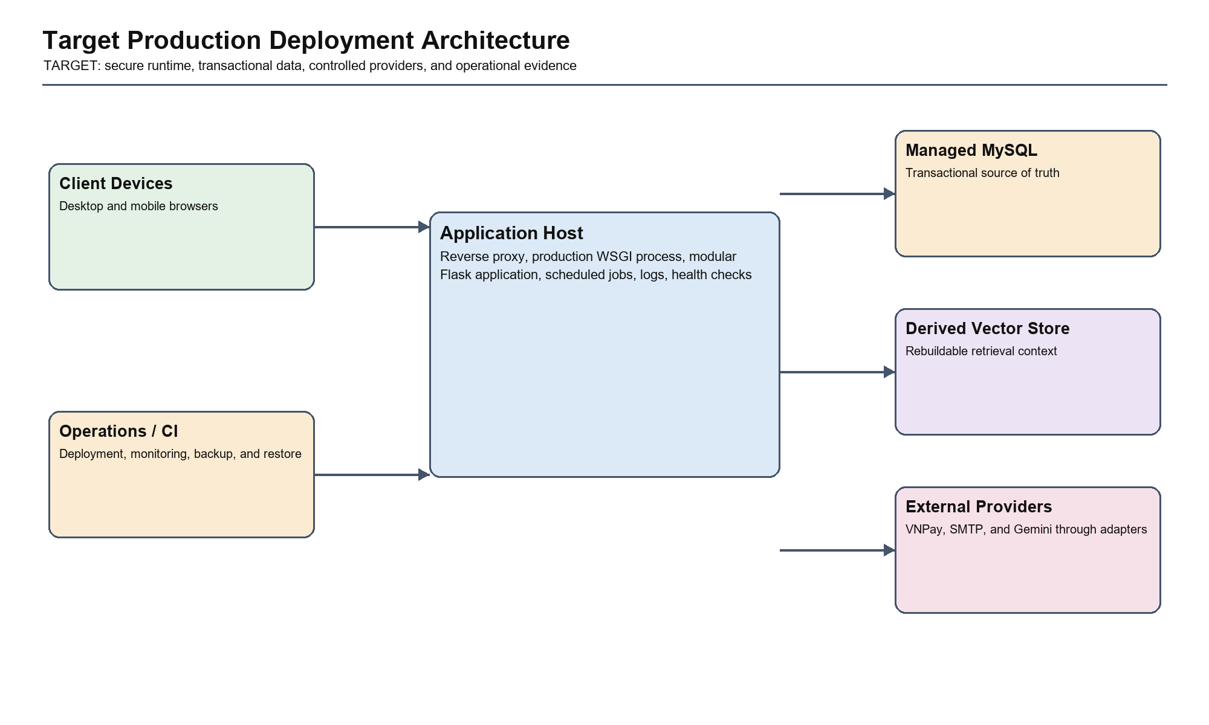
Figure 28. Target Production Deployment Architecture
The deployment view keeps transactional behavior in one production application and managed relational database while controlling provider access through adapters. Jobs, logs, health checks, backup, and restore evidence make operational responsibilities explicit without introducing microservices.

10.1 Development Deployment
Development uses a local Python environment, Flask development server, SQLite or local MySQL, suppressed email, sandbox/mock providers, and local logs. It prioritizes developer speed, not production resilience.

10.2 Test Deployment
Automated tests use isolated SQLite for core behavior and should add disposable MySQL for transaction and concurrency verification. External providers should be mocked by default, with separate sandbox suites.

10.3 Production Target Deployment
Production should use HTTPS termination, reverse proxy, production WSGI process, managed MySQL, secure environment secrets, scheduled jobs, structured logs, health checks, backups, and restricted external connectivity.
Table 43. Environment deployment comparison
Environment | Purpose | Database | External Services
Development | Local coding and debugging | SQLite or local MySQL | Mock or sandbox
Testing | Automated and integration verification | SQLite plus disposable test MySQL | Mocked plus controlled sandbox
Production | Real customer usage | Managed MySQL | VNPay, SMTP, Gemini with secure credentials

10.4 Environment Variables
Table 44. Environment variable policy
Variable Group | Examples | Rule
Database | DATABASE_URL, MYSQL_* | Never embed production credentials
Security | SECRET_KEY | Required strong secret in production
Email | MAIL_* | Use provider-specific credential storage
Payment | VNP_TMN_CODE, VNP_HASH_SECRET | Restrict access and rotate securely
AI | GEMINI_API_KEY | Minimize data and restrict key permissions

10.5 Backup and Recovery
Backups must cover relational business data, configuration metadata, and audit records. ChromaDB can be rebuilt from controlled source documents. Recovery procedures should be tested and should define recovery point and recovery time objectives.

10.6 Observability: Logs, Metrics, and Audit Trail
Table 45. Observability requirements
Signal | Required Content | Primary Use
Logs | Correlation ID, route, result, safe error context | Diagnosis
Metrics | Latency, error rate, booking/payment outcomes, provider failures | Operations and capacity
Audit Trail | Authentication, authorization denial, booking/payment transitions | Security and dispute analysis
Health Checks | Application, database, optional providers | Availability monitoring

11. Migration Roadmap

Figure 29. Current-to-Target Architecture Migration Roadmap
The roadmap orders work by verified risk and dependency. Security and transactional defects are stabilized before services and policies are extracted; operational controls follow only after the internal boundaries are dependable and regression-tested.

11.1 Migration Principles
- Stabilize verified critical behavior before refactoring.
- Extract one vertical business slice at a time.
- Preserve route contracts while moving orchestration behind services.
- Introduce abstractions only where they reduce real risk.
- Use tests and traceability as migration evidence.

11.2 Migration Backlog
Table 46. Migration backlog
Phase | Task | Risk Addressed | Success Evidence
Phase 1 | Verify VNPay callback and fix booking stock validation | Payment inconsistency and overbooking | Payment and booking tests pass
Phase 2 | Extract BookingService and PaymentService | Route complexity and transaction ambiguity | Focused service tests pass
Phase 3 | Split Blueprints and centralize authorization | Cross-tenant access and app.py growth | Endpoint-role matrix passes; app.py shrinks
Phase 4 | Add repositories, adapters, jobs, and CI | Infrastructure coupling and regression | Automated pipeline and operational evidence

11.3 Migration Risk Register
Table 47. Migration risk register
Migration Risk | Mitigation
Behavior regression | Characterization and regression tests before extraction
Duplicate business rules | One canonical service per use case
Over-abstraction | Introduce repositories/adapters only at meaningful boundaries
Long-running partial migration | Track current and target ownership explicitly
Documentation drift | Generate inventories and validate architecture artifacts

11.4 Migration Success Metrics
Table 48. Migration success metrics
Metric | Target
Critical failed tests | Zero
Business orchestration in route functions | Reduced to request/response translation
Authorization policy locations | Centralized and tested
Booking/payment transaction boundaries | Explicit and atomic
CI regression suite | Runs automatically with JUnit and coverage
Architecture documentation | Current and target views remain traceable

11.5 Refactoring Order
The recommended order is payment verification and booking integrity, followed by BookingService and PaymentService extraction, centralized authorization, Blueprint separation, repository/adapter isolation, scheduled jobs, and production operations. This order follows verified risk rather than code aesthetics.

11.6 Phase Objectives and Dependencies
Table 49. Migration phase objectives and dependencies
Phase | Primary Objective | Dependency | Exit Condition
Phase 1: Stabilize | Fix verified P0 security and consistency behavior without broad restructuring | Existing tests and route behavior | Critical regression tests pass and configuration is fail-safe
Phase 2: Extract Transactions | Create BookingService, PaymentService, repositories, and VNPayAdapter | Stable behavior from Phase 1 | Routes delegate to tested services; transactions are explicit
Phase 3: Enforce Boundaries | Split Blueprints and centralize authorization/validation | Service interfaces from Phase 2 | Role matrix passes and route responsibilities shrink
Phase 4: Operationalize | Add jobs, adapters, CI gates, observability, backup, and deployment controls | Stable module boundaries | Operational evidence and automated pipeline are available

11.7 Detailed Migration Backlog
Table 50. Detailed migration backlog
Work Item | Current Source | Target Boundary | Risk | Acceptance Evidence
Secure production configuration | app.py/config defaults | Central configuration validation | Predictable secrets | Startup regression passes
Verify payment callback | vnpay_return route | PaymentService and VNPayAdapter | Forged/replayed callback | Tamper and replay tests pass
Fix inventory validation | Booking routes/helpers | BookingPolicy | Insufficient stock accepted | TC-BOOK-02 passes
Add atomic inventory mutation | Distributed ORM mutation | BookingRepository transaction | Concurrent overbooking | Parallel MySQL test passes
Extract booking/payment services | app.py and utils.py | Application service layer | Route complexity | Service tests and unchanged route contracts
Centralize owner/admin policy | Distributed route checks | AuthorizationPolicy | Cross-tenant exposure | Endpoint-role matrix passes
Move provider integrations | Routes/helpers/AI modules | Integration adapters | Provider coupling and fallback | Adapter contract/failure tests
Move request cleanup to jobs | Request lifecycle | Scheduled jobs | Latency and unpredictable side effects | Job retry/idempotency evidence

11.8 Entry, Exit, and Rollback Criteria
Table 51. Migration entry, exit, and rollback criteria
Phase | Entry Criteria | Exit Criteria | Rollback Strategy
Stabilize | Current evidence captured and reproducible | Mapped critical defects fixed with passing tests | Revert isolated fix while retaining evidence
Extract Transactions | Stable booking/payment characterization tests | Service interfaces own orchestration and transactions | Route feature flag or delegation rollback
Enforce Boundaries | Services callable behind existing routes | Blueprint/policy migration passes role and contract tests | Restore route mapping to prior service-backed boundary
Operationalize | Stable modules and deployment baseline | CI, logs, backup, jobs, and provider policies verified | Disable new operational component independently

11.9 Migration Traceability Matrix
Table 52. Migration traceability matrix
Risk or Requirement | ADR | Target Module | Phase | Success Metric
Overbooking and inventory integrity | ADR-03/06 | Booking | 1–2 | No negative inventory; concurrency test passes
Payment callback integrity | ADR-05 | Payment | 1–2 | Tampered/replayed callback rejected
Cross-tenant authorization | ADR-04 | Owner/Admin and User Portal | 3 | Endpoint-role matrix passes
Route concentration and maintainability | ADR-01/02 | All domain modules | 2–3 | Routes become thin; service regression passes
AI safety and provider resilience | ADR-07 | AI Assistant and integrations | 3–4 | Unsafe mutation denied; fallback tests pass
Operational readiness | ADR-01 | Deployment/operations | 4 | CI, audit, health, backup/restore evidence

11.10 Delivery Governance and Metrics
Each migration work item must have one owner, one mapped risk, explicit acceptance evidence, and a reviewable rollback path. Progress is measured by reduced verified risk and clearer ownership rather than by the number of new classes or folders.
Migration governance metrics
Metric: Critical failed tests Baseline: Six failed checks in current evidence Target Direction: Zero unresolved critical failures Review Frequency: Every merge/release
Metric: Business orchestration in app.py Baseline: Broad route-centric responsibility Target Direction: Routes limited to interface translation Review Frequency: Each extraction phase
Metric: Authorization decision locations Baseline: Distributed Target Direction: Central policy with tested exceptions Review Frequency: Security review
Metric: Transaction boundaries Baseline: Implicit/distributed Target Direction: Explicit for booking/payment lifecycle Review Frequency: Integration test cycle
Metric: Operational evidence Baseline: Limited Target Direction: CI, logs, health, backup/restore, provider-failure evidence Review Frequency: Release readiness

12. Conclusion
Hanoi Booking has a practical current architecture for an academic project: a single Flask application, relational database, browser presentation, payment integration, and AI subsystem. The implemented architecture should not be described as a completed layered service/repository design; its main strength is deployment simplicity, while its main weakness is concentration of responsibility.
The recommended target is a modular monolith. It preserves transaction locality and operational simplicity while introducing application services, domain policies, selective repositories, integration adapters, centralized authorization, scheduled jobs, and production observability. This target directly addresses verified defects and provides a controlled path for future evolution.
Architecture quality will be demonstrated not by document length, but by whether the proposed decisions become executable evidence: verified payment callbacks, atomic booking inventory, consistent authorization, reliable fallbacks, and repeatable automated tests.

Appendix A. Source File Inventory
Table 53. Source and configuration file inventory
File | Type | Bytes
app.py | .py | 104424
config.py | .py | 2654
generate_architecture_report.py | .py | 44888
generate_detailed_architecture_report.py | .py | 55926
generate_detailed_architecture_report_v2.py | .py | 138193
generate_quality_testing_report_v2.py | .py | 32224
image.py | .py | 2108
models.py | .py | 7801
professional_diagrams.py | .py | 18705
prompt.txt | .txt | 1239
README.md | .md | 4444
requirements.txt | .txt | 274
setup_database.sql | .sql | 29717
utils.py | .py | 5440
.pytest_cache/README.md | .md | 310
ai_agent/graph.py | .py | 5060
ai_agent/prompts.py | .py | 3749
ai_agent/state.py | .py | 1523
ai_agent/test_agent.py | .py | 1789
ai_agent/__init__.py | .py | 123
ai_agent/nodes/booking.py | .py | 23681
ai_agent/nodes/management.py | .py | 3174
ai_agent/nodes/nearby.py | .py | 3696
ai_agent/nodes/rag_faq.py | .py | 1908
ai_agent/nodes/router.py | .py | 2907
ai_agent/nodes/__init__.py | .py | 26
ai_agent/tools/db_tools.py | .py | 21999
ai_agent/tools/location_tools.py | .py | 3058
ai_agent/tools/payment_tools.py | .py | 3119
ai_agent/tools/__init__.py | .py | 26
chatbot_system/build_vector_db.py | .py | 2746
chatbot_system/chatbot.py | .py | 1930
chatbot_system/extract_project_data.py | .py | 1744
chatbot_system/requirements.txt | .txt | 150
chatbot_system/test_chatbot.py | .py | 860
chatbot_system/docs/codebase_data.txt | .txt | 915212
hotelsmanagementweb/css/base.css | .css | 1620
hotelsmanagementweb/css/booking.css | .css | 10092
hotelsmanagementweb/css/detailroom.css | .css | 21428
hotelsmanagementweb/css/home.css | .css | 13383
hotelsmanagementweb/css/register.css | .css | 2336
hotelsmanagementweb/css/test.css | .css | 2280
hotelsmanagementweb/css/user.css | .css | 26591
hotelsmanagementweb/database/btl_csdl_bookings.sql | .sql | 2291
hotelsmanagementweb/database/btl_csdl_hotels.sql | .sql | 1946
hotelsmanagementweb/database/btl_csdl_hotel_images.sql | .sql | 1971
hotelsmanagementweb/database/btl_csdl_notifications.sql | .sql | 2033
hotelsmanagementweb/database/btl_csdl_payment.sql | .sql | 2273
hotelsmanagementweb/database/btl_csdl_rooms.sql | .sql | 1988
hotelsmanagementweb/database/btl_csdl_room_images.sql | .sql | 1961
hotelsmanagementweb/database/btl_csdl_services.sql | .sql | 1934
hotelsmanagementweb/database/btl_csdl_users.sql | .sql | 2114
hotelsmanagementweb/database/db.sql | .sql | 40029
hotelsmanagementweb/database/hotel.sql | .sql | 8170
hotelsmanagementweb/database/image.sql | .sql | 508
hotelsmanagementweb/database/room.sql | .sql | 1489
hotelsmanagementweb/database/services.sql | .sql | 24541
hotelsmanagementweb/database/update_hotels.sql | .sql | 649
hotelsmanagementweb/database/users.sql | .sql | 445
hotelsmanagementweb/js/main.js | .js | 701
hotelsmanagementweb/js/user.js | .js | 9117
hotelsmanagementweb/pages/ai_chat_widget.html | .html | 16330
hotelsmanagementweb/pages/booking.html | .html | 31972
hotelsmanagementweb/pages/detailroom.html | .html | 38067
hotelsmanagementweb/pages/header.html | .html | 5248
hotelsmanagementweb/pages/home.html | .html | 52521
hotelsmanagementweb/pages/register.html | .html | 9353
hotelsmanagementweb/pages/user.html | .html | 71213
migrations/alembic.ini | .ini | 907
migrations/env.py | .py | 3457
migrations/script.py.mako | .mako | 518
migrations/versions/b0ffc569636c_initial_migration.py | .py | 7061
tests/test_quality_core.py | .py | 6370
test_evidence/app_pid.txt | .txt | 6
test_evidence/app_stderr.txt | .txt | 1470
test_evidence/app_stdout.txt | .txt | 47
test_evidence/pytest_output.txt | .txt | 58332
test_evidence/ui_http_result.txt | .txt | 30

Appendix B. Complete Route Inventory
Table 54. Complete route inventory
Method | Endpoint | Function | Category | Entities
GET | / | home | Public | No direct entity access identified
GET, POST | /login | login | Authentication | User
GET, POST | /register | register | Authentication | User
GET, POST | /book/<int:room_id> | book_room | Booking | Hotel, Service, Review, Booking
GET | /booking/<int:booking_id> | booking_details | Booking | User
GET | /user/my-bookings | my_bookings | Booking | Booking
POST | /hotel/<int:hotel_id>/review | review_hotel | User Portal | No direct entity access identified
GET | /hotel/<int:hotel_id> | hotel_details | Hotel/Room | Hotel, Room, Review, Service, HotelLocation
GET | /logout | logout | Authentication | No direct entity access identified
GET | /user | user_profile | User Portal | Booking, Payment
GET | /api/room-images/<int:room_id> | get_room_images | Hotel/Room | No direct entity access identified
GET | /api/room-services/<int:room_id> | get_room_services | Hotel/Room | Service, Room
GET, POST | /booking | booking | Booking | No direct entity access identified
POST | /payment | create_payment | Payment | Room, Booking
GET | /booking/confirmation/<int:booking_id> | booking_confirmation | Booking | Booking
POST | /search | search_hotels | Hotel/Room | Hotel
GET | /search-by-name | search_hotels_by_name | Hotel/Room | No direct entity access identified
GET | /manage-hotels | manage_hotels | Owner/Admin | Hotel
GET | /manage-users | manage_users | Owner/Admin | User
GET | /payment/<int:booking_id> | payment | Payment | Booking
GET, POST | /hotel/edit/<int:hotel_id> | edit_hotel | Hotel/Room | Hotel
GET | /statistics | statistics | Owner/Admin | User, Hotel, Booking, Room
GET, POST | /forgot-password | forgot_password | Authentication | User, UserSecurity
GET, POST | /reset-password/<token> | reset_password | Authentication | UserSecurity
GET | /verify-email/<token> | verify_email | Authentication | UserSecurity
GET | /user/my-reviews | my_reviews | User Portal | Review
GET | /user/account-settings | account_settings | User Portal | No direct entity access identified
POST | /user/update-profile | update_profile | User Portal | No direct entity access identified
GET, POST | /user/change-password | change_password | Authentication | No direct entity access identified
POST | /vnpay_pay | vnpay_pay | Payment | Booking, Room, Payment
GET | /vnpay_return | vnpay_return | Payment | Payment, Booking, Room, User, Hotel, Notification
GET | /api/user/info | api_user_info | User Portal | No direct entity access identified
GET | /api/user/bookings | api_user_bookings | Booking | Booking, Room, Hotel, Payment
GET, POST | /booking/<int:hotel_id>/<int:room_id> | booking_hotel_room | Booking | Hotel, Room
POST | /api/user/update | api_user_update | User Portal | User
GET | /api/user/notifications | api_user_notifications | User Portal | Notification
GET | /api/user/transactions | api_user_transactions | User Portal | Payment, Booking, Room, Hotel
POST | /book_and_pay/<int:room_id> | book_and_pay | Booking | Room, Booking
GET | /debug/session | debug_session | Public | No direct entity access identified
GET | /api/owner/booking-history | api_owner_booking_history | Booking | Booking, User, Payment
GET | /api/owner/room-types | api_owner_room_types | Owner/Admin | Booking
GET | /api/owner/dashboard | owner_dashboard | Owner/Admin | Booking, Payment
GET | /api/hotel/<int:hotel_id>/dashboard | hotel_dashboard | Owner/Admin | Hotel, Room, Booking, Payment
GET | /api/hotel/<int:hotel_id>/payments | hotel_payments | Payment | Hotel, Booking, Room, Payment, User
POST | /api/user/change-password | api_change_password | Authentication | No direct entity access identified
DELETE | /api/user/booking/<int:booking_id> | api_delete_booking | Booking | Booking, Payment, Room
DELETE | /booking/<int:booking_id> | delete_booking | Booking | Booking, Payment, Room
POST | /api/chat | api_chat | AI Assistant | No direct entity access identified

Appendix C. Technology and Tool Environment
Table 55. Tools and implementation environment
Category | Tools | Purpose
Development | Python 3.11, Flask, SQLAlchemy, HTML/CSS/JS | Application implementation
Database | MySQL, SQLite tests, Alembic | Transactional data and migration
AI | LangGraph, Gemini, ChromaDB | Conversational and retrieval capabilities
Verification | pytest, pytest-cov, JUnit, Microsoft Edge | Automated and visual evidence
Documentation | python-docx, Pillow, Microsoft Word | Report and diagram generation

Appendix D. References
- ISO/IEC 25010 software product quality model.
- C4 model documentation.
- OWASP Application Security Verification Standard.
- Flask, Flask-Login, SQLAlchemy, LangGraph, ChromaDB, and Gemini documentation.
- VNPay integration guidance.
- Hanoi Booking source code, database schema, and actual test evidence.

